TOPIC 1.1 Environmental Value Systems
Case Study

Figure 1. World map showing the location of Plains bison
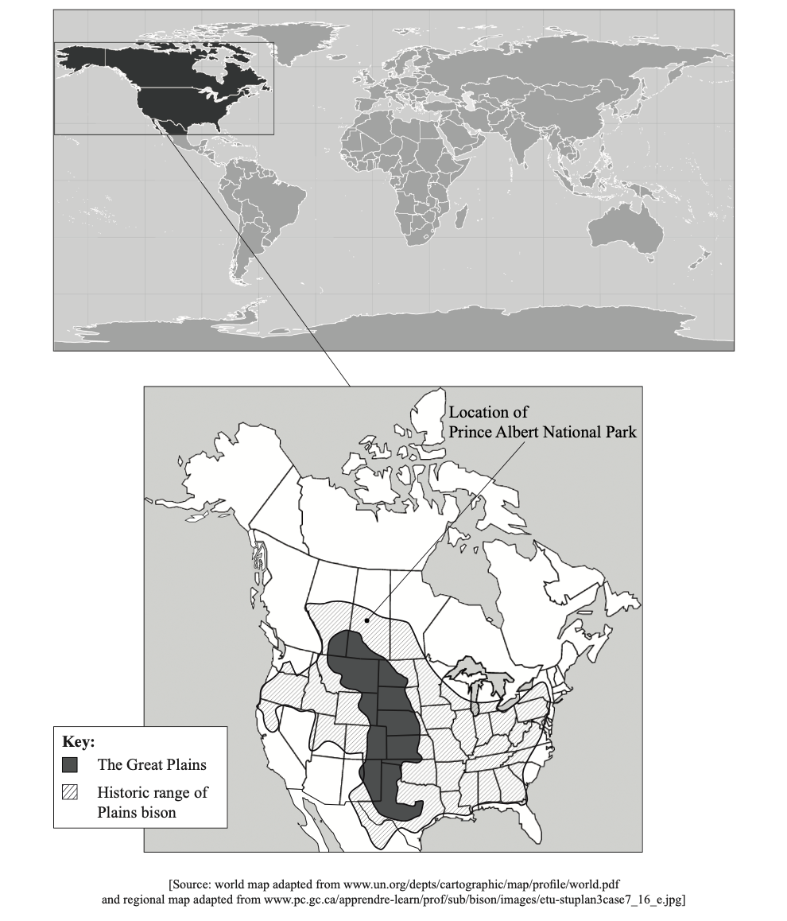

Figure 2. Background information on the American bison
The Plains bison (Bison bison bison) is a bovine (cow-like) mammal. Massive herds of these bison once inhabited the Great Plains (temperate grasslands) of the United States and Canada. They originally migrated from Europe and Asia over 10000 years ago.
In the past, American Indians used fire to deliberately create the large grasslands that provided the bison’s ideal habitat but they also kept the bison population regulated through hunting. Bison were a keystone species. This is a species which has a significant effect on the rest of the ecosystem in some way. Through their grazing they helped to preserve the grasslands.
The bison provided the American Indians with meat, leather, sinew for bows, grease, dried dung for fires, and the hooves could be boiled for glue. When food was scarce, bison were even consumed down to the last bit of marrow. The American Indians were sometimes wasteful, but this was not significant as the bison herds easily sustained the small number of animals taken. Bison were the most numerous single species of large wild mammal on Earth.

[Source: adapted from http://en.wikipedia.org/wiki/American_Bison]

Figure 3. Photographs of Plains bison and American Indians

- Plains bison

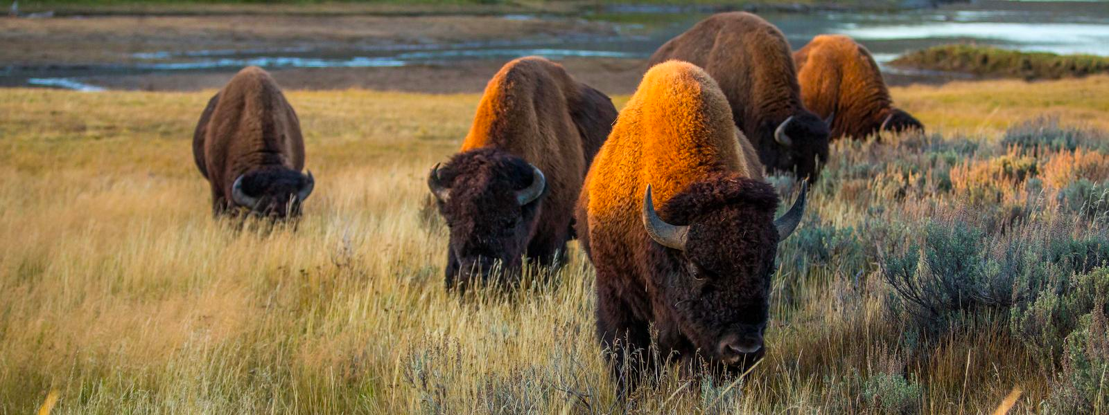

[Source https://www.worldwildlife.org/species/plains-bison]

- American Indian couple I bison hide wrap

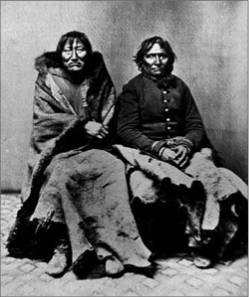

[Source: www.primitiveways.com/images/buffalo_comanche.jpg]

Figure 4 This is a hide yard, Dodge City, Kansas, off to the right is a scale used for weighing hides before they were shipped to the east (US) to be tanned
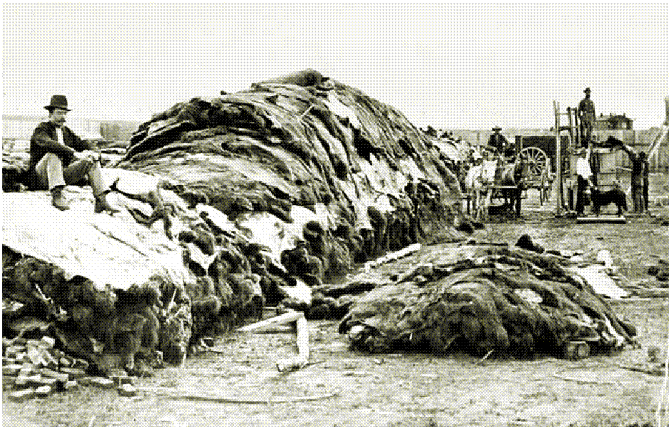

[Photo Credit; J. Peaco, Courtesy of Legends of America]

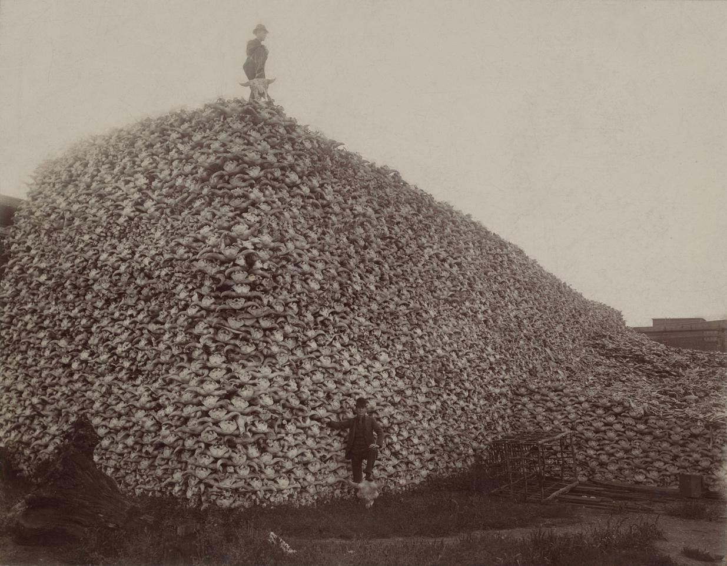

[https://en.wikipedia.org/wiki/Bison_hunting]

Figure 5 Map showing change in range of Plains bison over time
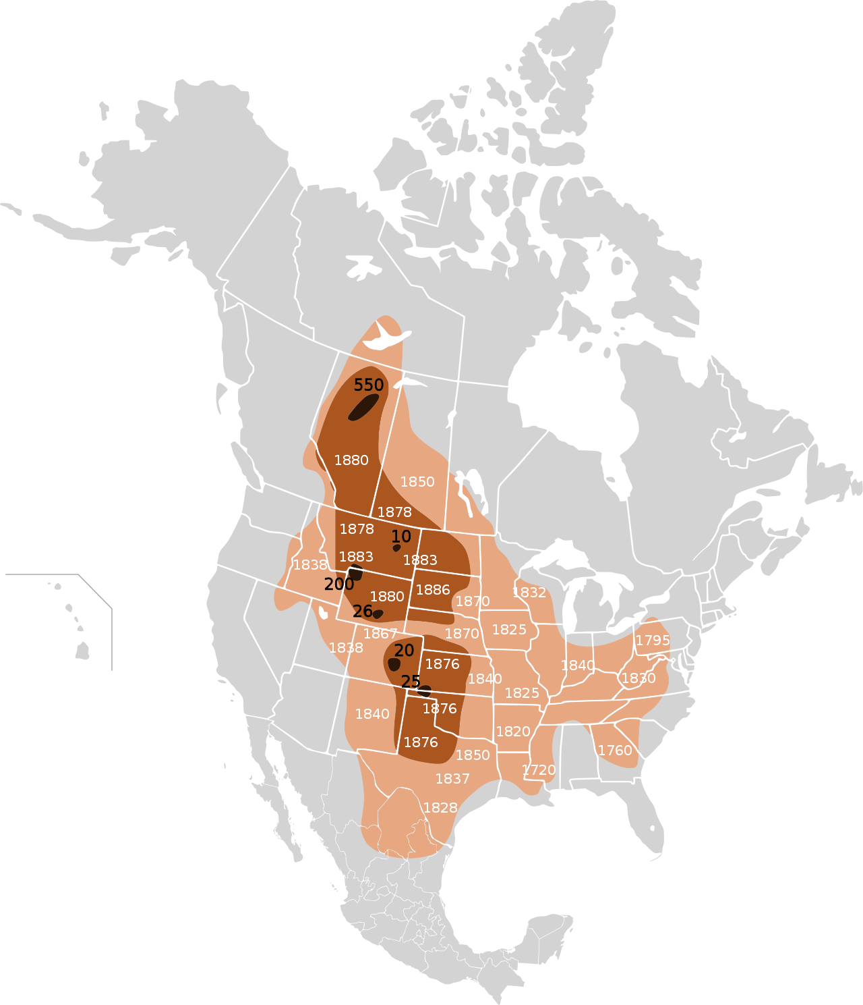

[Source: http://en.wikipedia.org/wiki/Image:Extermination_of_bison_to_1889.png]

Figure 6. 19th century bison hunts and near extinction
Bison Hunting was an activity fundamental to the economy and society of the Plains Indians people who inhabited the Interior Plains of North America. The species’ dramatic decline was the result of habitat loss due to the expansion of ranching and farming, industrial-scale hunting practiced by non-indigenous hunters, increased demand for bison hides and meat, and deliberate policy by the settler governments to destroy the food source of the Native Americans during the America-Indian Wars.

Plains bison once numbered in the tens of millions but were wiped out by commercial hunting and habitat loss. By 1889 fewer than 1100 animals survived. In 1905 the American Bison Society began efforts to repopulate reserves on the Great Plains with animals from zoo herds. Of the estimated 500000 Plains bison existing today, 20000 are considered wild; the rest live on private ranches

In the 16th century, North American was home to 25-30 million buffalo. BY the late 1880’s, less than 100 remained in the wild. The bison were hunted for their skins, with the rest of the carcass left to decay. The bones were then shipped back east.

[Source: http://en.wikipedia.org/wiki/Image:Extermination_of_bison_to_1889.png]

Figure 7 Video clip from Dances with Wolves – Buffalo Hunt

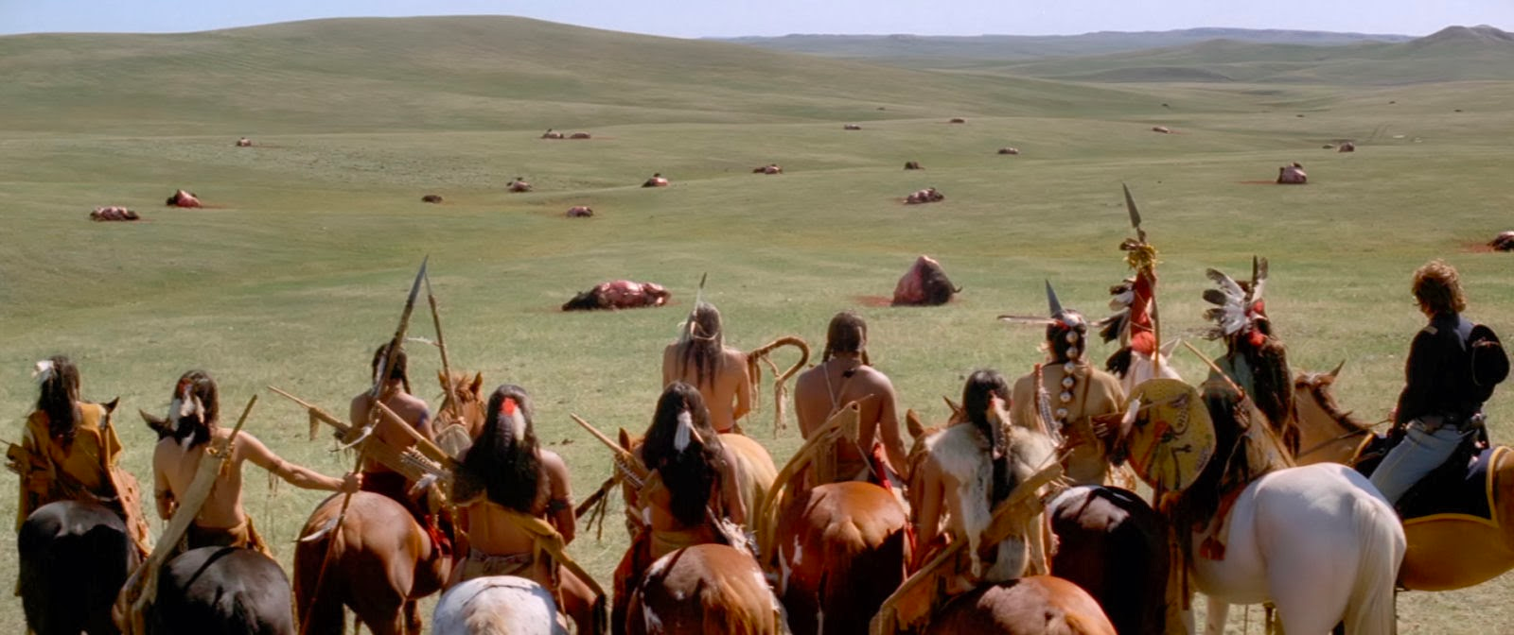

Click on the image and watch the video clip (https://www.youtube.com/watch?v=O9Sz2TGXuiM)

Figure 8 Wildlife Conservation Society report on the restoration potential of Plains bison
Plains bison can thrive again, study says
Plains bison could repopulate large areas from Alaska to Mexico over the next 100 years provided a series of conservation and restoration measures are taken, according to the Wildlife Conservation Society (WCS).
Mountain forests and grasslands across Canada and the United States and parts of the desert in Mexico could also again support herds that once lived there. Ecological restoration would occur when large herds of bison could move freely across large, open landscapes within major habitats of their historic ranges. It would also include bison interacting with a wide range of other native species. The WCS say it is also important that the bison are able to inspire, sustain and connect human cultures.
The researchers evaluated a range of factors, including the availability of existing habitat; potential for interaction with other native species (such as elk, prairie dogs and grassland birds); and the socio-economic and cultural factors in each location. The higher the score of these factors, the more likely restoration could take place. This is referred to as “restoration potential”.
Ecological restoration could take up to 100 years, and will only happen through collaboration with a broad range of people.

[Source: adapted from www.sciencedaily.com/releases/2008/04/080429130927.htm]
Figure 9 Plains bison and human interactions in Prince Albert National Park, Canada

There is a herd of 400 wild Plains bison in the Prince Albert National Park in Canada. The herd is not fenced in, and so can come in and out of the park at will. The herd brings benefits to the ecosystem but causes problems for landowners near the park.
The positive impacts of bison:
- they create trails through the forest that are used by other animals and people
- they modify vegetation through grazing
- they disperse seeds caught in their fur and through their droppings
- they are a food source for predators (e.g. wolves) and scavengers (e.g. ravens)
- birds eat insects on bison, and use underfur for nests
- their wallows (mud baths) allow for establishment of new plants
- their droppings provide nutrients to soil
- visitors come to the park to see them (ecotourism).
The negative impacts of bison:
- they damage/destroy farmland crops by grazing and wallowing
- they can transmit disease to domestic livestock
- they may damage fences so that domestic animals escape
- they may wander on roads causing vehicle collisions.
[Source: adapted from www.pc.gc.ca/apprendre-learn/prof/itm3-guides/vraie-true/etu-stuplan3case7_e.asp]

- Two incidents were involved in the buffalo hunt. One by white buffalo skinners and one by Sioux tribesmen. Contrast these two incidents with respect to EVSs and their relationship with the environment. (4 marks)

- Explain why early exploitation of Plains bison by American Indians could be considered sustainable. (4 marks)

- Outline three ways in which the status of Plains bison as a natural resource has changed over time. (3 marks)

- With reference to the map in Figure 5, describe how the range of Plains bison has changed over time. (2 marks)

- Suggest why the Plains bison is sometimes described as an “iconic” (representative, very significant) species. (1 mark)

- Outline the arguments that might be given for preserving Plains bison as a species by a deep ecologist and an environmental manager. (2 marks)

- Describe and justify your environmental value system. Include examples of environmental issues and your attitude towards them to support your answer. (4 marks)

