Notes: Structure of an Ecosystem Notes 2.2.2.1

THE ECOSYSTEM

Humans share the Earth with millions of other kinds of organisms. Unlike any other planet in our solar system, Earth has a protective, oxygen-rich atmosphere and an abundance of water, and it is this which has allowed life to develop.

The part of the Earth including air (atmosphere), water (hydrosphere) and minerals (lithosphere) where life can exist is called the BIOSPHERE. The biosphere is less than 20km thick, extending approximately 9km above sea level and approximately 11km below it. Within the biosphere, organisms interact. By providing oxygen, green plants enable animals to aerobically respire, a process that in turn releases the carbon dioxide which the plants use in photosynthesis. Plants provide food and habitats but rely upon animals and microorganisms to release the nutrients they need to grow. Animals such as insects are also frequently involved in the reproductive processes of plants.

The biosphere existed long before humans came along. In fact, in terms of geological time, we are the latest of latecomers, and just as dependent as any other organism on the complex inter-relationships which support life on the planet. If we are to play our part and maintain the biosphere, we need to understand it.
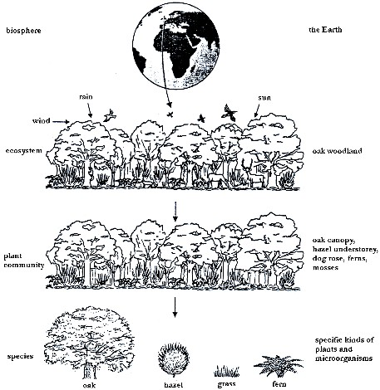
Structure of the biosphere

THE ECOSYSTEM –

ECOLOGY
Factors affecting the distribution of species

The environment is a collective term to include all the conditions in which an organism lives and it can be divided into two main parts:-

ABIOTIC FACTORS –

BIOTIC FACTORS –

Complete the following table using the factors list below:-

Temperature, light, soil pH, territory, salinity, mineral availability, interspecific competition (between different species), disease, predation, slope, soil structure, parasitism, wind speed, aspect (which direction a slope is facing), grazing, intraspecific competition (between organisms of the same species), fire, oxygen availability, pollution, agriculture.

ABIOTIC FACTORS (PHYSICAL) | BIOTIC FACTORS (LIVING)

Abiotic factors in an oak woodland.

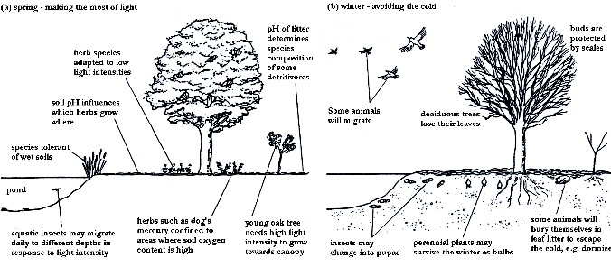

The abiotic influence:

The Law of Tolerance:

Limiting factors of Abiotic influences

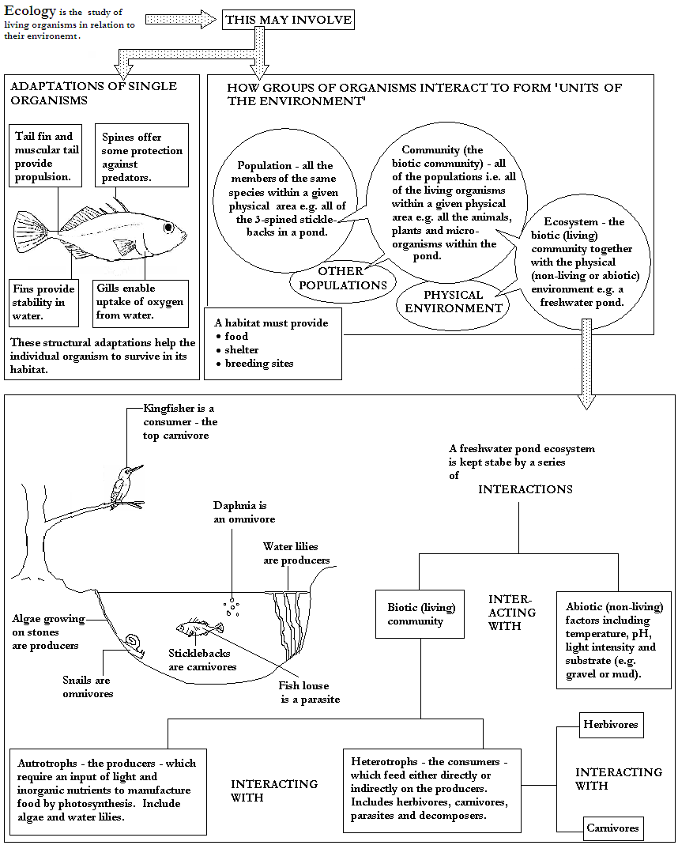

Terminology and Roles of Biota

Producers -

Consumers -

Decomposers -

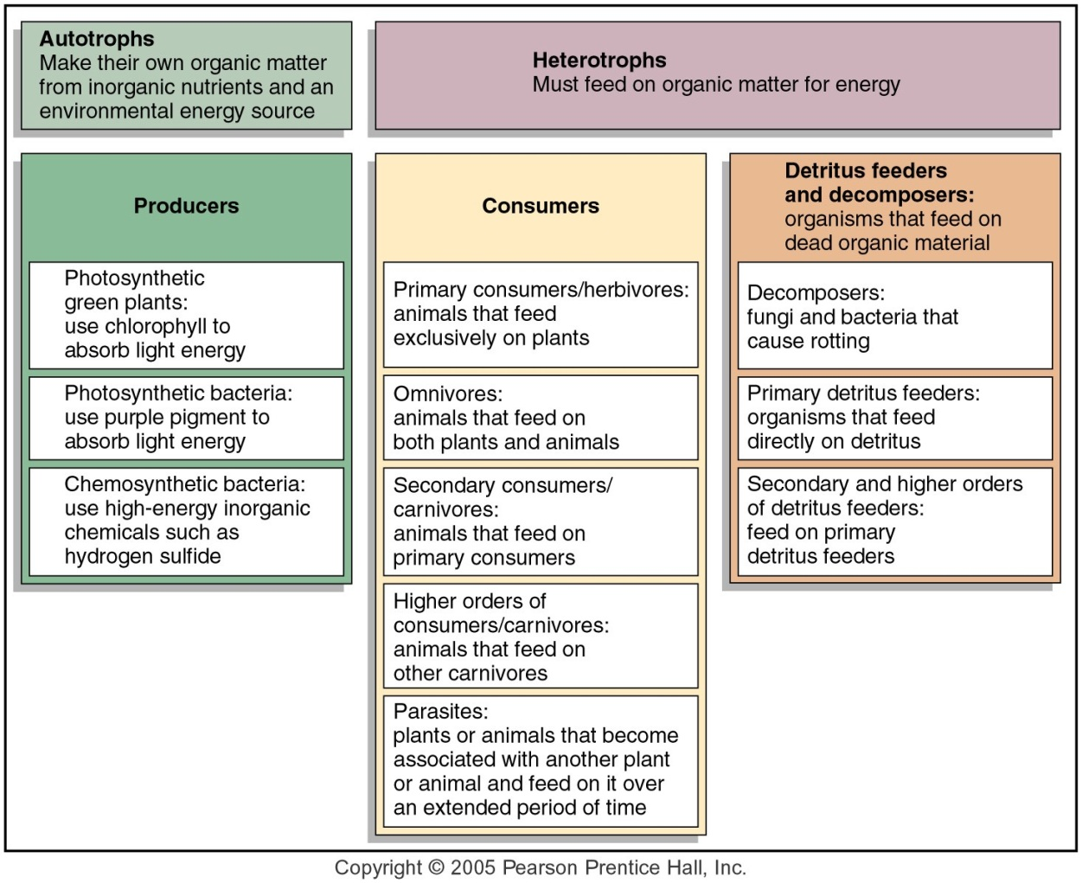
Food chains and webs

The terms producer, primary consumer, secondary consumer and tertiary consumer refer to the organisms feeding level in a food chain or web – this is called its

TROPHIC LEVEL –

Describe what is meant by a food chain.

Feeding levels in the chain (Trophic level) are:

-

-

-

-

The arrows in a food chain mean

Example of Local Tropic Levels
Trophic Level | Aquatic System | Terrestrial System
Producer

Primary Consumer

Secondary Consumer

Tertiary Consumer

Quaternary Consumer

6th Trophic Level

For complexity a real ecosystem needs which shows that individuals may exist at multiple trophic levels in a system

Define the following terms (giving examples where possible):-

- Producer (autotroph)

- Consumer (heterotroph)

- Detritivore

- Saprotroph (decomposer)

- Herbivore

- Carnivore

- Top carnivore

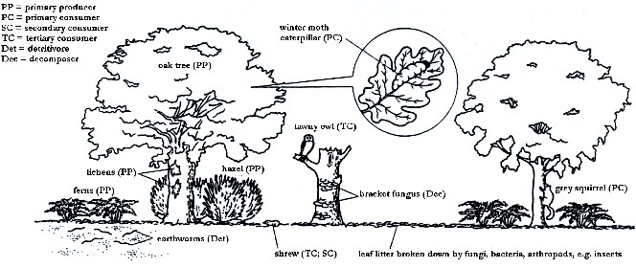
Define the following terms using the diagram below for reference.

Biotic of an oak woodland ecosystem

- Primary (1º) consumer

- Secondary (2º) consumer

- Tertiary (3º) consumer

- Which of the above is a herbivore?

- Which of the above are carnivores?

- What is an omnivore?

Describe what is meant by a food web. Draw a local example

Examples

Trophic levels of a food chain in each of 5 different habitats
Trophic level | Habitat
 | Grassland | Woodland | Freshwater pond | Rocky marine shore | Ocean
Quaternary consumers (3º carnivores) | Mammal  e.g. stoat | Bird  e.g. thrush | Large fish  e.g. pike | Bird  e.g. gull | Marine mammal  e.g. seal
Tertiary consumers (2º carnivores) | Reptile  e.g. grass snake | Arachnid  e.g. spider | Small fish  e.g. stickleback | Crustacean  e.g. crab | Large fish  e.g. herring
Secondary consumer (1º) carnivores) | Amphibian  e.g. toad | Carnivorous insect  e.g. ladybird | Annelid  e.g. leech | Carnivorous mollusc  e.g. whelk | Small fish  e.g. sand eel larvae
Primary consumers (herbivores) | Insect larva  e.g. caterpillar | Herbivorous insect  e.g. aphid | Mollusc  e.g. freshwater snail | Herbivorous mollusc  e.g. limpet | Zooplankton  e.g. copepods
Primary producers (e.g. photosynthetic organisms) | Grass  e.g. Festuca | Tree  e.g. oak leaves | Aquatic plant  e.g. Elodea | Seaweed  e.g. sea lettuce | Phytoplankton  e.g. diatom

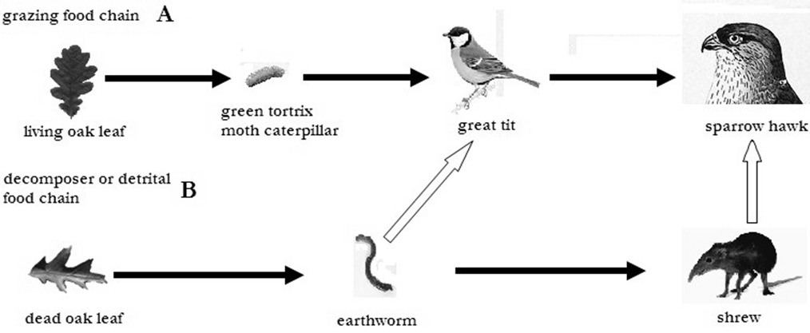
Woodland food chains and a food web: the white arrows indicate links between the food chains that make a food web

Look at the food chain/web on the previous page

  - How many trophic levels are there in food chain A?

  - Name the producer.

  - Label each trophic level in food chain B.

  - At which level is the sparrow hawk?

  - The caterpillar in food chain A is also eaten by a beetle (the devil’s coachhorse
beetle) which is itself also eaten by the great tit. Add the beetle to the web.

f) How has this addition changed our understanding of the great tit’s trophic level?

N.B. It is often difficult to classify organisms into definite trophic levels. They may occupy more than one level if they have a varied food source or change feeding patterns during different stages of their life cycle.

Data analysis practice question:
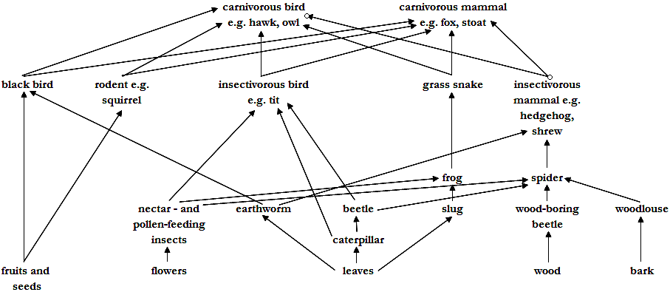
A food web for an oak woodland.
- Draw a food chain of 5 organisms from the web. Label it fully.

- Name one animal which is exclusively a secondary consumer.

- Name one animal which is at both the primary and secondary consumer trophic level i.e. an omnivore.

- Name one animal which is both a secondary and a tertiary consumer.

- The woodland is a bird sanctuary managed by a warden. In the summer of 1995 the oak trees were being eaten away by a large population of caterpillars. The warden sprayed the sanctuary (by light aircraft) with an insecticide which only killed insects. The caterpillar population was mostly destroyed. In late 1996 he noticed a reduction in the number of great tits in the wood but an increase in the number of young blackbirds. Explain this.

Below is an excerpt from a Year 12 student’s lab notebook during a visit to a tropical rainforest.

Date 14/05/2007
Location Bukit Timah Nature Reserve
Feeding relationships observations
TRF TREES (many species) all eaten by a caterpillar in a silken tube called a
BAGWORM.
TERMITES eating tree branches.
TREE SHREW (insectivorous mouse) eating termites and bagworms.
PYTHON found dead. Gut contained bones from tree shrew and a young
MONKEY skull.
Monkeys seen eating fruits from trees.
BULBUL (a type of tropical bird) seen eating bagworms, termites and
PRAYING MANTIS (an insect predator).
Praying mantis found with a bagworm in its jaws.
WOLF SPIDER found in crevice on tree trunk. It had termites and
bagworms stored in silk bundles.

- Using only the information from the notebook, construct a well organized food web. Your diagram should be organized into trophic levels as far as possible. Label the web.

Suggest a likely feeding relationship in this web which the student did not see

