4.1 Introduction to Water Systems Notes
Number of individuals throughout the world with inadequate water supply \

Importance of Water

Define the following terms:
Precipitation –

Evapotranspiration –

Infiltration –

Surface runoff –

Groundwater –

Percolation –

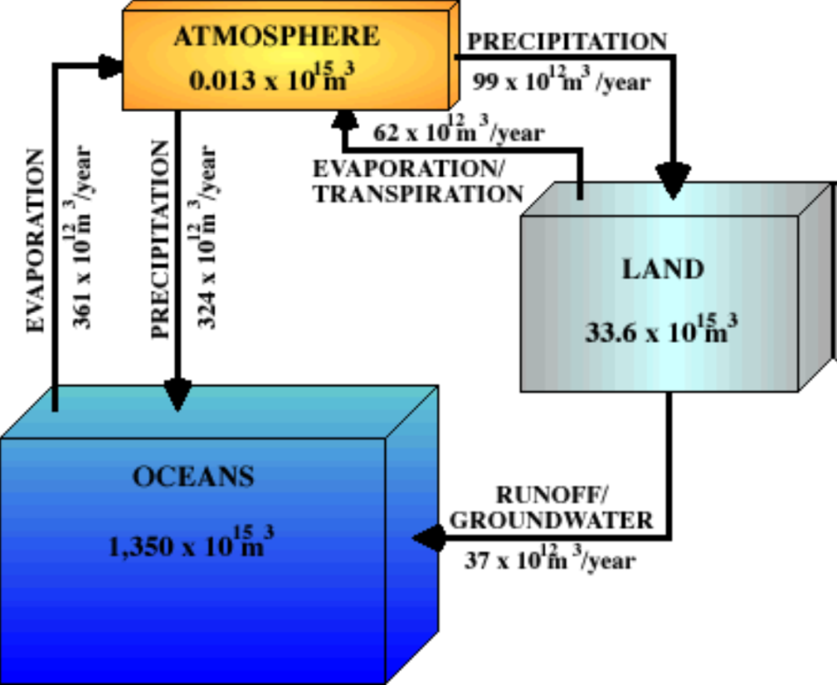

Water can be or depending on where it is stored. Water molecules in the and are locked in place from long periods. This water is Water in and move through cycles more quickly. This water is .
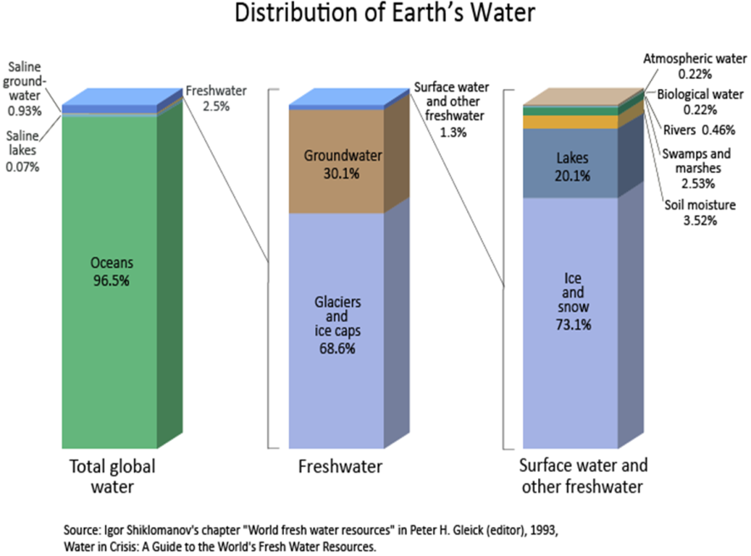
Only of water is fresh. is salt water
Of fresh water is in polar ice caps and glaciers
of fresh water is ground water while the remaining is in lakes, rivers, swamps and the atmosphere

Too Little Fresh Water

Water Consumption
North America
Europe
Sub-Saharan Africa

Turnover time –

Discuss human impact on the hydrological cycle
Withdrawals

Discharges

Changing flow speed

Diverting rivers

What is a glue-green city?

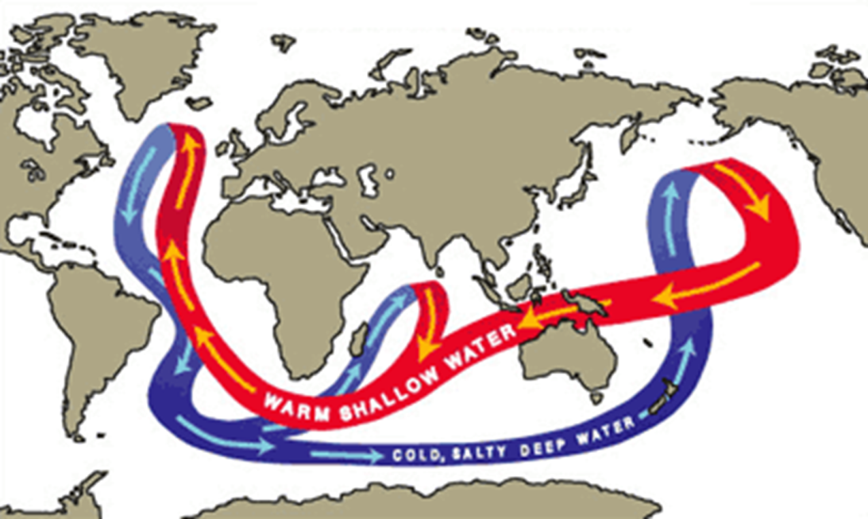
Great oceanic conveyor belt

Water has a heat capacity than land. Therefore it takes to heat and cool. This means land close to oceans has a

Review Questions
In the space below, draw a water cycle systems model. Make sure that you include inputs, outputs and storages. Also include any transformations or transfers

Explain how oceans currents can influence climate.

Explain El Nino and El Nina. How can these oscillations influence global climate?

