4.3 Aquatic Food Production Notes
Below create a spider diagram with everything you currently know about fisheries and fishing

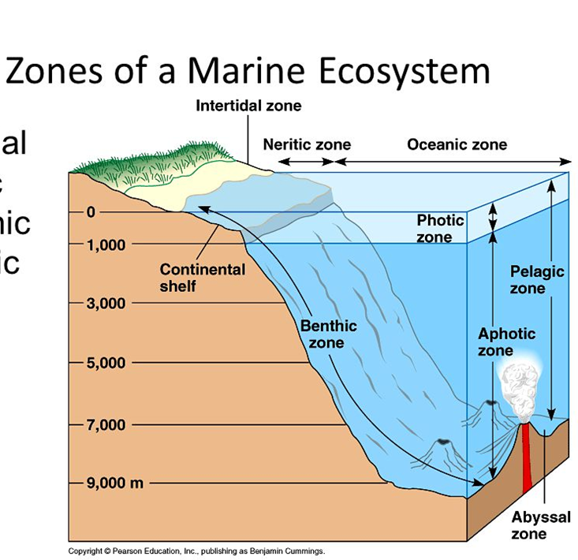
Marine Ecosystems include:

Continental Shelf makes up of marine productivity. The process of _____________increases nutrients in water. The waters in this area are so light can penetrate. These waters are close to the cost so can claim the rights.
Deep Oceans have __________ productivity and ________ belong to specific country
Energy from an aquatic ecosystem begins with:

Fisheries:

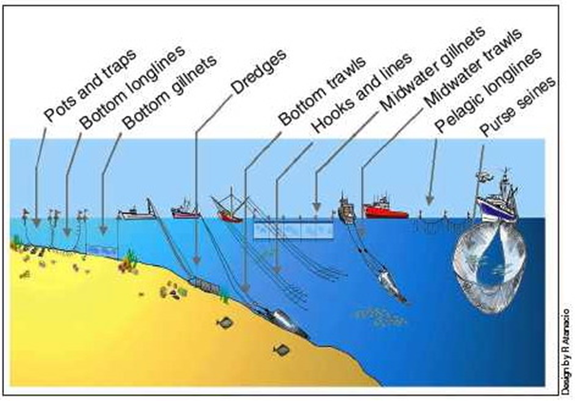
Identify the various methods of fishing

Why are current fishing methods cause problems with overfishing?

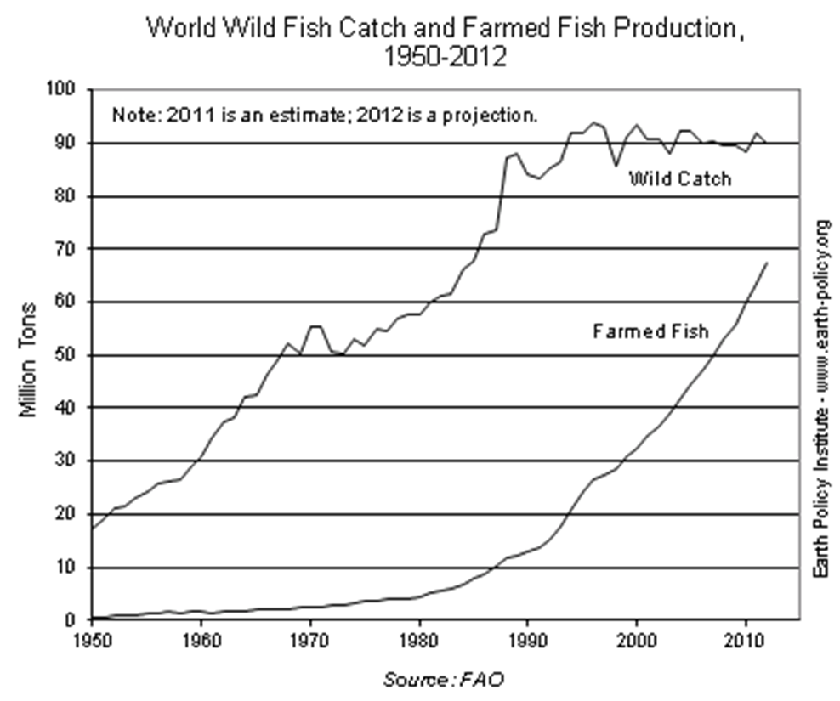

Benefits of aquaculture

Disadvantages of aquaculture

What is the Governance of the Ocean

Identify several named examples of International Conflicts of Fishing

Explain the Tragedy of the Commons

Define the following terms
Sustainable Yield

Maximum sustainable yield:

Carrying capacity of an aquatic system depends on

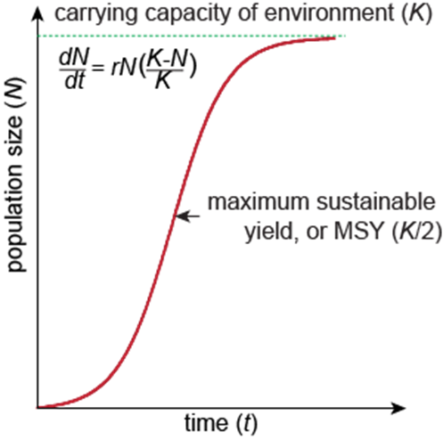
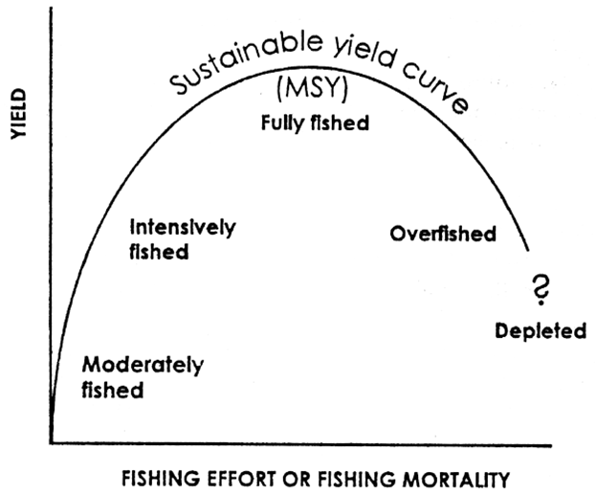

Calculations for Maximum Sustainable yield

Why is MSY not sustainable?

