Topic 5.2: Terrestrial food production systems and food choices
What do believe are the differences between subsistence farming and commercial farming? Give an example of each.
Definitions
LEDC

MEDC

Agribusiness

Commercial agriculture

Subsistence agriculture

Undernourished: not enough energy from food FAO: 854 million people (2007), 200 million are kids
Malnourished: Enough energy but not nutrient, 10% undernourished people die from malnutrition, 75% of deaths are kids under 5 yrs

Questions to consider
What are some of the reasons that people go hungry?

Can you name some places in the world where people are experiencing hunger right now?

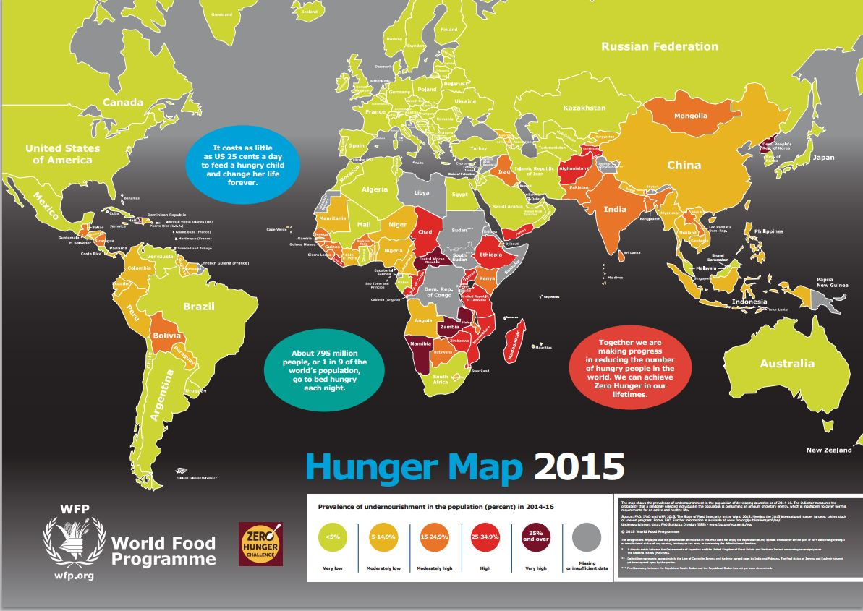
What are some specific things we as individuals can do to help end hunger for others, locally and globally?

What are the leading problems with world hunger?
- 870 million people suffer from
- Poor nutrition plays a role in at least
- World produces enough food but lacks
- ______________, _______________, ______________ and ___________ contribute to the problem of hunger.

Inequalities in Food Distribution
- ________ of the world is inadequately fed with ___________ going hungry
- Too much food is being produced in ___________ leading to ________________
- Some MEDCs have ______________ making food _________________
- LEDC food production is often used as_________________________ rather than __________________________
- Imbalance in __________________________
- Domestic support and export subsidies in MEDCs make LEDC crops ______________________
- Increased meat/dairy consumption and biofuels ____________________________________
- Climate change _____________________________________________________________
- MEDC farms are ____________________________. LEDC farms are _____________________________

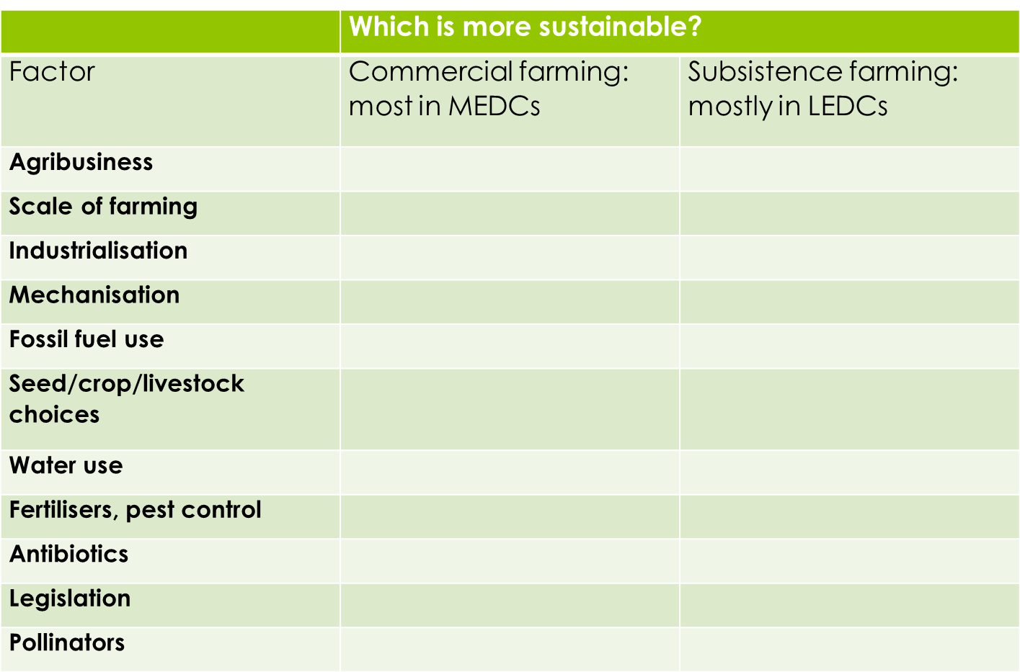

Farming Systems
Subsistence Farming

Commercial Farming

Pastoral Farming

Arable Farming

Mixed Farming

Food Waste

Food Energy Production
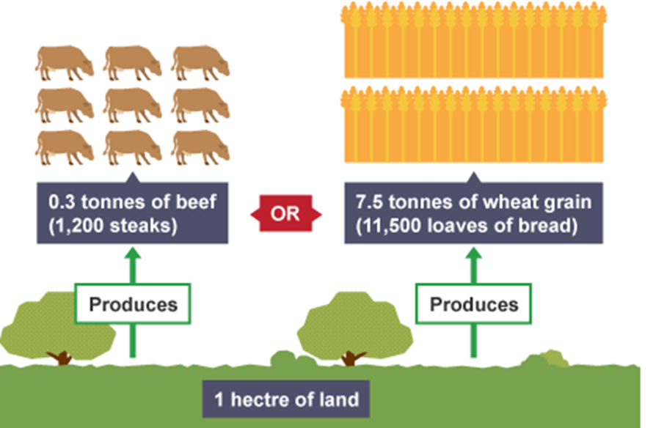

Western culture –

Eastern cultures –

Other cultures –

MEDC’s LEDC’s

What determines food choices?

Comparing Farming Systems
Inputs
Outputs
System characteristics
Environmental impact
Socio-economic factors

Aquatic Food Systems vs Terrestrial Food Systems

How can we be more sustainable?
Use the iPads to research the following, find example of each:
- Altering human activity
- Maximize yield
- Local produce
- Food Labels
- Monitoring multi-nationals
- Buffer zones (nutrient run-off)
- Food Waste
- Changing attitudes about food diets

Extra Help
European Union CAP: Common Agricultural Policy
a. System of government subsidies
b. Guarantees prices for European farmers (5% of pop’l)
c. Tariffs on imported products from LEDCs

Study Table 13.2 on p.250 – you’re likely to see it on exams
a. subsistence farming in Amazon basin
b. grain/cereal production in Canadian prairies
c. rice production in Ganges River basin
d. horticulture and dairy production in Netherlands

Compare rice production in Kalimantan and California (Topic 3.5.3)

Part 1: Define and summarize subsistence and commercial farming

Part 2: Select two named food production systems. Summarize each; a good idea would be to use the same ones that you did in the soil research. Then fill out the table below to compare the two.

 | Subsistence farming system: | Commercial farming system:
Inputs (material and energy)

Outputs (materials and energy)

Environmental impacts of the system

Human impacts on the system

Part 3: Complete the following tables to help show links between soil, food, and social systems

Table 1:Soil degradation and conservation methods

Type of soil degradation | location | impacts | conservation strategies
overgrazing | cattle ranches | soil erosion | Plant trees as wind breaks
deforestation | tropical rainforest | soil erosion
unsustainable agriculture |  | loss of topsoil, therefore fertility
soil erosion | various | sheet wash, gullying, wind erosion
toxification | acidic regsions, ie Ohio Valley, USA
salinization | warm and dry locations
desertification |  | degradation of land, occurs most in poor countries | terracing, contour planting, wind breaks

Table 2: Strategies for Global Food Supply

Strategies | Advantages | Disadvantages
increase use of GMO (genetically modified organisms) |  | possible human health danger due to genetic recombination, possible introduction of new species in ecosystem with unknown effects
increase irrigation

farm marginal lands | Suitable for grazing cattle | Overgrazing, not fit for growing crops
increase fertilizer use
increase use of antibiotics and growth hormone in cattle, fish, chicken, etc | Cows can produce milk and milk output from 8-12 weeks
increase use of pesticides and herbicide |  | May damage the environment. Can kill non target insects. Can destroy crops and move away from their original point of application. Health risks

Table 3: Comparing the efficiency of terrestrial and aquatic food production system

 | Aquatic | Terrestrial
Number of trophic levels

Efficiency of energy conversion

Initial fixing of solar energy

- Outline the differences between undernourishment and malnourishment.

- Contrast the availability of food resources in MEDC’s with that in LEDC’s and explain the differences.

- Discuss the reasons for an imbalance in food production and the distribution of food resources on a global scale.

- Contrast the typical diets of people in MEDC’s with those in LEDC’s.

- Do you consider bush meat to be a good thing or bad thing? Justify your answer.

- List and define the 2 types of farming systems.

- Outline the major differences between the inputs and outputs of subsistence and commercial farming systems.

- Define and describe the following:
  - cash crop

  - extensive farming

  - intensive farming

  - pastoral farming

  - arable farming

  - mixed farming

- Evaluate and discuss the advantages and disadvantages of the farming systems outlined in Table 13.2 on page 250. (These are good examples to keep in mind for the IB ESS Exam!)

- Which of the above types of farming do you think is most commonly practiced in Malawi? In France? Justify your answer with examples.

- Case Study #1: Palm oil. Outline the issues surrounding palm oil production in Asia pg 249
Pro’s/advantages | Con’s/Disadvantages
profit for small-scale farmers | loss of biodiversity
employment in LEDC’s | palm oil bad for consumer health (heart)
exports earn foreign currency | pesticides get into local food web
consumers benefit (products they like) | habitat loss
can be used as biofuel (renewable) | forest animals killed when invading plantations
 | high demand → increasing rate of rainforest loss/deforestation
 | clearing primary forest through fire → smoke/haze create health hazard and air quality problems (‘brown cloud’)

- Describe the difference between the maximum sustainable yield and the optimal sustainable yield. Explain why they are different.

- How would an increasing number of vegetarians impact global food supplies? Why?

- Case Study #2: Civil war, environmental crises, and food production in Sudan and South Sudan. Pg 260

Outline the issues contributing to poverty and environmental degradation in Sudan.
  - North = Muslim population involved in producing cotton, peanuts (groundnuts), coffee, dates, sugar cane, tobacco, citrus fruits → cash cropping reliant on irrigation from Nile River.
  - South = Christian/animist subsistence farmers and herders.
  - South Sudan has all the resources: fertile soil, mineral resources, timber, natural resources, precipitation; Northern Sudan is the seat of government, but they derive their income from the resources in the south.
  - Government of North also tried to impose sharia law on non-Muslim south, who resented someone else’s religion and so took up arms.
  - Civil war meant that government money was being spent on military weapons instead of development of agriculture, infrastructure, education, and health care, so the people of Sudan (both north and south) became even more impoverished.
  - Existing infrastructure and agriculture destroyed in fighting → mass starvation & famine.

- Case Study #3: Agricultural Production in Australia.
Pg 261
  - Most of Australia is arid, with little annual precipitation, so that agriculture requires large inputs of irrigation and fertilizers.
  - Agricultural production is concentrated in southeastern mountains, where most rainfall occurs.
  - Agriculture in northwestern Australia depends on annual flooding/monsoon cycle to provide soil nutrients and moisture, but changing climate patterns threaten that model and require higher inputs of
  - Most beef (75%) is exported to the US, UK, and Canada. That means large inputs of fuel for shipping or air freight. Compared to efficiency of crop production (lower on the food web) beef production is already inefficient; adding the fuel inputs required for export makes it even more inefficient from an energy perspective.
  - Dairy production requires lush grasslands, which are not common in Australia, so that milk production requires large inputs of irrigation, fertilizers, and pesticides.

Table 4: Linking Social systems and Food production

Social system | food production system | links- what does this type of production mean for the society? how does it benefit society? harm it? is it good? bad?
low population density, shifting cultivators | slash and burn
high population density, culture, soil fertility | wet-rice ecosystem of South-East Asia
Modern urban society, capitalism | Agribusiness, argo- ecosystem

