Notes 6.2 Stratospheric Ozone

Review of the overall structure and composition of the atmosphere.

  - Layers within the atmosphere (from the ground up) and their characteristics
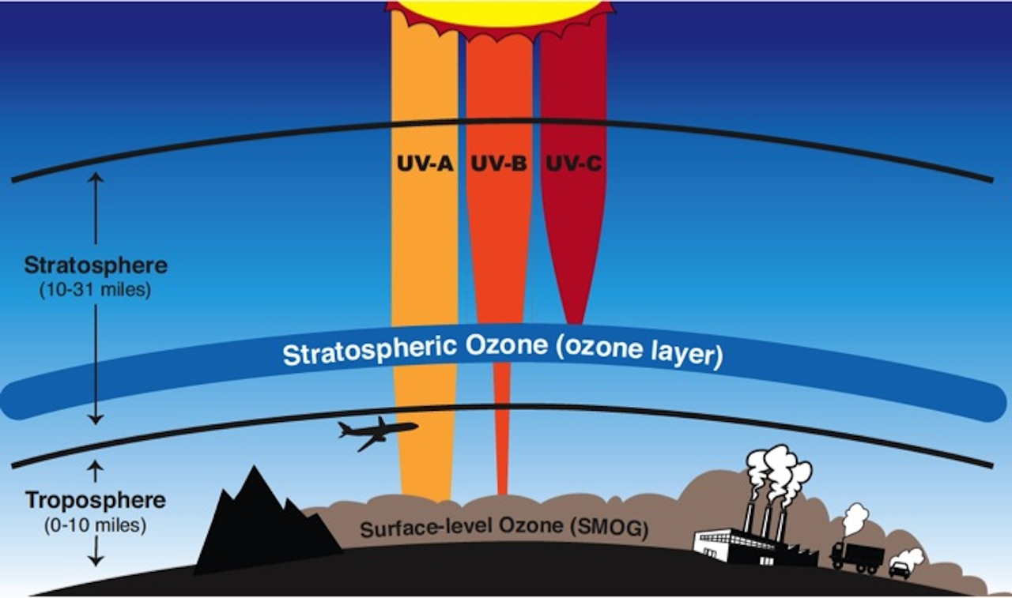
    - Troposphere -
      - 0-12km thick;
      - 75% of all gases in atmosphere;
      - all weather happens here;
      - temperature falls with altitude
    - Stratosphere -
      - 12-50 km thick
      - temperature increases with altitude (gets warmer!)
      - horizontal winds (jet stream)
      - contains ozone layer
    - Mesosphere -
      - 50-80km thick
      - temperature falls with altitude
      - meteor showers happen here
    - Thermosphere -
      - aurora borealis and aurora australis
      - ionosphere here (reflects radio waves for communications)
      - can be very very hot (2000 C+) !
    - Exosphere -
      - outermost layer of earth’s atmosphere
      - 550km+ above earth’s surface
      - satellites orbit here

Draw the structure of the ozone molecule

UV (ultraviolet) radiation is during the formation and destruction of into oxygen (O₂)

Ozone and UV light

  - allows and through, but blocks waves

    - UVa – causes
    - UVb - causes
    - UVc - worst one because of damage to
    - Damage to organisms especially

O2 + O + UV → O3
the energy provided by incoming UV light changes O2 → O3

Beneficial Effect of UV Light

Damage to the Ozone: Research the following information for your notes

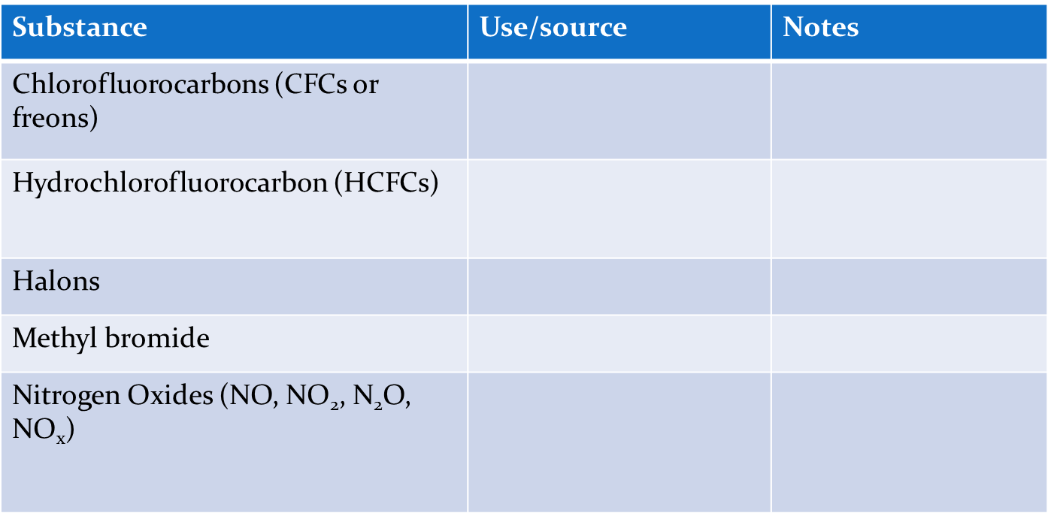

The interaction between ozone and halogenated organic gases.

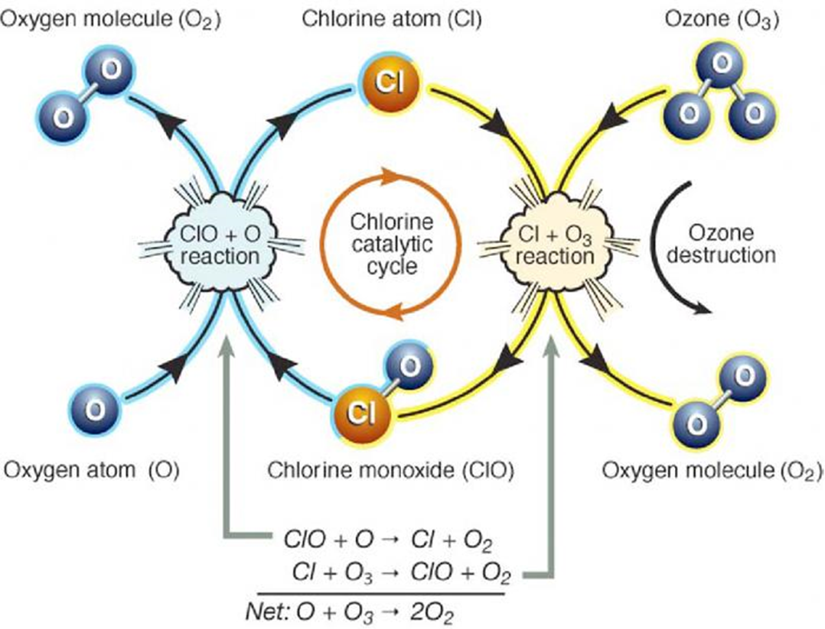
CFCs

How ozone is depleted by CFC’s:
    - UV radiation breaks off a chlorine atom from a CFC molecule.
    - The chlorine atom attacks an ozone molecule (O₃), breaking it apart and destroying the ozone.
    - The result is an ordinary oxygen molecule (O₂) and a chlorine monoxide molecule (ClO).
    - The chlorine monoxide molecule (ClO) is attacked by a free oxygen atom releasing the chlorine atom and forming an ordinary oxygen molecule (O₂).

    - The chlorine atom is now free to attack and destroy another ozone molecule (O₃). One chlorine atom can repeat this destructive cycle thousands of times.

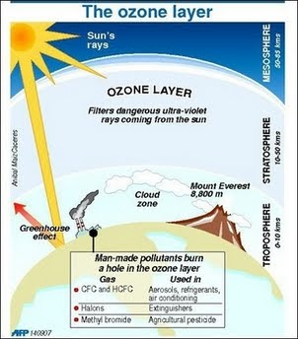

HOGS (Halogenated Organic Gases)

Sources of HOG’s and CFC

Apply the “Replace, regulate and restore” model of pollution management to ODS.

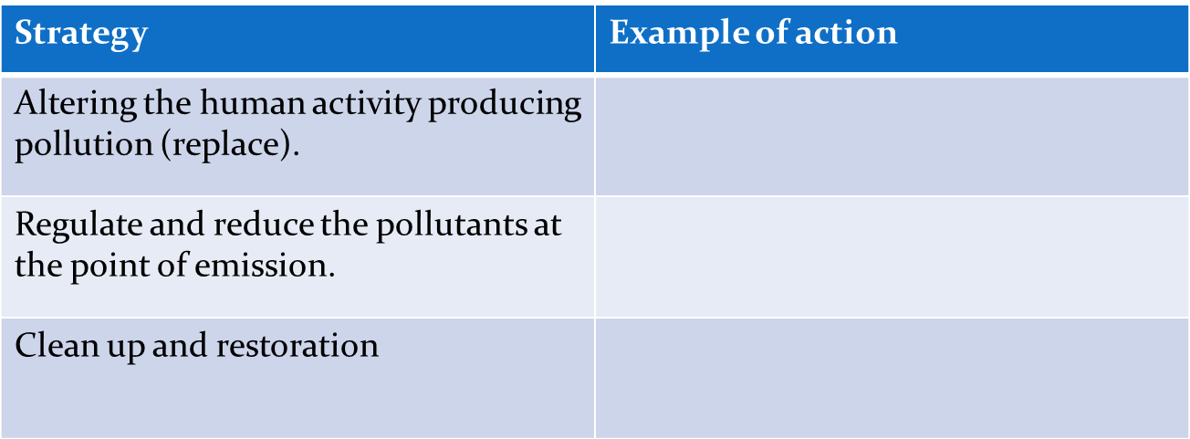

The role of national and international organizations in reducing the emissions of ozone-depleting substances.

  - UNEP (United Nations Environment Programme) forges agreements on:

  - 1987 Montreal Protocol

Precautionary principle:

