Urban Air Pollution Notes
In our last section we discussed the importance of Ozone as a protectant from UV radiation. How can troposphere ozone be a problem?

Primary pollutants
- Emitted directly from the polluting process.
- The process could be natural or anthropogenic.
- Fossil fuel combustion primary pollutants

Create a list of natural and anthropogenic sources of primary pollutants

Secondary pollutants
- Formed when primary pollutants undergo reactions with other chemicals already present in the atmosphere; sometimes this is a photochemical reaction in the presence of sunlight.

Formation of tropospheric ozone
Most urban air pollution is caused by . form as a byproduct of reactions. Oxygen and nitrogen (both from the air) react together as a results of the high temperatures. In normal conditions most ozone molecules ________________nitric oxide back into , creating a cycle.
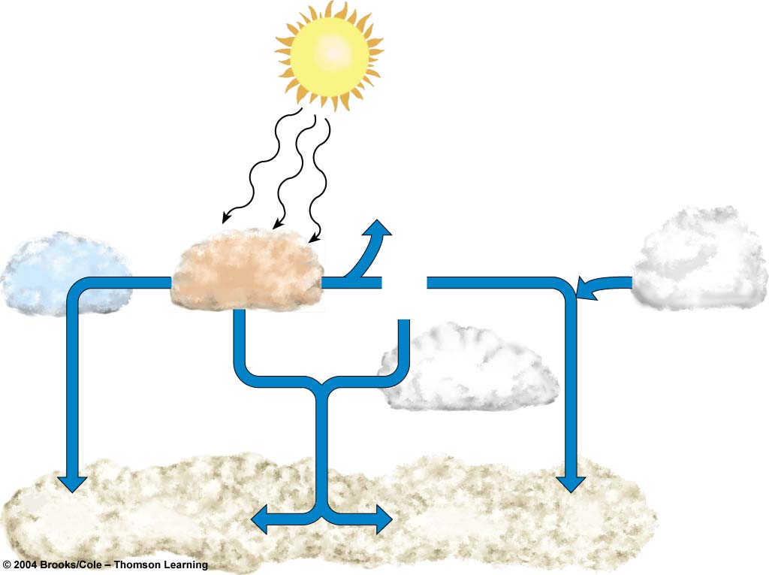

Complete the diagram
Complete the diagram

Identify the Factors Affecting Smog
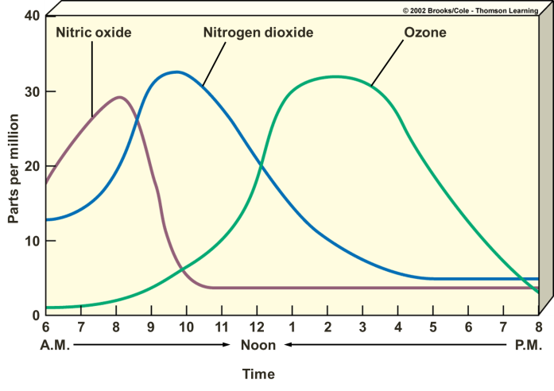

Formation of Tropospheric Ozone

Check out these websites
http://aqicn.org/map/world/#@g/66.3942/-242.6039/2z
http://www.londonair.org.uk/london/asp/annualmaps.asp?species=O3&LayerStrength=75&lat=51.5008010864&lon=-0.124632000923&zoom=14

Formation of Particles
Source Dangers:
Burning almost any organic material or fossil fuel released small particles of carbon and other substances

Poorly maintained diesel engines are particularly polluting.

Often referred to as particulate matter, PM10 or PM.

Haze caused by high levels of atmospheric pollutants, primarily ozone and nitrogen oxides, interacting with strong sunlight.

Thermal Inversions
- Precipitation washes it out of the air and winds disperse it
- When thermal inversions happen it can trap the air in valley areas

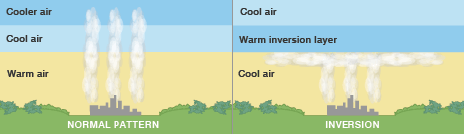
Industrial smog is gray air smog. This is mostly from . It is composed of , . and . This is found mostly in .

Why are the richest areas of cities usually to the west and on hills?

Possible Effects of Photochemical Ozone
Plants:

Humans:

Materials and products:

What are the pollution management strategies for air pollution
Reduction

Regulate

Replace

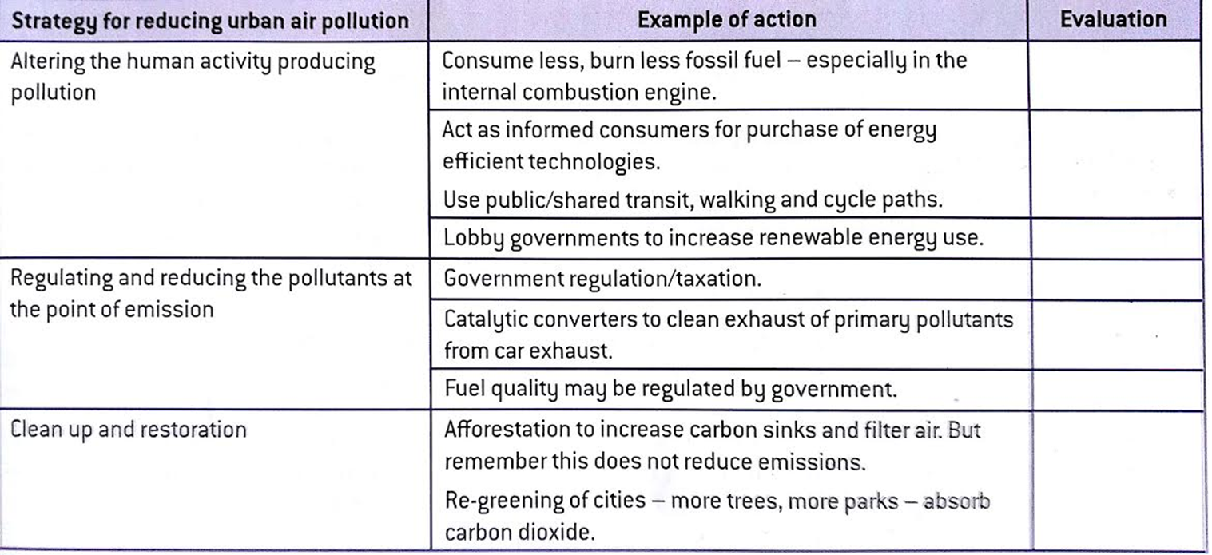

Check out http://www.zipcar.com/

Complete the following table
Explain each type of pollutant. Be specific. Use real environments and situations.

Pollutant | Source | Effect
OZONE

CARBON MONOXIDE

NITROGEN OXIDES

PARTICULATE

SULFUR DIOXIDE

LEAD

CARBON DIOXIDE

VOLATILE ORGANIC COMPOUNDS

RADON

CFC’s

Asbestos

Mercury

Photochemical smog

Industrial smog

Formaldehyde

Lichens and air pollution
Lichens as a measure of air pollution due to sulfur dioxide
Lichens are mutualistic associations of a fungus and an alga. They are very sensitive to sulfur dioxide pollution in the air. After industrialisation, many lichen species became extinct in large areas (e.g. beard moss Usnea articulate). This is mainly due to sulfur dioxide pollution, but loss of habitat can also lead to reductions in some species. During the early and mid-twentieth century, air pollution levels in many MEDCs* were much greater than they are today. However, the air quality is declining today in many LEDCs**.
Lichens are widely used as bio-indicators. If air is very badly polluted, there may be no lichens present, just green algae. If the air is clean, lichens become abundant. A few lichen species can tolerate quite high levels of pollution and may be found on pavements, walls and tree bark in urban areas. The most sensitive lichens are shrubby and leafy, whereas the most pollution-tolerant lichens are crusty in appearance. Since industrialisation, many of the shrubby and leafy lichens such as Ramalina, Usnea and Lobaria species have declined in their range.
Some species of lichens have become more widely distributed as they are more tolerant of acid conditions; examples include Bryoria, Parmeliopsis, Pseudevernia and Rinodina.
* more economically developed countries
** less economically developed countries
Zonation of lichens
A lichen zone pattern which corresponds to the mean levels of sulfur dioxide experienced may be observed in large towns and cities, or around industrial complexes. Particular species of lichen present on tree bark can indicate the typical sulfur dioxide levels found in that area:
• No lichens present: the air quality is very poor (zone 1)
• Only crusty lichens present: the air quality is poor (zone 3)
• Leafy lichens present: the air quality is moderate to good (zone 6)
• Rare species present: the air quality is very clean (zone 10).

Sulfur dioxide air quality and lichen zones: the Hawksworth & Rose zone scale for the estimation of mean winter sulfur dioxide levels in England and Wales, using lichens growing on acidic and non-nutrient-enriched tree bark.
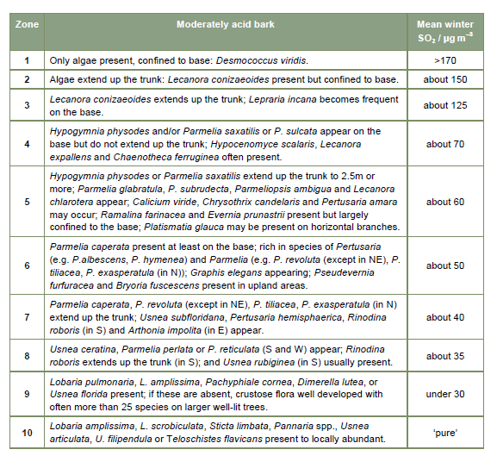

The Common Air Pollutants (Criteria Air Pollutants)
Ozone (ground-level ozone is the principal component of smog)
• Source - chemical reaction of pollutants; VOCs and NOx
• Health Effects - breathing problems, reduced lung function, asthma, irritates eyes, stuffy nose, reduced resistance to colds and other infections, may speed up aging of lung tissue
• Environmental Effects - ozone can damage plants and trees; smog can cause reduced visibility
• Property Damage - Damages rubber, fabrics, etc.
VOCs* (volatile organic compounds); smog-formers
• Source - VOCs are released from burning fuel (gasoline, oil, wood coal, natural gas, etc.), solvents, paints glues and other products used at work or at home. Cars are an important source of VOCs. VOCs include chemicals such as benzene, toluene, methylene chloride and methyl chloroform
• Health Effects - In addition to ozone (smog) effects, many VOCs can cause serious health problems such as cancer and other effects
• Environmental Effects - In addition to ozone (smog) effects, some VOCs such as formaldehyde and ethylene may harm plants
* All VOCs contain carbon (C), the basic chemical element found in living beings. Carbon-containing chemicals are called organic. Volatile chemicals escape into the air easily. Many VOCs, such as the chemicals listed in the table, are also hazardous air pollutants, which can cause very serious illnesses. EPA does not list VOCs as criteria air pollutants, but they are included in this list of pollutants because efforts to control smog target VOCs for reduction.
Nitrogen Dioxide (One of the NOx); smog-forming chemical
• Source - burning of gasoline, natural gas, coal, oil etc. Cars are an important source of NO2.
• Health Effects - lung damage, illnesses of breathing passages and lungs (respiratory system)
• Environmental Effects - nitrogen dioxide is an ingredient of acid rain (acid aerosols), which can damage trees and lakes. Acid aerosols can reduce visibility.
• Property Damage - acid aerosols can eat away stone used on buildings, statues, monuments, etc.
Carbon Monoxide (CO)
• Source - burning of gasoline, natural gas, coal, oil etc.
• Health Effects - reduces ability of blood to bring oxygen to body cells and tissues; cells and tissues need oxygen to work. Carbon monoxide may be particularly hazardous to people who have heart or circulatory (blood vessel) problems and people who have damaged lungs or breathing passages
Particulate Matter (PM-10); (dust, smoke, soot)
• Source - burning of wood, diesel and other fuels; industrial plants; agriculture (plowing, burning off fields); unpaved roads
• Health Effects - nose and throat irritation, lung damage, bronchitis, early death
• Environmental Effects - particulates are the main source of haze that reduces visibility
• Property Damage - ashes, soots, smokes and dusts can dirty and discolor structures and other property, including clothes and furniture
Sulfur Dioxide
• Source - burning of coal and oil, especially high-sulfur coal from the Eastern United States; industrial processes (paper, metals)
• Health Effects - breathing problems, may cause permanent damage to lungs
• Environmental Effects - SO2 is an ingredient in acid rain (acid aerosols), which can damage trees and lakes. Acid aerosols can also reduce visibility.
• Property Damage - acid aerosols can eat away stone used in buildings, statues, monuments, etc.
Lead
• Source - leaded gasoline (being phased out), paint (houses, cars), smelters (metal refineries); manufacture of lead storage batteries
• Health Effects - brain and other nervous system damage; children are at special risk. Some lead-containing chemicals cause cancer in animals. Lead causes digestive and other health problems.
• Environmental Effects - Lead can harm wildlife.

