CLASSIFICATION
Biological classification is:

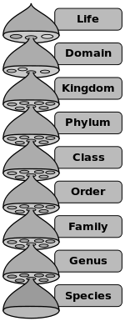

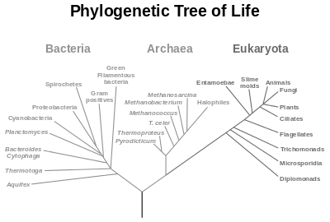

Binomial nomenclature is:

Bionomial nomenclature is to be written out it ______________________ and typed in _____________________. Give an example of each.

The system of naming organisms was consolidated and popularized by ___________________________. His book _________________________ was the first to list organisms by genus

List the reasons for classification:

Using the first letter of hierarchy of classications, develop a Mnemonic that will help you remember each level.
D
K
P
C
O
F
G
S

