EQUALIBRIUM, FEEDBACKS AND ENERGY TRANSFER
Steady-State  Equilibrium | Continuous inputs & outputs of energy & matter; the system remains more or less constant; small short term changes to occur | 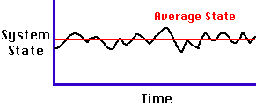 | This can be seen in a classic study of the populations of Snowshoe Hares and Lynx in Canada. As the population of the Lynx rises the Hare population falls this is then followed by a fall in the Lynx population which in itself is followed by a rise in the Hare population etc. etc.
Static  Equilibrium | No change occurs; does not occur in living systems; when change occurs, a NEW equilibrium is found | 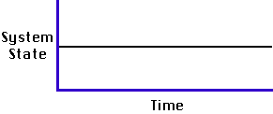 | Possibly the best example of static equilibrium in the environmental system in which we ourselves have to survive is the oxygen content of the atmosphere.
Stable  Equilibrium | A system will return to the same equilibrium after a disturbance | 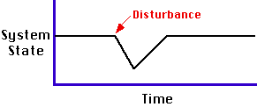 | Some organisms have internal feedback systems; physiological changes occurring that prevent breeding when population densities are high, promoting breeding when they are low. This maintains the balance of an ecosystem.
Unstable  Equilibrium | After a disturbance, a system will return to a NEW equilibrium | 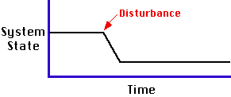 | The predator-prey model and shows the effect of changing number of prey on predator numbers. When prey populations increase, there is more prey for the predator so they can eat more and breed more, resulting in more predators which eat more pretty so the prey numbers decrease. If there are fewer prey, there is less food, and the predator numbers decrease.
Positive  Feedback | The system is reinforced and strengthened | The movement of material trough living organisms  (carnivores eating other organisms) | In some developing countries poverty causes illness and contributes to poor standards of education. In the absence of knowledge of family planning methods and hygiene, this contributes to population growth and illness, adding further to the causes of poverty
The movement o material in non-living process
(water being carried by a stream)
Negative  Feedback | The system is dampened, neutralized, or counteracted. This caused the system to self-regulate | The movement of energy (ocean currents transferring heat) | When the population of plants increases it leads to increase in the population of herbivore animals. It increases the population of frogs and birds. Similarly, the increased population of insectivorous animals acts on the herbivorous insect by the process of predation
 |  | Matter to matter (soluble glucose converted to insoluble starch in plants)
Transformation  of energy & matter | Flow involves a change of state | Energy to energy  (light converted to heat by radiating surface)
Matter to energy
(burning fossil fuels)
Energy to matter
(photosynthesis
Transfer  of energy & matter | Flow does not involve a change of state, requires less energy | Movement of material through living organisms  (carnivores earth other animals) | Energy is transferred between organisms in food webs from producers to consumers. The energy is used by organisms to carry out complex tasks
Movement of material in a non-living process
((water being carried by a stream)
Movement of energy
(ocean currents transferring heat)

