Name: _____________________ Set: _______ House: ______

Hormones

WORDS: chemical endocrine gland secretion exocrine
duct

A hormone is a ……………..………. that is released into the blood by a …………………...

The release of hormones is called ………………

What are the two types of gland?

………………………………………and…………………………………………

What is the difference between the two types of gland?

…………………………………………………………………………………………………………………………………..

Using the table below, can you list as many differences between hormones and nerves as possible?

Hormones | Nerves
Pituitary Gland

Where is the pituitary gland found?

…………………………………………………………………………………………………………………………………..

Circle the hormones produced here:

FSH testosterone ADH Thyroxin oestrogen

Pancreas

What does the pancreas secrete?

…………………………………………………………………………………………………………………………………..
…………………………………………………………………………………………………………………………………..

Put a star next to the endocrine function and a circle next to the exocrine function.

Which hormones are produced where?

Hormone | Endocrine Gland | Target Organ | Action
Adrenaline
 | Pituitary gland
Insulin |  | Liver and Muscles
 | Pancreas |  | Increases glucose level of blood
Oestrogen |  | Ovaries, uterus, pituitary gland
 | Testes

Adrenaline

The …………………………….. or ………………………….. response.

Secreted by your ……………………… glands.

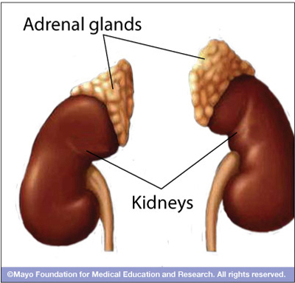

Think about a time when you were really scared. What biological changes did you feel?

…………………………………………………………………………………………………………………………………..…………………………………………………………………………………………………………………………………..…………………………………………………………………………………………………………………………………..…………………………………………………………………………………………………………………………………..…………………………………………………………………………………………………………………………………..…………………………………………………………………………………………………………………………………..…………………………………………………………………………………………………………………………………..

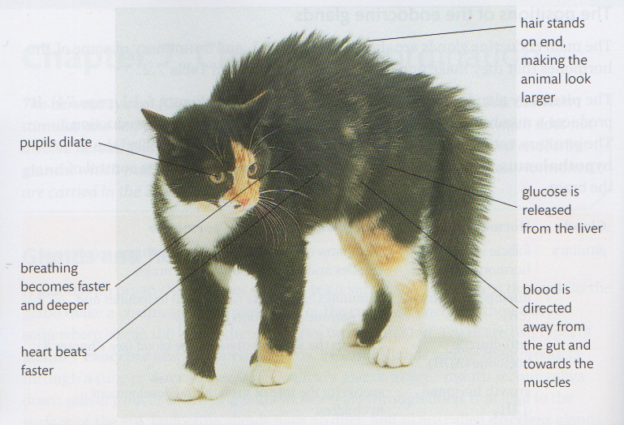
Write a biological reason why each of the changes happen to the cat:

The pupils dilate in order to ………………………………………………………………………………………

The breathing changes in order to ……………………………………………………………………………..

The heart beats faster in order to ………………………………………………………………………………

The hair stands on end in order to ……………………………………………………………………………..

Blood is diverted to muscles in order to …………………………………………………………………….

Glucose is release into the blood because ………………………………………………………………….

