Name:___________________________________ Pd: ______ Date:____________________

Review of Common Misconceptions

AIM: How do scientists compare and contrast various elements of the atmosphere and climate change?

OBJECTIVES:
• Differentiate various characteristics of the atmosphere and climate change
• Investigate the importance of certain aspects of Earth’s atmosphere

Directions. Use your prior knowledge, notes and images to describe each essential term.

Essential Term | Description
Ozone

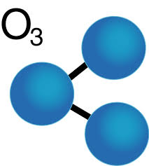
Ozone Layer

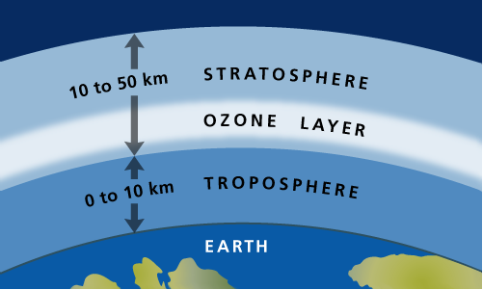

Greenhouse Effect

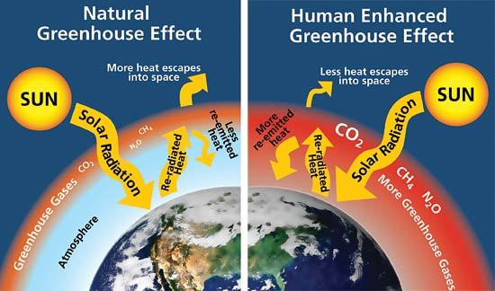

Common Misconceptions.
Depending on who is talking, there can be an enormous difference between global warming and climate change — or no difference at all. A lot of people, including many journalists who write about the topic, use the two terms interchangeably.

Global warming is a more specific term. It refers to increases in the Earth’s average temperature because of greenhouse gas build up in the atmosphere. Climate change is a broader term. It refers to changes (increases and decreases) in climate which involves not just average temperature, but also other factors that vary, such as humidity, cloudiness, rain (or snow), clouds, precipitation, snow cover, ice cover, sea level, etc.

Scientists have learned that raising the Earth’s temperature is very likely to change many of these climatic factors. So while global warming is what’s causing it, what most people are going to notice is not necessarily warming but rather a change in climate.

The bottom line is that while global warming is not wrong, climate change more accurately describes what is happening. But most of the time, whether people use global warming or climate change, they’re almost certainly talking about the same thing.
SOURCE: Climate Central & EPA

Impact of Temperature Increase on Aspects of the Environment and Society
Feature | Effect or Impact
Environmental features
ice and snow | retreat of polar ice caps and glaciers
coastlines | increase in sea level causing coastal flooding
water cycle | increased flooding
ecosystems | change in biome distribution and species composition
Societal features
water resources | severe water shortages and possibly wars over supply
agriculture | may shift away from drought areas
coastal occupation | relocation due to flooding and storms
human health | increased disease
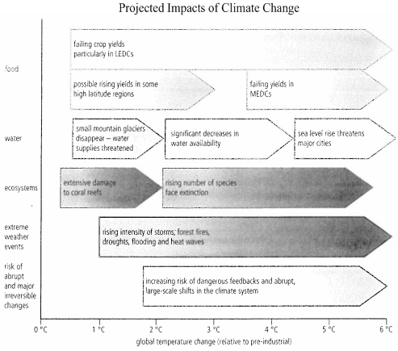
Impact of Climate Change on Aspects of the Environment and Society

Discuss the similarities and differences among global warming and climate change.

