Name:___________________________________ Pd: ______ Date:____________________

Soil Conservation

AIM: How can we conserve soil and reduce major world food problems?

OBJECTIVES:
• Describe methods for reducing world food problems

Solving the World’s Food Problems
There are many ways of protecting and managing topsoil and reducing erosion. Soil usually erodes downhill, therefore many soil conservation methods are designed to prevent downhill erosion.

Literacy Skills. Use your online textbook (pages 387-388) to complete the graphic organizer.

Method of Soil Conservation | Essential Questions
Contour Plowing  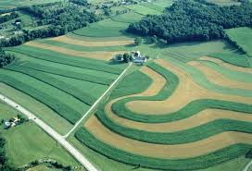 | Describe contour plowing.  When is contour plowing used?
No-Till Farming  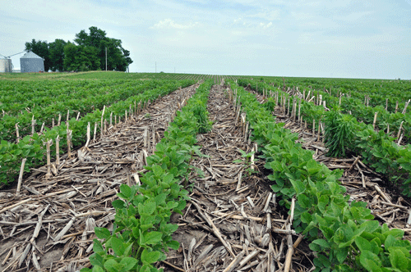 | Explain no-till farming.  Advantages:  Disadvantages:
Enriching the Soil | Discuss compost.
The Green Revolution
Between 1950 and 1970, Mexico increased its production of wheat eight-fold and India doubled its production of rice. Worldwide, increases in crop yields resulted from the use of new crop varieties and the application of modern agricultural techniques. These changes were called the green revolution. Since the 1950s, the green revolution has changed the lives of millions of people.
However, the green revolution also had some negative effects. Most new varieties of grain produce large yields only if they receive large amounts of water, fertilizer, and pesticides. In addition, the machinery, irrigation, and chemicals required by new crop varieties can degrade the soil if they are not used properly. As a result of the overuse of fertilizers and pesticides, yields from green revolution crops are falling in many areas. Grain production in the United States has decreased since 1990, partly because the amount of water used for irrigation has decreased during the same period.

______ 1. Between 1950 and 1970, the green revolution led to
a. increases in crop yields worldwide.
b. the failure of new crop varieties.
c. water shortages in the United States.
d. grain shortages in Mexico and India.

______ 2. Irrigation refers to
a. varieties of crop yields. c. fertilizer used to increase crop yields.
b. water used for crops. d. machinery used to harvest crops.

______ 3. According to the passage, one problem with the green revolution is that
a. few people have access to new techniques and machinery.
b. it did not last long enough to make a difference in grain production.
c. it led to widespread drought.
d. it led to the overuse of fertilizers and pesticides.

4. How did Mexico benefit from the green revolution between 1950 and 1970? How did India benefit?

5. How was agriculture after the green revolution different from agriculture before the green revolution?

6. Why has grain production in the United States decreased since 1990?

7. Why are yields from green revolution crops falling in many areas?

8. What effect do the machinery, irrigation, and chemicals required by new crop varieties have on soil?

Video. Norman Borlaug and The Green Revolution (8:00)
Evaluate the video.

How would an environmental organization, such as Greenpeace, portray The Green Revolution. Explain.

