Notes: Energy Flow Through an Ecosystem Notes 2.2.2.2

Food chains, webs and pyramids, ultimately show energy flow. The obey the

Obey systems laws –

Universal laws that govern all energy changes in the universe.
Review – First Law of Thermodynamics

Review – Second Law of Thermodynamics

Energy unlike matter does not recycle through a community it . Energy comes from the and is converted by into

Gross Primary Production GPP –

Net Primary Production NPP –

Write out the productivity formula. We will talk about this in more detail later

All energy on Earth comes from the . Earth receives 1 billionth of the Energy. Most is

That energy that reaches Earth is:

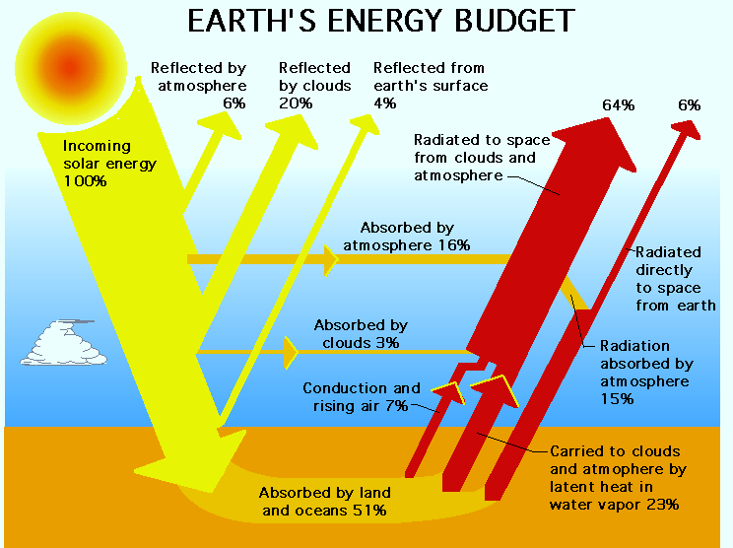

So if sunlight in = sunlight + heat out, what state is the system in?

Summary of solar radiation pathways:

Energy Flow

Energy measured in :

Energy conversion is never :

Some energy lost as :

Of visible light reaching producers, only is converted to chemical energy. Other levels are __________ efficient – only assimilate of energy from previous level

Biomass is:

Useable energy is degraded by:

As the trophic level increases usable energy

Complete the empty blanks

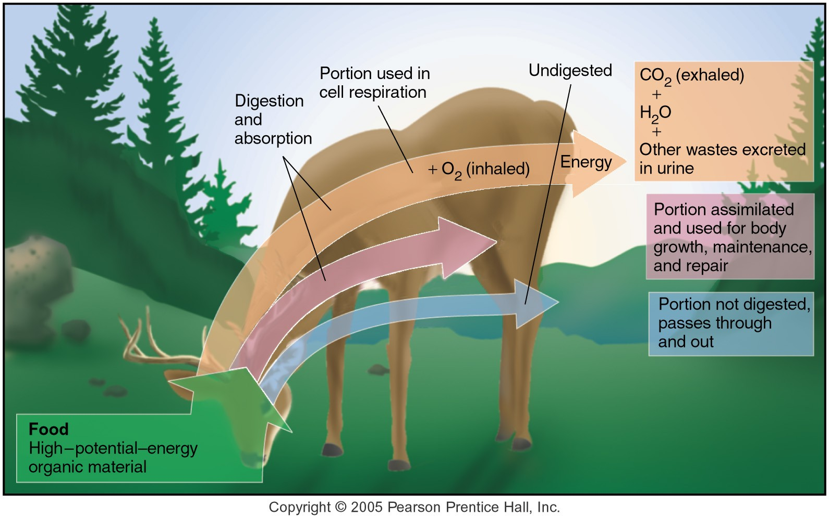

Energy Flow through Producers

Energy Flow through Consumers

Complete the diagram

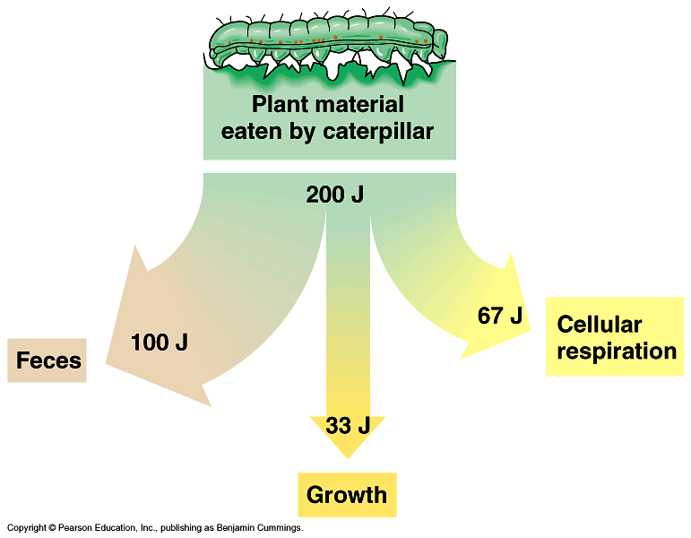

Energy flow through Decomposers

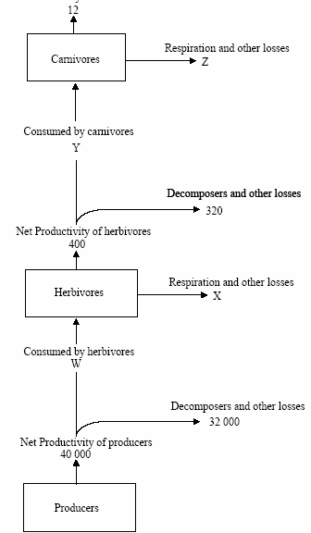

Trophic level boxes are storages – biomass per area (g m-2)

Energy Flow in arrows – rate of energy transfer

