Ecological Pyramids. Notes 2.2.2.3

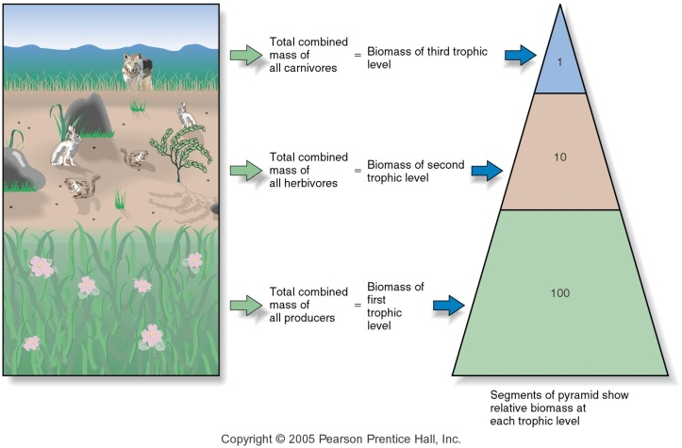
Ecological pyramids are . By the second law of thermodynamics energy along food webs. Therefore pyramids are .

Energy is lost by

Mass is lost by

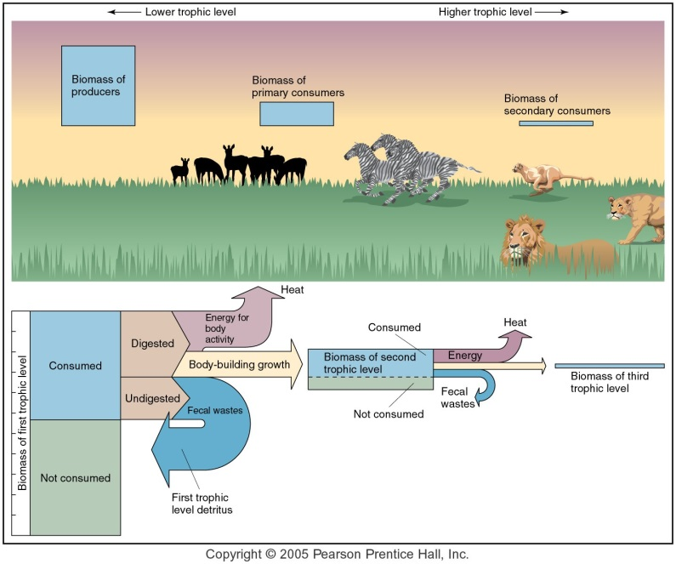

Pyramid of Numbers

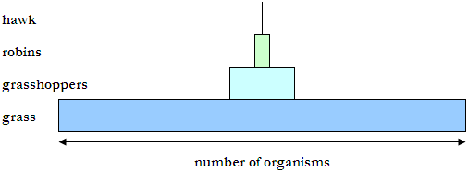

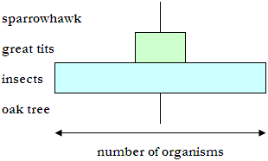

Pyramid of biomass

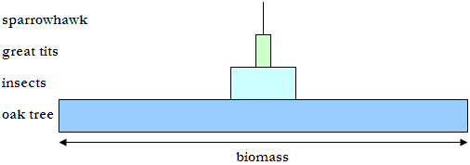

Pyramid of biomass will represent

How do we get the biomass of a trophic level to make these pyramids?
Above is the pyramid of biomass for the woodland food chain. Biomass is a measurement of body size (dry mass/g m-2). One oak tree is very large.

Why does biomass decrease at each trophic level?

green plant zebra lion

- Zebras only eat a proportion of the plant i.e. roots are left
- Zebras lose energy because they can not digest and break down all the material they consume and so energy is lost in the faeces.
- Most of the energy that is obtained from the grass is used for respiration to keep the zebra alive or is lost as heat when energy is transformed, during respiration from one form to another. This energy cannot be used to create biomass.
- The lion will not always consume the entire zebra i.e. bones etc.

Consequently, it may take 100kg of grass to make 10kg of zebra which supports 1kg of lion (Ref:- 2nd law of thermodynamics)

The apparent rule of nature, that a large biomass supports a small biomass, is broken by the pyramid shown overleaf. Here a huge biomass of zooplankton seems to be supported by a much smaller biomass of phytoplankton. To produce a pyramid like this we would need to collect a sample of sea water and establish the standing crop of phytoplankton and zooplankton in it. But we would just be taking a snapshot, not taking into account how fast the standing crop of phytoplankton is producing more phytoplankton.

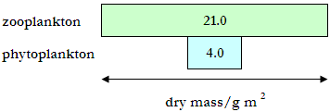
In reality, the phytoplankton is growing very fast and its productivity, or amount of energy it can pass on to the next trophic level, is very high, (analogy – mowing the lawn i.e. if we collected all the lawn clippings for a year, we would have a much clearer idea as to how productive the grass has been).
Consequently, the zooplankton is not being supported by the standing crop of phytoplankton we measure at the moment when we take our single sample, but by their productivity over time.

Pyramid of Productivity

Productivity pyramids ALWAYS decrease as they go higher because of the

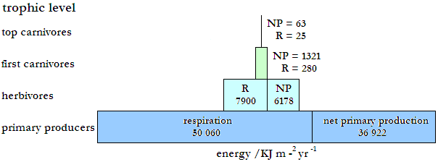

A pyramid of productivity for a pond ecosystem is shown above. The energy of each trophic level has two parts i.e. NP (Net Production) and R (Respiration) and is measured in KJ m-2 yr-1.

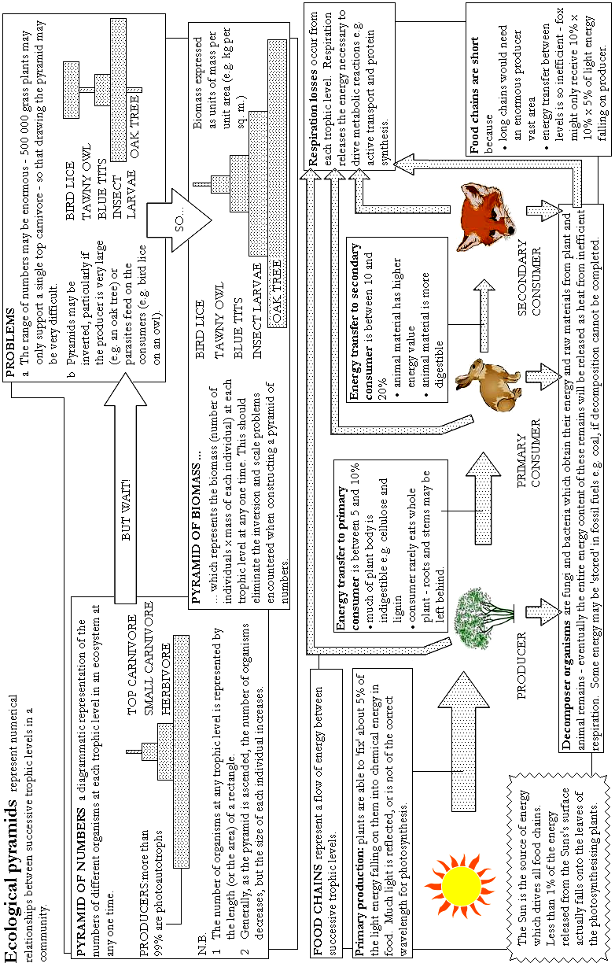

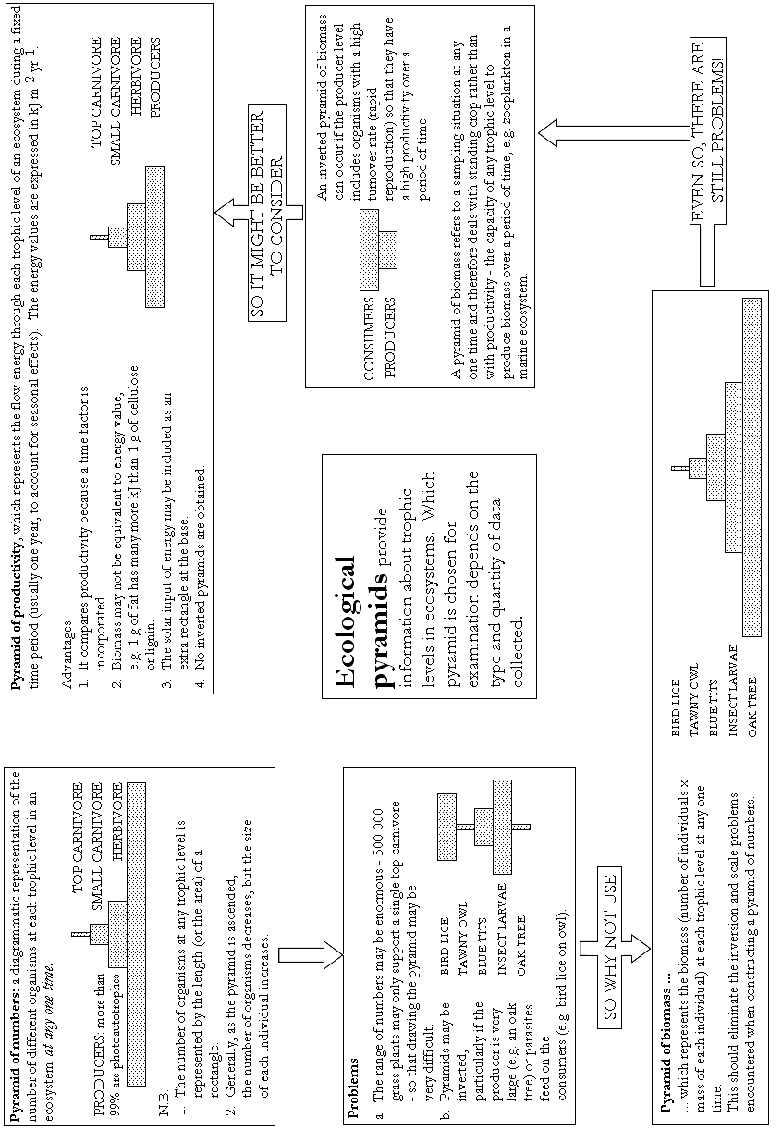

Using the information in the diagram, draw a scale diagram of the productivity pyramid for this grazing food chain on a separate sheet of graph paper.
