2.3.1 Flows of Energy and Matter Notes

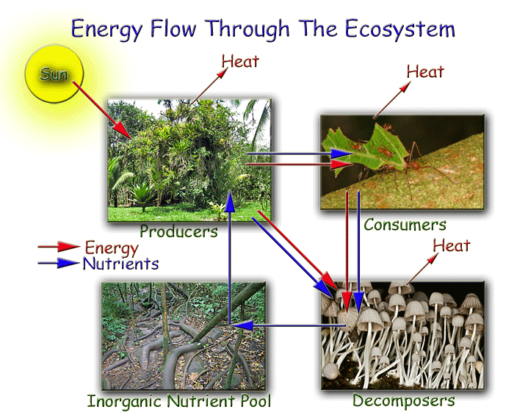

Not all solar radiation ends up as biomass. Losses include:

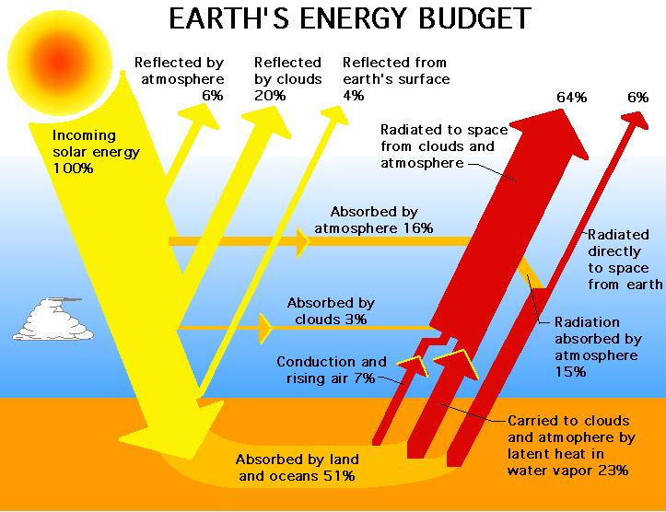

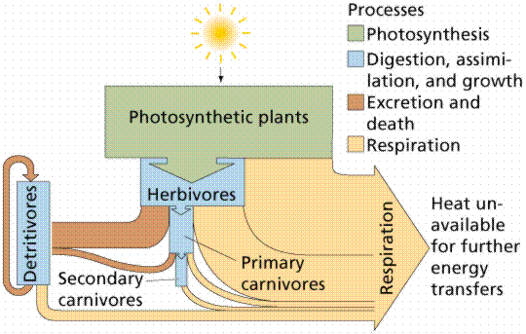
Only of the light energy falling on a plant is used to . The rest is , or just warms up the plant as it is.

Energy comes into the ecosystem as . Energy converted into energy by producers. That is transferred as organisms are eaten, with energy being lost as and

Photosynthesis
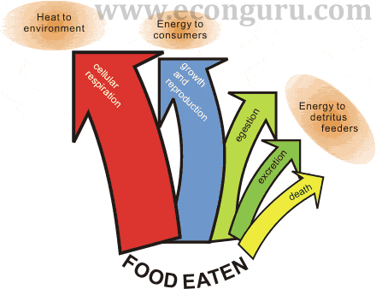
- Equation

- Inputs

- Outputs

- Energy transformation

Respiration
- Equation

- Inputs

- Outputs

- Energy transformation

Complete the energy flow diagram

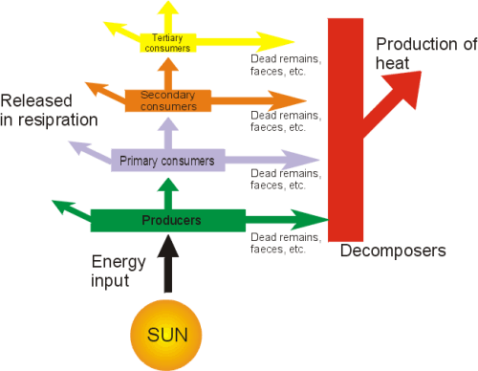

Conversation of energy into for a given period of time is measured as . Gross productivity is the or by an organism. This is measured in ____________________. Plants gross productivity is defined as . This is sunlight energy used during . Animal gross productivity is defined as . This is the amount of and the energy in

Net productivity is the energy left after as used what they need to . All organisms have and given off as heat , This is the (R) value when calculating productivity

To formula for net productivity is or using symbols :
.
PLANTS

ANIMALS

Productivity
Primary productivity

Secondary productivity

Gross primary productivity

Net primary productivity

Gross secondary productivity

Net secondary productivity
In a food web diagram, you can assume that:

The least productive ecosystems are those with limited heat and light energy, limited water and limited nutrients.

Example biome:_______________

The most productive ecosystems are those with high temperature, lots of water light and nutrients.
Example biome:__________________

Measuring productivity

Harvest method –

CO2 assimilation-

O2 production-

Radiosotope method-

Chlorophyl measurement-

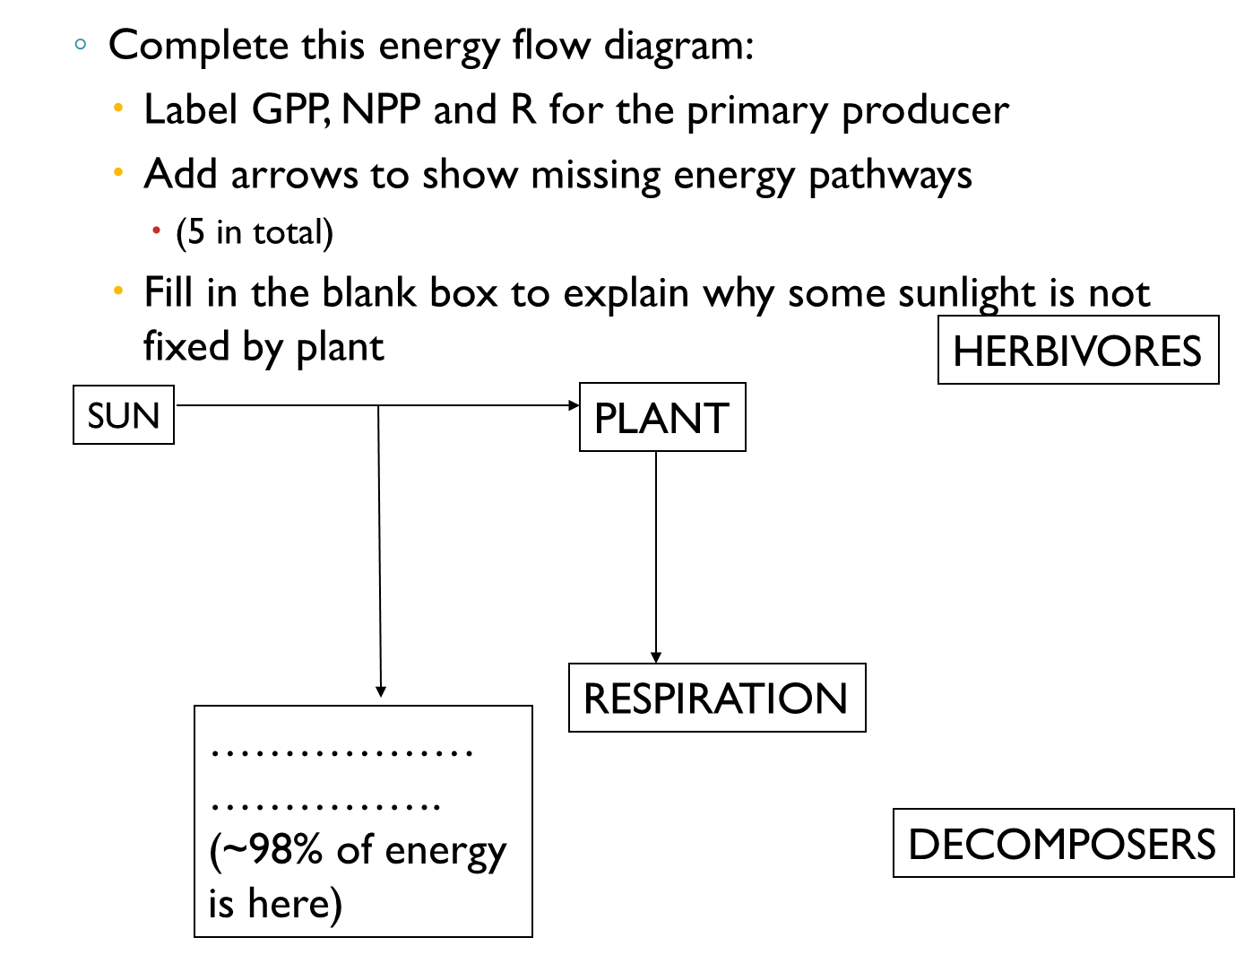

Draw a complete food web for an ecosystem of your choice, which should include:
• the sun and its energy
• named primary producers (at least 2)
• named primary consumers (at least 3)
• named secondary consumers (at least 2)
• named decomposers (at least 2)
• respiration energy loss (use red marker for this arrow)
On your diagram use arrows to show direction of energy flow

Draw your own energy flow diagram, rather like the one on the one on the previous page energy flows through the trophic levels in your food web. You may on the web to help find examples. Include the following labels:
• Start with sunlight energy
• Include all trophic levels from your food web
• Include arrows showing energy moving from each trophic level to another and to decomposers
• Show energy lost in faeces
• Show Respiration loss (heat energy) USE RED MARKER!
• Label each individual arrow with a letter (A,B,C,D,E…)
• Use the lettered arrows to write an equation for GPP, NPP
• Write an equation for GSP, NSP for primary consumers

The data in the table below relate to the transfer of energy in a small clearly defined habitat. The units in each case are in kJ m-2 yr-1

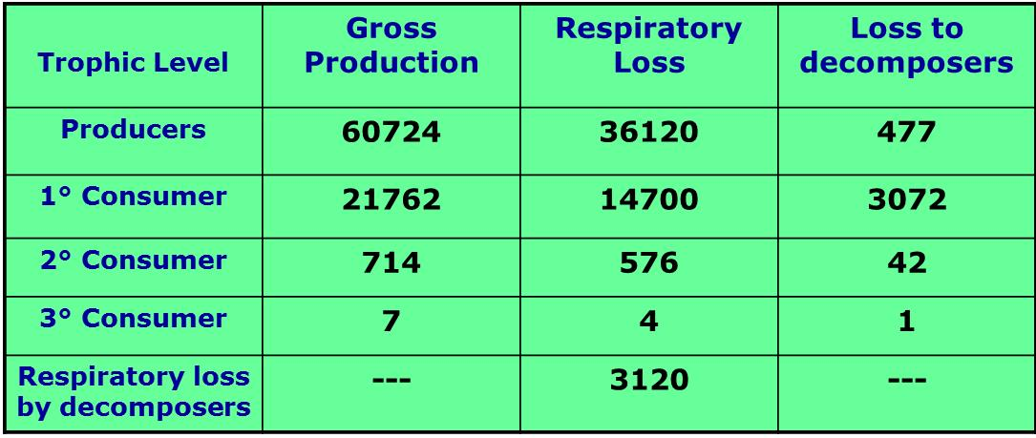

Construct an energy flow model to represent all these data – Label each arrow with the appropriate amount from the data table above.
Use boxes to represent each trophic level and arrows to show the flow of energy
Calculate the Net Productivity for
- NPP for Producers
- NSP for 1°Consumers, 2°Consumers, 3°Consumers
- NSP for Decomposers

