2.4.2 Succession and Zonation Notes

SUCCESSION –

Changes in the community of organisms frequently causes changes in the physical environment that allow another community to become established and replace the former through competition. Often, but not inevitably, the later communities in such a sequence or sere are more complex than those that appear earlier.
It is clear that the physical characteristics (e.g. light availability, temperature etc.) or chemical characteristics (e.g. soil pH, salinity etc), of a habitat influence the species of plant or animal that live there. For example, a canopy of beech trees may drastically reduce the amount of light reaching the soil surface, and this may, in turn, affect the water content and temperature of the soil. Also, by absorbing particular nutrients from the soil or by adding leaf litter, the trees could change the soil pH.
Such changes may allow species that were previously excluded from that habitat to invade. These new species may then change the habitat, making conditions less favourable for the species already there, the populations of which might then decline.
In this way, there may be a gradual progression from one community to another, and this progression is called NATURAL SUCCESSION.
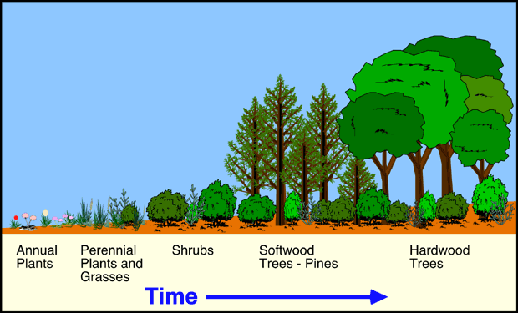

PRIMARY SUCCESSION –

Stages of primary succession
Stage 1 Colonization

Stage 2 Establishment:

Stage 3 Competition:

Stage 4 Stabilization:

The final stage

Primary succession of a bare rock surface
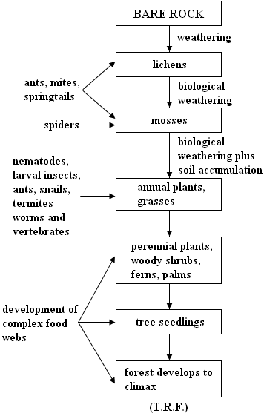

SECONDARY SUCCESSION –

For example:-

Changes that occur during succession:

Climax Communities

**Complex ecosystems are more stable due to the variety of nutrient and energy pathways.
If one collapses its overall effect is low as there are many others to takes its place.

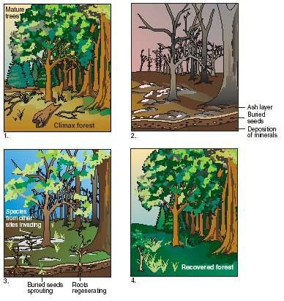

Such disturbances may be natural e.g. a hurricane, flooding or fire, or they may be a result of human activities e.g. forest clearance for house or road building. The common factor is that the existing vegetation and most of the animal species living in and on it are removed or destroyed. However, the soils of these areas are often fertile and contain many seeds, spores and eggs, which then allow very rapid re-colonisation.

GPP and NP during succession

Early Stages Middle Stages Late Stages

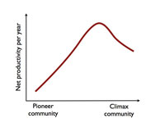
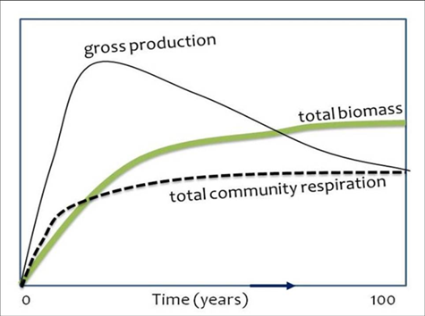

Both biodiversity and mineral cycling increase strongly as succession progresses.

Biodiversity in Succession

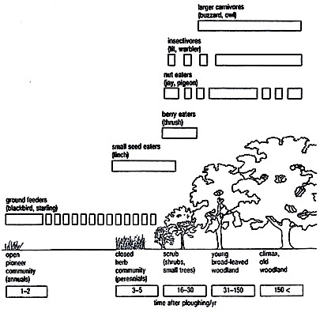

Fig 2.22 Secondary succession in an abandoned ploughed field. The climax community is woodland. The animal community changes with the plant community as illustrated by the birds in the diagram

Examples of human activities that cause secondary succession

Examples of natural causes
States of Succession

Primary Succession

Gross Productivity:

Respiration loss:

Net Productivity:

Productivity/Respiration:

Secondary Succession

Gross Productivity:

Respiration loss:

Net Productivity:

Productivity/Respiration:

As succession continues, the number of different species in the ecosystem increases, and the food webs become more complex. Eventually a stable ecosystem develops which is in equilibrium with its environment and which normally undergoes little further change. This is called the . In equatorial regions the climax community is tropical rainforest.

A climax community produced by the action of humans is called a PLAGIOCLIMAX. This may occur for the following reasons:-

Summary of the changes that occur during succession:-

SERE | SPECIES DIVERSITY | NO. OF INTERACTIONS BETWEEN ORGANISMS | RESISTANCE OF COMMUNITY TO ENVIRONMENTAL CHANGE
Pioneer community | Few species | Few | Susceptible
↓ | ↓ | ↓ | ↓
Sub-climax community |  |  | Resistant
↓ |  |  | ↓
Climax community | Many species | Many | Resistant

The concept of succession i.e. change over time, must not be confused with ZONATION.

ZONATION -.

For example:-
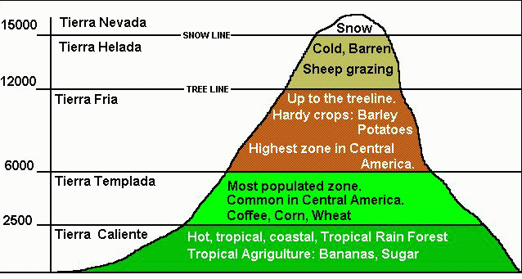

OR
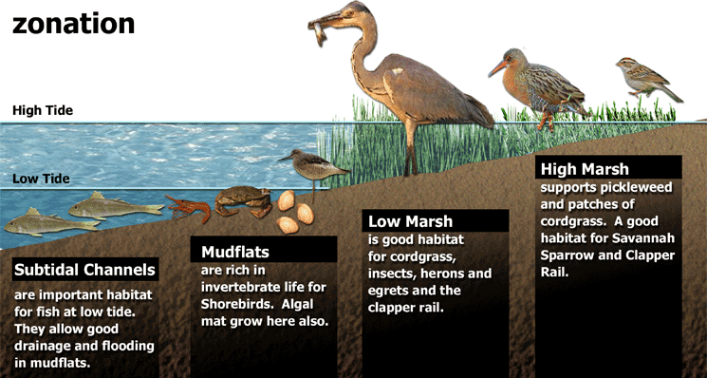

Each species has an ecological niche (boundaries).The niches change as we increase the altitude.
Temperature

Precipitation

Solar insulation

Soil type

Species interaction

Succession vs Zonation

Reproductive Strategies

Species can be roughly divided into and selected species. These are two variables that determine the shape of a population growth curve.

Role of reproductive strategies in succession

- K =
- r =

These strategies describe the different approaches species take to getting their genes passed onto the next generation and ensuring the survival of the species.

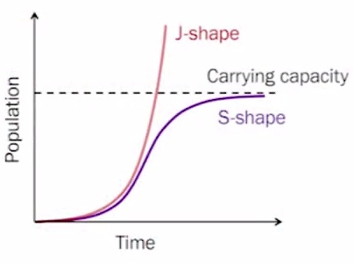

Species differ in the rate at which their populations increase in numbers. As an extreme example, populations of bacteria increase in size rapidly, while populations of elephants increase in size much more slowly.

Population ecologists have identified two main strategies shown by organisms.

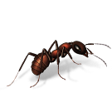
Small organisms, such as bacteria, reproduce rapidly and therefore use up the available resources of a habitat before other, competing species can exploit them. Because of their high rate of reproduction, such species have a high value or r, the intrinsic rate of increase, and are said to be ‘r-selected’ or ‘r-strategists’.

r-strategists – species using r-strategies will tend to spread their reproductive investment among a large number of offspring so that they are well adapted to colonise new habitats rapidly and make opportunistic use of short-lived resources.

Characteristics of r strategy

Other species reproduce slowly and have much lower values of r. They spend much of their time in quite stable habitats and at population levels near to the carrying capacity (K). Accordingly, they are said to be ‘K- selected’ or ‘K-strategists’.
K-selected species show adaptations that enable them to survive even when their population sizes are close to the maximum.

K-strategists – species using K-strategies will usually concentrate their reproductive investment in a small number of offspring thus increasing their survival rate and adapting them for living in long-term climax communities.

Characteristics of K strategy

e.g.
An area of soil becomes cleared of vegetation, perhaps as a result of a fire. Within a short time plants start to grow as a result of seeds that arrive and germinate. Such seeds tend to have good means of dispersal and are often produced by annual weeds. These plants are r-strategists and are efficient at exploiting new habitats. However, eventually they lose out to more K-selected plants. These species take longer to colonise the area but are better adapted to it, competing more effectively for light and nutrients

Survivorship Curves
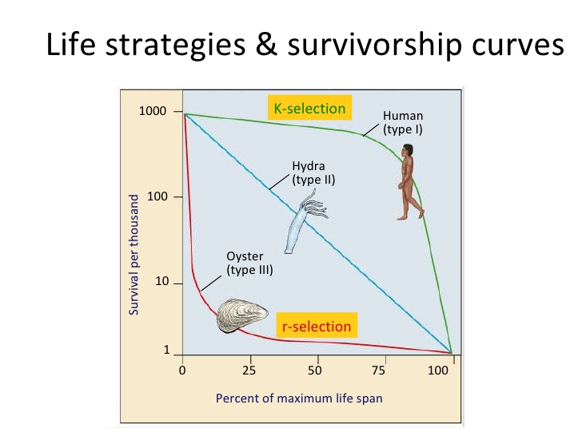
Limiting factors that affect the shape of the curve include predation, competition, environmental conditions.

Curve II is rare in that species have an equal chance of dying at any age (ex. Hydra and some bird species).

Summary
In the early stages of succession, gross productivity is low due to the initial conditions and low density of producers. The proportion of energy lost through community respiration is relatively low too, so net productivity is high, i.e. the system is growing and biomass is accumulating. In later stages, with an increased consumer community, gross productivity may be high in a climax community.

However, this is balanced by respiration, so net productivity approaches zero and the production : respiration (P : R) ratio approaches 1.

Suggest, with reasons, whether each of the following will (i) increase, (ii) decrease or (iii) stay the same as succession proceeds:-

  - Nutrient content of the soil or water

  - Productivity

  - Number of species (species diversity)

  - Biomass

  - Rate at which populations replace each other

Read the following extract:-

Krakatoa – an example of primary succession ( a Lithosere).

Extract taken from “The Living Planet” by David Attenborough

It was one of the Indonesian volcanoes that produced the most catastrophic explosion yet recorded. In 1883, a small island named Krakatau, 7 kilometres long by 5 kilometres wide, lying in the straits between Sumatra and Java, began to emit clouds of smoke. The eruptions continued with increasing severity day after day. Ships sailing nearby had to make their way through immense rafts of pumice that floated on the surface of the sea. Ash rained down on their decks and electric flames played along their rigging. Day after day, enormous quantities of ash, pumice and lava blocks were thrown out from the crater, accompanied by deafening explosions. But the subterranean chamber from which all this material was coming was slowly emptying. At 10 a.m. on 28 August, the rock roof of the chamber, insufficiently supported by lava beneath, could bear the weight of the ocean and its floor no longer. It collapsed. Millions of tons of water fell on to the molten lava in the chamber and two-thirds of the island tumbled on top of it. The result was an explosion of such magnitude that it produced the loudest noise ever to echo around the world in recorded history. It was heard quite distinctly over 3000 kilometres away in Australia. Five thousand kilometres away, on the small island of Rodriguez, the commander of the British garrison thought it was the sound of distant gunfire and put out to sea. A tempest of wind swept away from the site and circled the earth seven times before it finally died away. Most catastrophic of all, the explosion produced an immense wave in the sea. As it travelled towards the coast of Java, it became a wall of water as high as a four-storey house. It picked up a naval gunboat, carried it bodily nearly 2 kilometres inland and dumped it on top of a hill. It overwhelmed village after village along the thickly populated coast. Over 36,000 people died.

Krakatau shows how complete a recovery can be. Fifty years after the catastrophe, a small vent spouting fire arose from the sea. The people called it Anak – the child – of Krakatau. Already it has thickets of casuarina and wild sugar cane growing on its flanks. A remnant of the old island, now called Rakata, lies a mile or so away across the sea. The slopes that a century ago were bare are now covered by a dense tropical forest. Some of the seeds from which it sprang must have floated here across the sea. Others were carried by the wind or brought on the feet or in the stomach of birds. In this forest live many winged creatures – birds, butterflies and other insects – that clearly had little difficulty in reaching the island from the mainland a mere 40 kilometres away. Pythons, monitor lizards and rats have also arrived here, perhaps on floating rafts of vegetation that frequently get swept down tropical rivers. But evidence of the newness of the forest, and the cataclysm that preceded it, is easy to find. The tree roots cover the surface of the ground with a lattice that clasps the earth together, but here and there, a stream has undermined them, and a tree has toppled to reveal the still loose and powdery volcanic dust beneath. Once the plant cover has been broken in this way, the loose ash is easily eroded by the stream and a narrow gorge, 6 or 7 metres deep, appears beneath a roof of interlaced roots. But these breaks are the exception. The tropical forest has, within a century, reclaimed Krakatau. Without much doubt, the coniferous forest, in another century, will have reclaimed Mount St. Helen’s.

RESEARCH – Complete the research task on page 274 of your Environmental Systems & Societies textbook about Mount St. Helens.

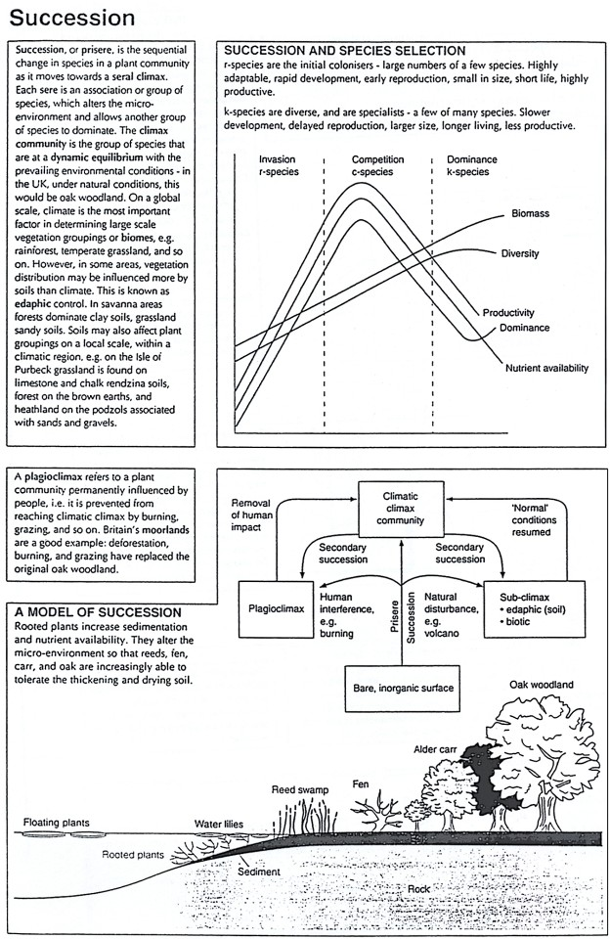

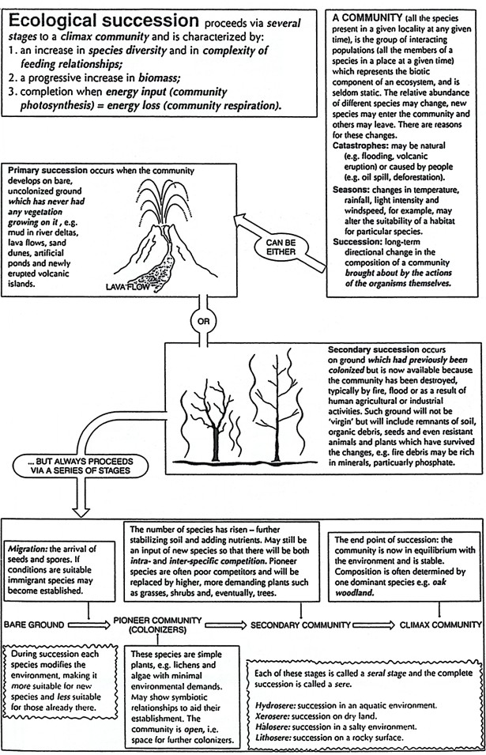

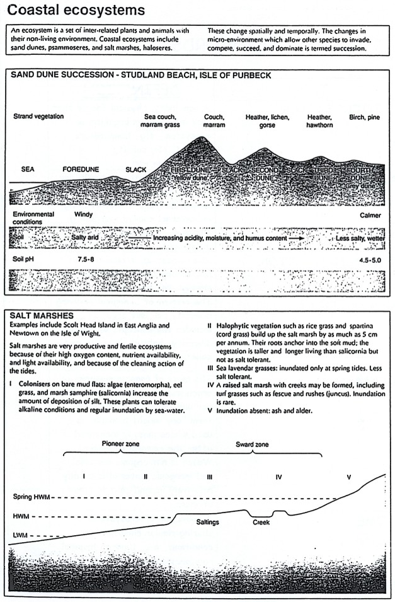
Complete the following table to illustrate the differences between r- and k- strategists.

FEATURES | r-strategists | K-strategists
Size
Life span
Colonising ability
Number of offspring
Care of the young
Competitive ability
Adaptability
Reproductive episodes
Reproductive cycle
Dispersal
Population density
Examples of organisms

r- and K-strategists between represent idealized categories and many organisms occupy a place on the continuum.

During this ecological succession, explain how:-

    - The minerals accumulate

    - Erosion is reduced

    - Drainage may be affected

    - Rainfall may increase

The earlier species (colonizers) changes the conditions. Suggest some examples of how this occurs.

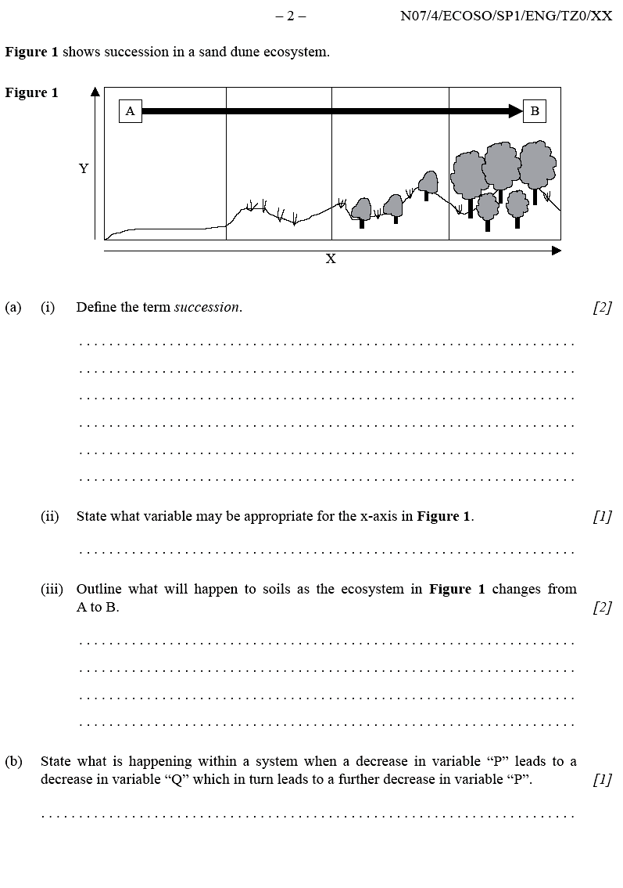

KEY WORDS

TERM | DEFINITION
ABIOTIC FACTOR | A non-living, physical factor that may influence an organism or ecosystem, e.g. temperature, sunlight, pH, salinity, precipitation etc.
BIODIVERSITY | The amount of biological or living diversity per unit area. It includes the concepts of species diversity, habitat diversity and genetic diversity.
BIOMASS | The mass of organic material in organisms or ecosystems, usually per unit area. Sometimes the term “dry weight biomass” is used where mass is measured after the removal of water. Water is not organic material and inorganic material is usually relatively insignificant in terms of mass.
BIOTIC FACTOR | A living, biological factor that may influence an organism or ecosystem, e.g. predation, parasitism, disease, competition.
CARRYING CAPACITY | The maximum number of a species or “load” that can be sustainably supported by a given environment.
CLIMAX COMMUNITY | A community of organisms that is more or less stable, and that is in equilibrium with natural environmental conditions such as climate; the end-point of ecological succession.
COMMUNITY | A Group of populations living and interacting with each other in a common habitat.
COMPETITION | A common demand by two or more organisms upon a limited supply of a resource (e.g. food, water, light, space, mates, nesting sites). It may be intraspecific or interspecific.
DECOMPOSITION | The degradation of organic material into smaller molecules by fungi and bacteria.

DENSITY-DEPENDENT FACTOR | Factors which lower the birth rate or increase the death rate as a population grows in size e.g. quantity of food.
DENSITY-INDEPENDENT FACTOR | Factors which affect population size irrespective of population density e.g. climate, fire etc.
K-STRATEGISTS | Species using K-strategies will usually concentrate their reproductive investment in a small number of offspring thus increasing their survival rate and adapting them for living in long-term climax communities.
J-CURVE | A growth curve which illustrates exponential growth.
LIMITING FACTORS | Various factors which limit the distribution or numbers of an organism.
NICHE | A species’ shape of a habitat and the resources in it. An organism’s ecological niche depends not only on where it lives but on what it does.
PHOTOSYNTHESIS | The process by which autotrophs (plants) make their own food by converting light energy into chemical energy.
PIONEER SPECIES | The first plant colonisers of a newly created habitat as part of the first stage of succession  e.g. lichens on bare rock.
POPULATION | A group of organisms of the same species living, in the same area at the same time, and which are capable of interbreeding.
PRODUCTIVITY | Production over time (see previous glossary for definitions of GPP and NPP)
RESPIRATION | The breakdown of food to release energy.

r-STRATEGISTS | Species using r-strategies will tend to spread their reproductive investment among a large number of offspring so that they are well adapted to colonise new habitats rapidly and make opportunistic use of short-lived resources.
SERE | The set of communities that succeed one another over the course of succession at a given location.
SUCCESSION | The orderly process of change over time in a community. Changes in the community of organisms frequently cause changes in the physical environment that allow another community to become established and replace the former through competition. Often, but not inevitably, the later communities in such a sequence or sere are more complex than those that appear earlier.
TRANSECT | A line, strip or profile of vegetation which has been selected for study.
ZONATION | The arrangement or patterning of plant communities or ecosystems into parallel or sub- parallel bands in response to change, over a distance, in some environmental factor. The main biomes display zonation in relation to latitude and climate. Plant communities may also display zonation with altitude on a mountain, or around the edge of a pond in relation to soil moisture.

