Topic 2.5 Investigation Ecosystems Notes

Review.

An environmental gradient is a trend in one or more abiotic and/or biotic components of an ecosystem. These can be spatial and static i.e. ZONATION or dynamic and taking place over long periods of time i.e. SUCCESSION.

Place the following examples into their correct place in the table (some examples can fit into both categories although this is unusual):-

- ROCKY SHORES i.e. populations of organisms changing from salt-resistant species to more common inland species with increasing distance from the sea.
- TROPICAL RAINFORESTS i.e. the formation of a tropical rainforest over thousands of years after a volcanic event.
- ABANDONED FARMLAND turning slowly into lowland scrub due to lack of management.
- The transition of a SHALLOW POND into oak woodland.
- The transition from DECIDUOUS WOODLAND to ALPINE FOREST / HIGHLAND SCRUB when hiking up a large mountain.
- SAND DUNE COLONISATION i.e. the change in the populations of plant species found with increasing distance from the sea as the dunes stabilise over time to create distinct vegetational zones at various points along the dune transect.

SUCCESSION | ZONATION

It is important to understand how to measure these areas in order to determine number of species and biodiversity within the ecosystems. We estimate populations because it would take way too long to count every living thing in a given ecosystem.

MONITORING ABIOTIC (PHYSICAL) FACTORS

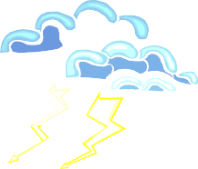Ecosystems can be roughly divided into:-

Each of these is influenced by many abiotic factors which can be measured using a variety of equipment and can be monitored on a regular basis to observe changes over time and space. The equipment that can be used to measure these factors and techniques to eliminate inconsistency in measuring

If you were studying the following ecosystems, which key abiotic factors would you focus on measuring and what equipment would you require?

N.B. the three most significant / influential abiotic factors should be chosen and how these may vary with depth, time or distance should also be stated.

ECOSYSTEM | Significant Abiotic Factors | Equipment required | Possible variation in time, depth or space (choose one)?
TROPICAL RAINFOREST | 1
 | 2
 | 3
ESTUARINE  MUDFLAT (i.e. near the mouth of a river) | 1
 | 2
 | 3
A POND | 1
 | 2
 | 3
DEEP OCEAN | 1
 | 2
 | 3
ROCKY SHORE | 1
 | 2
 | 3
A STREAM | 1
 | 2
 | 3
MOUNTAIN SUMMIT | 1
 | 2
 | 3
CONIFEROUS FOREST FLOOR | 1
 | 2
 | 3

When collecting data it is almost impossible to collect data from every location or point. Instead you must:

Methods to determine where to collect samples:

Assumptions Made in Sampling:

Common Sampling Methods:

Homework:
Measuring abiotic factors

Choose a one factor from each type of ecosystem and research how it is measured.

Produce a detailed methodology with supporting diagrams if necessary.

Marine: Salinity, pH, temperature, dissolved oxygen, wave action.

Freshwater: Turbidity, flow velocity, pH, temperature, dissolved oxygen.

Terrestrial: Temperature, light intensity, wind speed, particle size, slope, soil moisture, drainage, mineral content.

Quadrat Estimation

Population Density-

Percentage Coverage-

Frequency-

Quadrat Method Formula

Ex. If you count an average of 10 live oak trees per square hectare in a given area, and there are 100 square hectares in your area, then

Choosing Quadrate Size:

TRANSECTS

To measure any of these abiotic and/or biotic components of an ecosystem along an environmental gradient should be done using a TRANSECT. It is usually easier to study changes in immobile species such as plants, corals, barnacles etc.
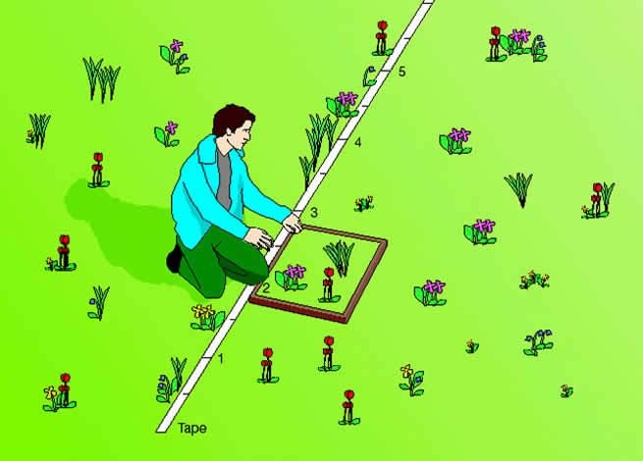
A TRANSECT -
In order to complete a transect, a piece of string or measuring tape is laid out along the selected gradient. There are a variety of possible methods for collecting data including:-

- A Line Transect –
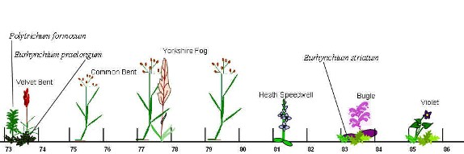

- A Belt Transect –

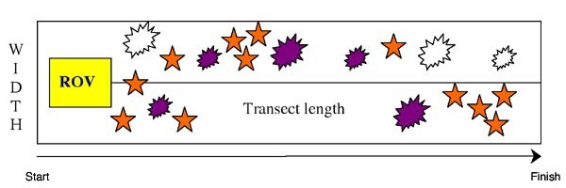

KITE DIAGRAMS

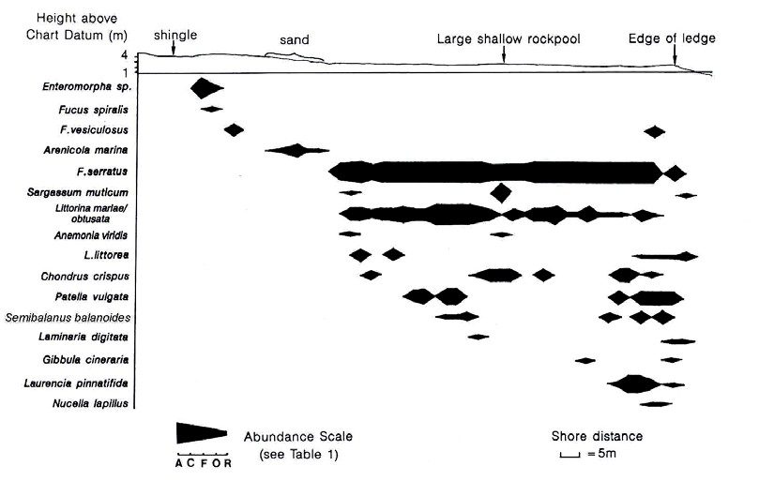
N.B. ACFOR scale = A- Abundant, C – Common, F- Frequent, O – Occasional, R - Rare

MONITORING BIOTIC (LIVING) FACTORS

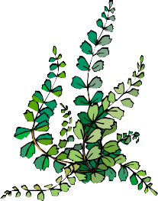
Once the abiotic conditions within an environmental gradient have been measured, we can begin to ask questions about the distribution of organisms within the study area. This can be done in many ways depending on what needs to be measured i.e.

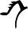

Plant Biomass and Primary Productivity

Place quadrat

Harvest all above ground vegetation

Wash and remove insects

Dry until constant mass is achieved

Should be repeat 3-5 times

Can be extrapolated

*Different methods for terrestrial and aquatic habitats.

Method for primary productivity

Method for secondary productivity

How to capture organisms that like to run away from you

Terrestrial Aquatic

Estimating Populations

Why do we estimate populations?

Estimating abundance of motile organisms can be either:

Example of direct sampling
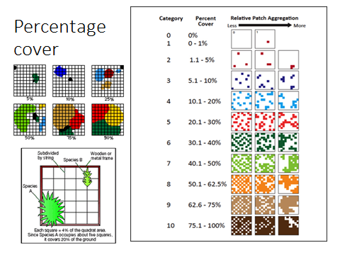
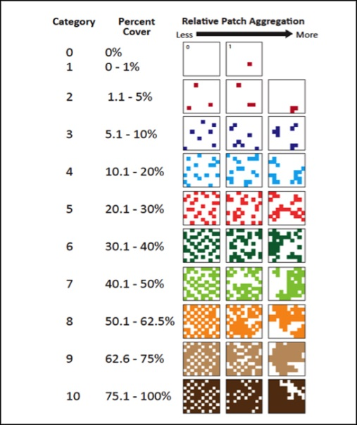
Percentage cover

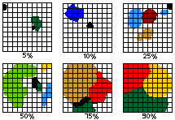

Estimating animal populations with the Lincoln Index (capture-release-capture)

Write out the formula for Lincoln Index

When using any sampling method certain assumptions must be made. Assumptions for the Lincoln Index are:

Species richness:

Diversity:

Complete the following using the Simpson’s Index

 | Number of individuals of species
 | A | B | C
Ecosystem 1: | 25 | 24 | 21
Ecosystem 2: | 65 | 3 | 4

50 snowshoe hares are captured in box traps, marked with ear tags and released. Two weeks later, 100 hares are captured and checked for ear tags. If 10 hares in the second catch are already marked (10%), provide an estimate of N

Dichotomous keys

MEASURING CHANGES CAUSED BY HUMAN ACTIVITY

Measuring changes over time is also important when assessing the impact of human activity on an ecosystem e.g. toxins from mining activities, landfills, eutrophication, effluent, oil spills and overexploitation. Depending on the scale of the activity, repeated measurements can be made from the ground (see below) or from satellite images and maps.

For each measurement technique, state how it could be used to monitor a specific environmental problem to detect whether any detrimental changes have occurred within the ecosystem in response to human interference.

INSTRUMENT | PHYSICAL FACTOR MEASURED | HOW COULD THE INFORMATION BE USED TO MONITOR POLLUTION? (What  kind?)
Light Meter | Light Intensity | Density of algal blooms created by eutrophication from fertilisers.
Dissolved Oxygen Meter | Dissolved oxygen
pH Meter | pH
Total Dissolved Solids (TDS) Meter | Total Dissolved Solids
Current Meter | Flow rate
Secchi Disc | Turbidity
Wind Meter | Wind speed and direction

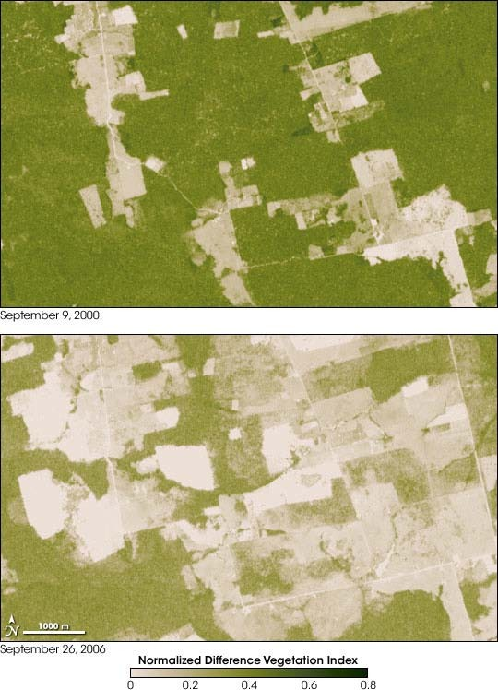Satellite images and maps are particularly useful when studying human impact over a large area e.g. decline in productivity in an area due to the overexploitation of resources.

NASA’s Earth Observatory is currently assessing current trends in deforestation, a
major global issue:-

http://earthobservatory.nasa.gov/Features/Deforestation/deforestation_update4.php

Q1. Do you think there were other satellite images of the same area recorded during this time period? Explain your answer.

Q2. How could these maps help to determine the rate of destruction of the natural vegetation in this area?

Q3. Suggest reasons why this change may have occurred (try to include economic and social reasons as well as environmental ones).

Q4. Explain the impact that this change may have on the community of organisms living in the area (consider productivity, complexity, stability, diversity etc. in your answer).

Q5. Why is it important to have records in the form of data, maps, satellite images or photographs of areas which have yet to be influenced by any human activity? How could this information prove useful if human interference did start to occur

Complete the following table to remind you of some of the measuring
techniques discussed in ‘THE ECOSYSTEM – Measuring Components of the Ecosystem’ booklet. (Remember you have evaluated these techniques already and should be aware of their strengths and limitations)

BIOTIC COMPONENT | Equipment required | Formula required | Possible abiotic factors which may have had an influence
SPECIES PRESENCE  / ABSENCE |  | NONE
POPULATION SIZE (SESSILE ORGANISMS) |  | Running average of no. found in one quadrat x total area
POPULATION SIZE (MOTILE ORGANISMS) i.e. | VARIABLE i.e.  ↓ | LINCOLN INDEX  =
Soil organisms | Tullgren funnel
Small insects
Small crawling organisms
Small mammals | Longworth mammal trap
Flying / swimming organisms
PRODUCTIVITY  /BIOMASS / ORGANIC MATTER |  | Humus = (Initial mass(g) – final mass(g)) x 100 Content % Initial mass(g)
SPECIES DIVERSITY | Quadrat

Example questions

