4.2 Access To Water Notes
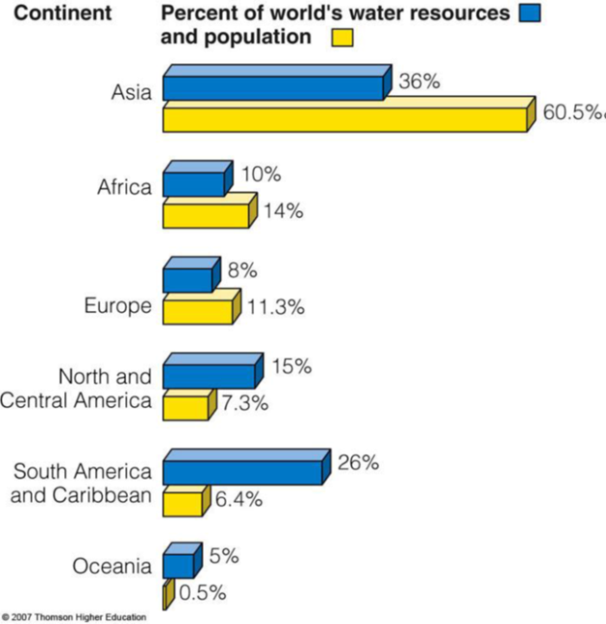
Water scarcity is affected by water availability and how water is used
Agriculture ( ), Industry ( ). Distribution of available water is uneven. We only use worlds' reliable runoff. of water withdraws from rivers, lakes and aquifers are not returned to the source.

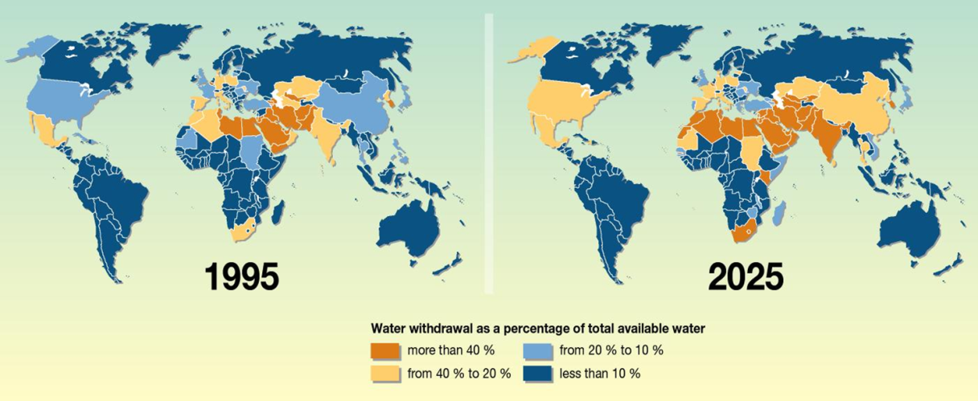

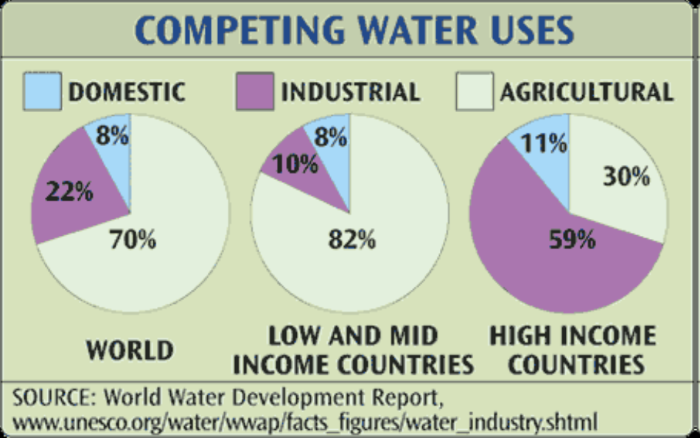

Sustainable water use:

Water Scarcity Issues:

Water Scarcity Solutions:

Water Degradation Issues:

Water Degradation Solutions:

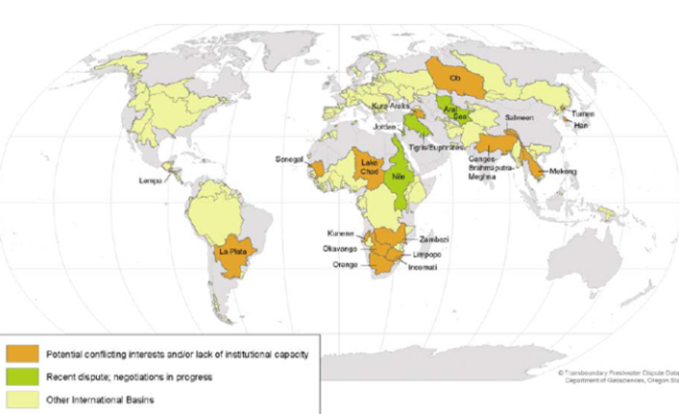
Examples Water Conflicts around the World

Answers the following
- Distinguish between ‘physical water scarcity’ and ‘economic water scarcity’.

- Suggest contrasting reasons to explain the distribution of water scarcity.

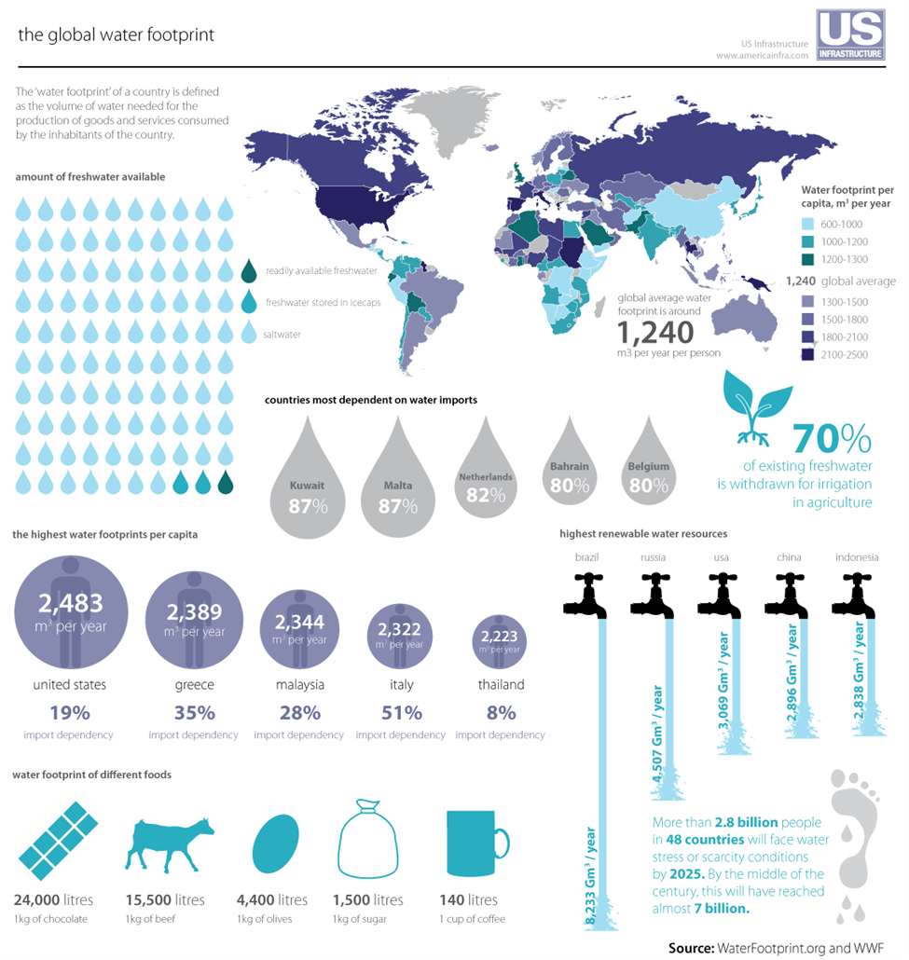

Define
Economic water scarcity:

Physical water scarcity:

Describe the distribution of countries with above global average water footprints.

Why is Kuwait the most dependent country on earth for water imports?

Explain why a typical USA citizen has such a high Water Footprint and give examples.

Explain why chocolate has such a high Water Footprint (link to farming - inputs - processes - outputs)

Explain why Brazil has the highest renewable water resources in the world

Assuming there are 6.6 billion people alive on Earth, what is the percentage of the world’s population that have no clean drinking water?

How may days of water use by one person in Europe would it take to produce on kilogram of beef?

