Topic 4.4 Water Pollution Notes
List as many sources of water pollution as you can think of. Suggest how we could reduce each of these

Types of Water Pollution

Possible Sources of Water Pollution

Possible Effects of Water Pollution

Ways to measure water pollution (direct method)

Ways to measure water pollution (indirect method)
Biochemical Oxygen Demand (BOD)

Indicator Species

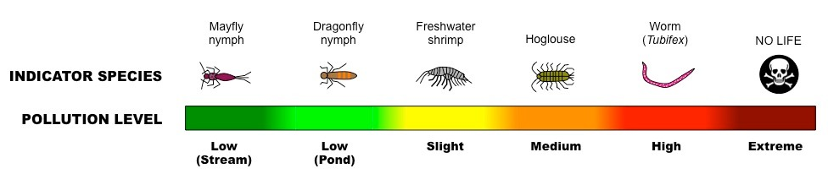

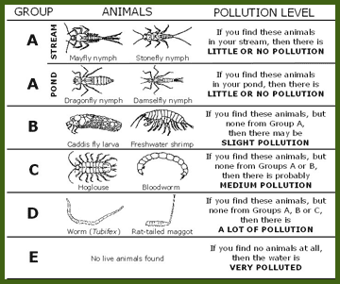

- Biotic Indices (ex Trent Biotic Index)
- Indirect measure of pollution
- Often used in conjunction with BOD as invertebrates are sensitive to decreases in oxygen demand
- Often used to compare 2 ecosystems or point source pollutants using Simpson’s diversity index
- Measures the effect of pollutants on biodiversity

Eutrophication
Occurs when –

Process of Eutrophication
- Fertilizers (or detergents) wash into river lake
- High levels of nitrates and/or phosphates lead to increased algal
- Algal blooms block sunlight from penetrating deeper into the lake
- More producers result in increased consumer
- Plants not on surface die due to lack of sunlight Plants not on surface die due to lack of sunlight
- Decomposer population grows significantly Decomposer population grows significantly
- Increased decomposition and consumer population leads to decreased dissolved oxygen
- Due to low levels of oxygen everything begins die Due to low levels of oxygen everything begins die
- May result in dead zones (oceans or freshwater)
Impacts of Eurtophication
- Anaerobic (anoxic) water
- Loss of biodiversity
- Death of aerobic organisms
- Death of plants
- Increased turbidity
- Produced topic (and smelly) gases such as methane, hydrogen sulfide and ammonia (due to anaerobic decomposition)
Dealing with Pollution
The three main ways to reduce all types of pollution
1.
2.
3.

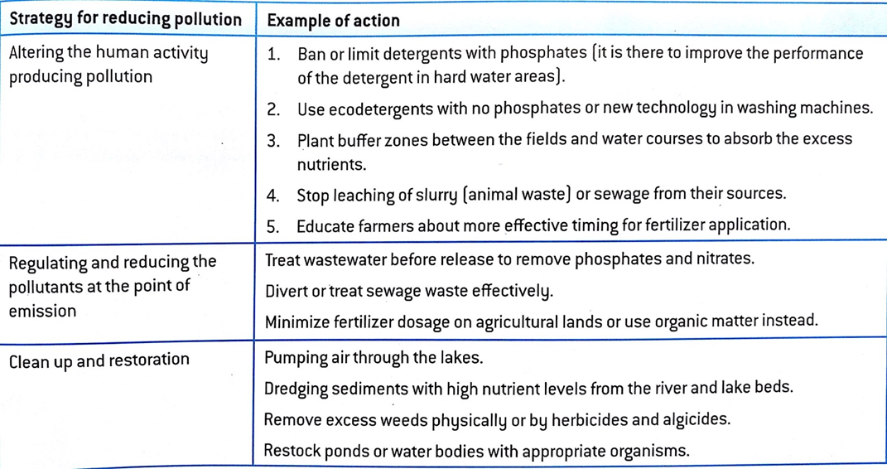

Research methods aimed at mitigating the effects of eutrophication and place them in one of the above categories.
Then evaluate 3 of your methods.
E.g.
Ban or limit detergents with phosphate (phosphate are only needed in hard water areas).
This could be difficult as you would have to get companies to agree to make two products, and would people accept their washing powder being not as effective

