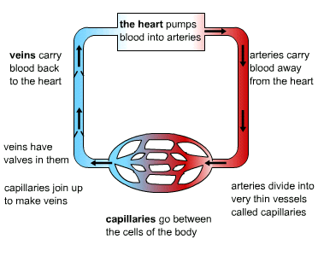

1. Name the three types of blood vessel.
2. Which vein is the exception to the rule that veins carry deoxygenated blood.
3. Which artery is the exception to the rule that arteries carry oxygenated blood?
4. Why do veins contain valves? Why don’t arteries need them?
5. At capillaries the exchange of substances takes place. What substances:

a) go into the blood

b) come out of the blood at the capillaries in the lungs?

6. What substances:

a) go into the blood

b) come out of the blood at the capillaries around body cells?

7. Why do capillaries have very thin walls (one cell thick)?

**Blood Vessels**

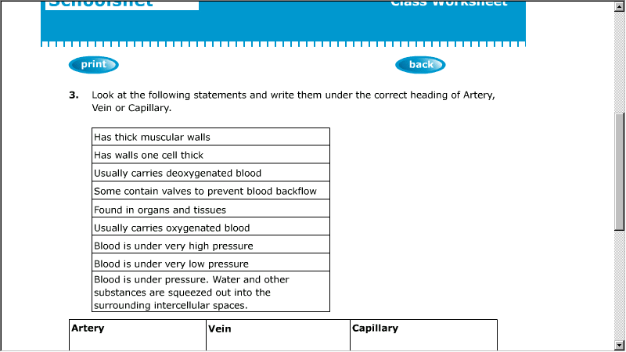

**Artery Vein Capillary**

Draw a labelled cross-section of each type of blood vessel in the box