Comparing Human Circulation System with other species
There are two main types of circulatory systems in higher organisms, the open and close circulatory systems. These two different types of circulatory systems differ in many ways and are also found in different animals. This site will go further in depth of these two different types of circulation systems and show you more about it:
Closed Circulatory System:
The closed circulatory system is mostly used by vertebrates and a few invertebrates. In this system the blood is closed for most of the time within the vessels of different size and wall thickness. As a part of this system, the blood is pumped by the heart through vessels, and does not normally fill body cavities
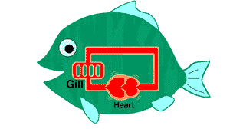
Closed Circulation System
(From: http://www2.gsu.edu/~bioasx/closeopen.html)
Open Circulatory System:
The Open Circulatory system is mostly used by mollusks,arthropods and other invertebrates.In this form of circulatory system blood is pumped into a hemocoel and then this leads the blood to diffuse back to the circulatory system between cells. In this process the blood is pumped by the heart into the cavities of the body where the blood surrounds the tissues.
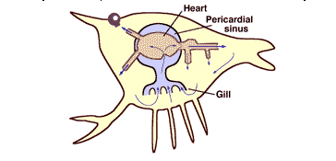
Open Circulatory System
(From: http://www2.gsu.edu/~bioasx/closeopen.html)
Open Vs Closed Circulatory Systems:
(From: http://www.youtube.com/watch?v=vGriV82EyeA&feature=player_embedded)
Single circulatory system
In a single circulatory system, the blood flows through the heart only once during each circuit of blood throughout the body.
Double circulatory system
The double circulatory system commonly found in mammals, amphibians, reptiles, and birds. In this circulatory system, the blood passes through the heart twice for each circuit of blood that is pumped around the body. The oxygenated blood enters the heart, from the lungs, and is then distributed to other parts of the body. The deoxygenated blood is returned to the heart to be delivered to the lung to be oxygenated again.
For further information on the double circulation, please watch the following video:
(From: http://www.youtube.com/watch?v=0jznS5psypI&feature=player_embedded)
Video of explanation of double circulation (Systemic and Pulmonary)
Insects
Circulatory system:
Insects have an open circulatory system and the cavities and appendages of its body contain most of the body fluid(hemolymph). The closed organ in insects, the dorsal vessel, extends from the hind end of the insect all the way up through the thorax and then onto the head. This vessel is a continuous tube which contains two regions, the heart, which is restricted to the abdomen and the aorta or conducting vessel and this goes forward passing through the thorax into the head.
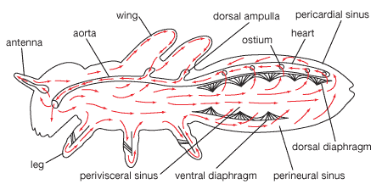
Insect Circulatory system
(From: http://www.britannica.com/EBchecked/media/43602/Circulatory-system-of-a-generalized-insect)Hemolymph, which has been pumped from the rear end and sides of the insect body along the dorsal vessel, passes through a series of the valve chambers, with each having a pair of lateral openings called ostia, going into the aorta and it is from there discharged in the front of the head. The hemolymph is then carried by accessory pumps, through the wings and along the antennae and legs it flows backward again to the abdomen.
Worms
Circulatory system:
Earthworms consist of two main blood vessels, A dorsal and a ventral vessel which is used to carry the blood towards the head or tail of the worm. Blood is moved across the dorsal vessel by waves of contraction in the wall of the vessel. The contractible waves are known as 'peristalsis'. The anterior part of the worm contains five sets of vessels, which are also known as "hearts", which link the dorsal and ventral vessels. These connecting vessels act as rudimentary hearts and make the blood move into the ventral vessel. Since the outer layer(epidermis) of the earthworms body is substantially thin and constantly moist, there is an ample opportunity for exchange of gases, making this relatively inefficient system possible. There are also designated organs in the earthworm for the removal of nitrogenous wastes, still blood can flow backward and the system is more efficient than the open system of insects.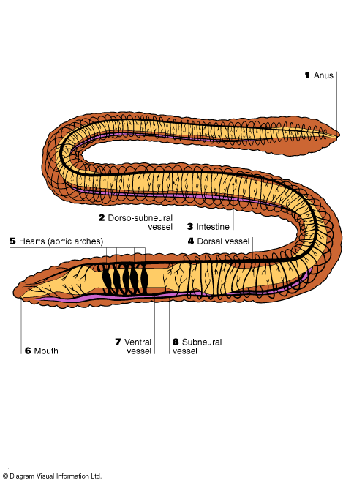
(From: [[http://www.sas.upenn.edu/‌~rlenet/‌Earthworms.html]])
Diagram of worm circulatory system (Diagram of earthworm)
Fish
- The circulatory system of fishes is responsible for transporting blood and nutrients throughout the body. For example, blood travels across the body through the blood vessels. Unlike humans, fishes exhibit single cycle circulation, where the oxygen deprived blood comes to the heart, from where it is pumped to the gills and then circulated to the entire body. It’s quite simple, like mammals, the circulatory system of fish consists of a heart, blood and blood vessels.
In fish, the deoxygenated or oxygen deprived blood, is carried by the veins to the sinus venosus which is an important constituent of the circulator system of lower vertebrates. The deoxygenated blood collected by the veins accumulates in the sinus venosus, before entering the heart. Blood first enters the atrium of the heart which is a large chamber. Then it enters the ventricle, from where it is pumped into the tube, bulbus arteriosus. Through this, the blood reaches the aorta and then the gills. The gills are the respiratory organ of a fish and they execute the activities performed by human lungs. They facilitate the exchange of gases, for example, absorption of oxygen from water and elimination of carbon dioxide. Then the oxygenated blood is transported throughout the body with the help of blood vessels. Blood facilitates the transport of oxygen and nutrients. It also collects carbon dioxide which is again transported to the heart and then to the gills to be removed from the body.
Through the circulatory system of a fish is quite simple compared to that of humans and other mammals, it serves and important purpose by illustrating the different stages of the evolution of the circulatory system in animals. Its heart is also studied to learn the progressive evolution of the four chambered heart.
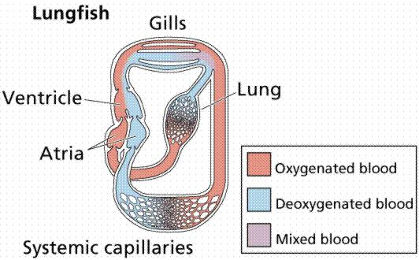
Diagram of fish circulatory system (Diagram of fish)
(From: http://www2.estrellamountain.edu/faculty/farabee/biobk/BioBookcircSYS.html)
Heart:
- The heart of a fish is the simplest vertebrate hearts. They are made up of two main chambers: a thin walled atrium, and a more muscular ventricle. The atrium pumps the blood into the ventricle, which in turn pumps the blood into the conus, and elastic compartment which does not pump, but has the ability to stretch and squeezes. From the conus the blood travels straight to the gills where it is enriched with oxygen. The oxygenated blood then flows through the body and returns to the atrium. The fish therefore has a single – circuit circulation through which blood is driven by a simple two chambered heart.
Amphibian
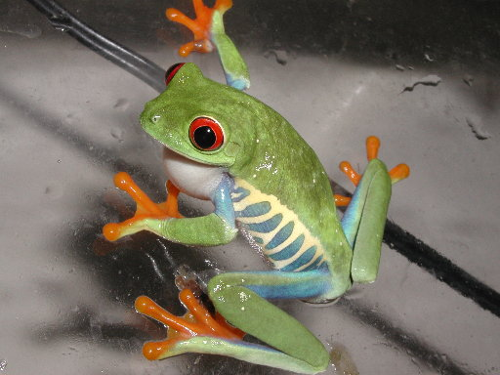
Frog:A type of Amphibian
Circulatory system & Heart:The circulatory system inside amphibians has phenomenal life adaptions that is split between aquatic and terrestrial habitats. The atriums of amphibians are separated into urodeles and are completely separated into anurans. Also their ventricles have no septum. A spiral valve is located in the ventral aorta and it aids the amphibian to direct blood into the pulmonary systemic circuits. The blood that goes into the right side of the heart is almost as oxygenated as blood that comes into the heart from the lungs. If an amphibian is completely submerged in water, gas exchange takes place on the skin and most areas, therefore the blood flowing into the right atrium contains a higher concentration of oxygen than blood returning to the left atrium from the lungs.
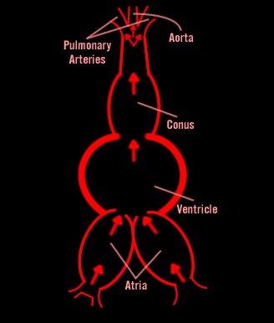
Diagram of Amphibian Heart
In these events, blood vessels leading to the lungs constrict, and this causes the blood flow going to the lungs and conserves energy. When the blood leaves the conus arteriosus it may enter the carotid artery which transports blood to the head, the systemic artery which takes blood to the body, or the plumonary artery. To add to that the vascular system allows blood to circulate, amphibians have a highly developed lymphatic system of blind ending vessels that return fluids, proteins and ions that have been filtered from capillary beds in tissue spaces to the circulatory system.
Human
- In out body, the heart is the main pump which divided into four chambers. The top two chambers the atriums and the bottom two chambers are the ventricles. The atriums both contract at the same time as do the two ventricles. Blood enters the heart via the superior and the inferior vena cava. These are the two largest veins in the body. The right atrium receives the blood first.
- The right atrium contracts and forces the blood into the right ventricle. When the right ventricle contracts the blood is pumped into both lungs via the pulmonary artery. This portion of the circulatory system is sometimes referred to as pulmonary circulation or lesser circulation. The pulmonary artery is the only artery in the body that carries deoxygenated blood. Blood is returned from the lungs via the pulmonary veins. These are the only veins in the body that carry oxygenated blood. The oxygenated blood is forced into the left ventricle which is the strongest and most muscular portion of a healthy heart. When the left ventricle contracts, blood is forced into the aorta. The oxygenated blood is forced throughout the body through a series of arteries that into arterioles and into capillaries. The blood starts its return trip to the heart. From capillaries the blood flows into venules (very small vein). Blood is forced into veins; veins all return blood either into the superior or the inferior vena cava and return the deoxygenated blood to the right atrium of the heart. As the deoxygenated blood makes its way back to the heart it is cleaned of waste products that occur as a result of cellular activity. This is accomplished via the liver and the kidneys. Deoxygenated blood is heavy with carbon dioxide. Carbon dioxide is vented by the body with every breath we exhale. It is oxygenated with every breath we inhale.
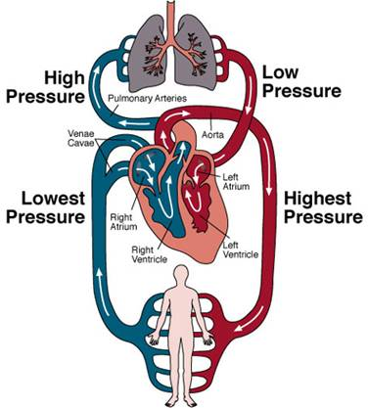
Circulatory System." The Worlds of David Darling. Web. 30 May 2011. http://www.daviddarling.info/encyclopedia/C/circulatory_system.html.
Heart:
- The heart is one of the most important organs in the entire human body, composed of muscle which pumps blood throughout the body, beating 72 times per minute. The heart pumps the blood, which carries all the vital materials which help out bodies function and removes the waste products that we do not need. The heart is essentially a muscle. Like any other muscle in the human body, it contracts and expands. The walls of the heart are made up of three layers, while the cavity is divided into four parts. There are two upper chambers, called the right and left atria, and two lower chambers called the right and left ventricles.
Heart:
The Dorsal vessel is a flexible tube that runs through the thorax and abdomen, along the inner part of the dorsal body wall. The dorsal vessel is closed at the rear end and open at the anterior end. In the abdomen of the insect the dorsal vessel is known as the heart, which is split up into chambers separated by small-valve-like openings called ostia, and through these openings, blood enters the heart.
﻿
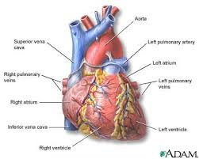
"Heart, Front View: MedlinePlus Medical Encyclopedia Image." National Library of Medicine - National Institutes of Health. Web. 30 May 2011.http://www.nlm.nih.gov/medlineplus/ency/imagepages/1097.htm.
Every chamber has a set of alary muscles which expand and contract in order to facilitate the flow of hemolymph through the heart. The section of the dorsal vessel after the heart dose not have valves or musculature but in place of this a simple tube called the aorta which facilitates the movement of hemolymph to the head(anterior end) where it empties into the body cavity.
Work Cited
"Amphibia." Snow College | It's SNOWing. Web. 25 May 2011. <http://www.snow.edu/allans/biology1320/amphibia.html>.
"Closed and Open Circulatory System." Welcome to Georgia State University. Web. 25 May 2011. <http://www2.gsu.edu/~bioasx/closeopen.html>.
Diagram of earthworm circulatory system. N.d. University of Pennsylvania . N.p., n.d. Web. 25 May 2011. <http://www.sas.upenn.edu/‌~rlenet/‌Earthworms.html>.
Diagram of fish circulatory system . N.d. Estrella Mountain Community College. Web. 25 May 2011. <http://www2.estrellamountain.edu/faculty/farabee/biobk/BioBookcircSYS.html>.
"Insect (arthropod Class) :: Circulatory System -- Britannica Online Encyclopedia." Encyclopedia - Britannica Online Encyclopedia. Web. 25 May 2011. <http://www.britannica.com/EBchecked/topic/289001/insect/41290/Circulatory-system>.
insect: generalize insect circulatory system. Art. Encyclopædia Britannica Online. Web. 25 May. 2011. <http://www.britannica.com/EBchecked/media/43602/Circulatory-system-of-a-generalized-insect>.
The Insect Heart." Redirection Page to Http://bugs.bio.usyd.edu.au/learning/. Web. 25 May 2011. <http://bugs.bio.usyd.edu.au/learning/resources/Entomology/internalAnatomy/imagePages/heart.htm>.
Human Body of a Man with Muscles | Stock Photo | IStockphoto.com." Stock Photography: Search Royalty Free Images & Photos | IStockphoto.com. Web. 27 May 2011.
<http://www.istockphoto.com/stock-photo-6467037-human-body-of-a-man-with-muscles.php>.
"Fish Anatomy." Dr. Lin's Instructional Web. Web. 27 May 2011. <http://snhs-plin.barry.edu/Research/Fish_Anatomy.htm>.
Systemic and Pulmonary Circulation . You Tube. N.p., n.d. Web. 25 May 2011. <http://www.youtube.com/watch?v=0jznS5psypI>.
"¢¼_àÙ_AmyÀÇ °úÇÐ°øºÎ¹æ_àÙ_¢¼ :: ³×ÀÌ¹ö Ä«Æä." 네이버카페 :: 키워드로찾아라, 키워드로뭉쳐라!Web. 27 May 2011. <http://cafe.naver.com/amyscienceroom.cafe?iframe_url=/ArticleRead.nhn?articleid=6305>.
네이버백과사전. Web. 27 May 2011. <http://100.naver.com/100.nhn?docid=727835>.
"네이버 :: 지식iN." 네이버지식iN :: 지식과내가함께커가는곳. Web. 27 May 2011. <http://kin.naver.com/qna/detail.nhn?d1id=11>.
"사랑으로가득한공간." Daum 블로그. Web. 27 May 2011. http://blog.daum.net/331204/11566078.

