**DNA 🡪 Chromosome**

Why does DNA condense into chromosome?

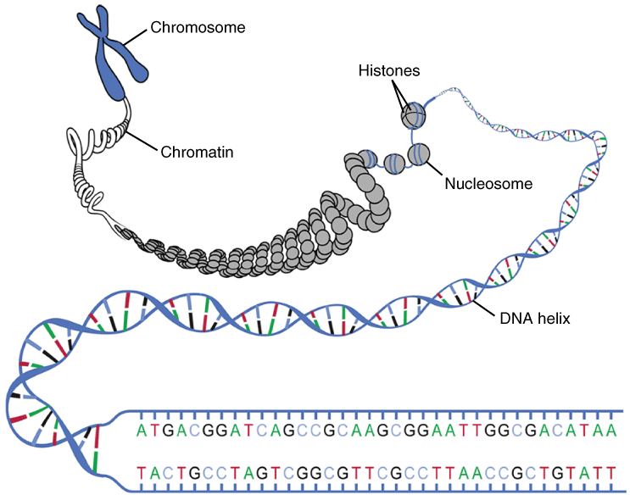

Why does the DNA stay coiled around the histone proteins?



