TASK: Create an Environmental Value Systems Survey?

Attitudes towards the environment can vary a great deal depending on age, gender, place in society, upbringing, education, and many other factors. Showing different environmental viewpoints visually (i.e. in graph or chart form) can summarize complex information in a simple yet effective way. A good way of illustrating different attitudes to the environment is by using different shades of green to represent different viewpoints. This was done in an on-line survey of homeowners in the USA which divided environmental attitudes into different shades of green (see Figure 7.6, page 297 of the textbook). The following shades were used:
• yellow–green: those unmoved by environmental issues
• light green: don’t particularly care, but may act in a minor way in response
• mid-green: are aware and taking steps
• forest green: are vocal in their support but may not always take action
• dark green: the environment is a passionate concern central to their personal value system
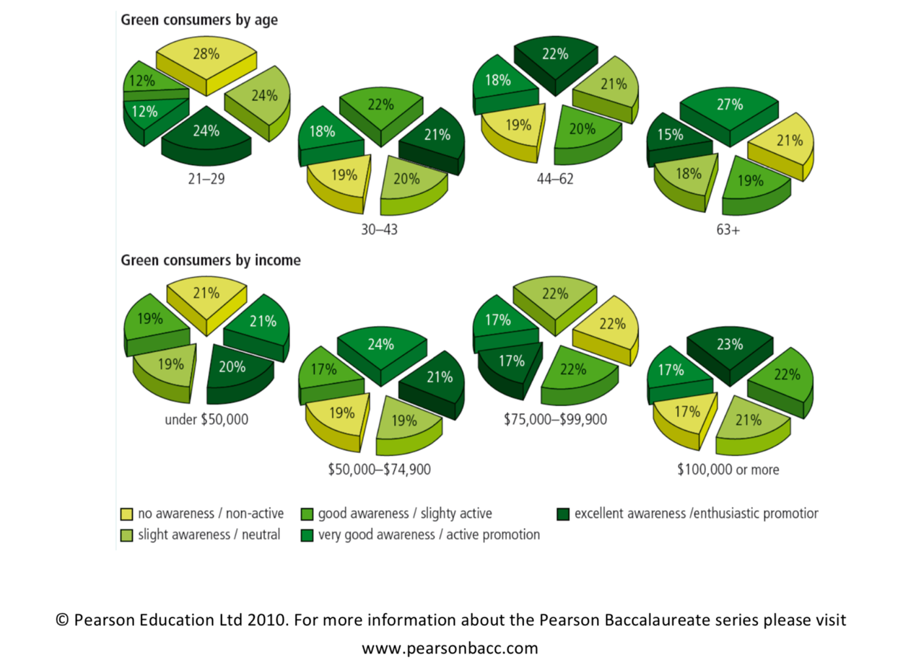

Read through the information about EVS. Once you understand Environmental Value Systems, you will team up with one other classmate. Your group will create a survey to determine the EVS of AIS.

The survey shows that green concerns are limited and not yet a compelling driver of green choices (those people in the darker shades of green make up a minority of the total population). Dividing personal value systems into shades of green provides a visual way of summarizing the views of society in relation to the environment.

Your task
- Develop a questionnaire to explore the environmental attitudes of different groups in your school or community.
- The questionnaire could be used to examine different age ranges (as shown in the study above), different genders (males vs. females), or some other factor.
- Plot pie charts to illustrate your data. The following shades of green could be used:
  - yellow–green (no awareness/non-active) – use this shade in the chart
  - light green (slight awareness/neutral) – use this shade in the chart
  - mid-green (good awareness/slightly active) – use this shade in the chart
  - forest green (very good awareness/actively promote) – use this shade in the chart
  - dark green (excellent awareness/enthusiastically promote) – use this shade in the chart
- What conclusions can you draw from your data? Discuss your results.
- What were the problems with your method? What affect may these limitations have had on your data? How could you improve the method if you were to do the survey again?

An example of the type of questionnaire you could use can be found below. Don’t just copy – develop your own ideas!

Sample questionnaire
• Read each statement carefully.
• Tick the box that best matches your level of agreement with each statement:
1 – strongly disagree
2 – do not really agree 3 – partly agree
4 – agree
5 – strongly agree
6 – very strongly agree

Environmental Value Systems
What is it? This is the “world view” or set of paradigms that shape the ways that individuals and groups approach environmental issues. It can also be viewed as a system as there are inputs and outputs that influence it.

Inputs
Media
Religion
Science
Education
Politics
Culture
Outputs
Decisions
Perspective
Course of Action

Continuum of Environmental Thought
A range of perspectives on environmental thought can be classified and ordered into a continuum as shown in the diagram below.
Environmentalism

Ecocentric
Anthropocentric
Technocentric

Nature Centred People Centred…. Technology Centred

It is important to recognise that this scale and the following outlines represent great generalisations of complicated political beliefs. Individuals are rarely likely to fit such simplistic classifications.

ECOCENTRIC PERSPECTIVES

“Humankind has not woven the web of life. We are but one thread within it. Whatever we do to the web, we do to ourselves. All things are bound together. All things connect.” Chief Seattle, 1855

“We abuse land because we regard it as a commodity belonging to us. When we see land as a community to which we belong, we may begin to use it with love and respect.” Aldo Leopold, A Sand County Almanac

The philosophy of Deep Ecology
Arne Naess is widely regarded as the father of the deep ecology movement, a Norwegian university professor who first outlined this perspective in his book Ecology, Community and Lifestyle. Central to his ideas is a spiritual belief that human desire was a driving factor in the whole process of environmental degradation. Naess believes that spiritual impoverishment leads to this desire and that this is the driving force behind rapid rise of the global consumer, which has parallels in Buddhist teaching. There are also parallels in the writings of American wilderness authors such as Leopold and Thoreau

Self Reliance Ecologists
Based on the promotion of self sufficiency in resource management. The influences are not necessarily the spiritual ideas of deep ecology, it may stem from other academic readings or other inputs. Systems of land use management such as Bill Mollison’s “permaculture” demonstrate how resources can be used more sustainably in way that integrates diverse farming and resource sharing through local economy trading systems (LETS). In economics the teachings of EF Schumacher in his book “Small is Beautiful” focused on the benefits of small scale economy in contrast to the large scale economies promoted under capitalism or communism.

Radical Perspectives
Non-violent direct action (NVDA), following in the techniques of Mahatma Gandhi have come to be the course of action chosen by NGO’s such as Greenpeace (Whaling protests, Nuclear testing protests) and Earth First! (No Compromise in the Defence of Mother Earth). Throughout Britain in the 1990’s there were many examples of protests organized such as “Pure Genius Campaign” encouraging the homeless to squat on land owned by Guinness in London (Key NGO -The land is ours – for protection of common land, and applying permaculture techniques to the management of this land). The Earth First! style protests at Twyford Down by the Donga Tribe and A380 road protests by Swampy, Animal et al.

The social ecologist Murray Bookchin accuses the whole deep ecology, perspective of being “politically naïve” and “intellectually impoverished”. His more anthropocentric approach to environmental problems stemming from his own radical political beliefs. Other criticisms of the ecocentric schools of thought include the notion that ecocentrism promotes misanthropy, or dislike of general society. Connected to this is the idea that many ecocentred prophesies of doom may lead to a loss of faith in the ability of society to change and paradoxically help to fulfill those prophesies.

ANTHROPOCENTRIC PERSPECTIVES

“The most serious, insidious danger in the environmental movement is that it may sap the will of advanced communities to face the problems which no doubt lie ahead. Throughout history, hope for the future has been a powerful incentive for constructive change.”
Maddox (1972)
in Environmentalism T. O’Riordan

Environmental Managers

This perspective does not see any need for a radical political agenda along the lines of some ecocentred approaches, but instead are working to change the existing social and political structures. Those believing in this perspective are unlikely to see a problem with current economic growth that cannot be resolved by legal means or political agreement.

It is the typical approach of those working as Civil Servants for English Nature, Department for the Environment, or for the United Nations. The kind of policy influence of NGOs such as “Friends of the Earth” would be typical of this approach. Campaign material is designed to influence existing government structures to solve environmental problems.

TECHNOCENTRIC PERSPECTIVES

“Necessity is the mother of invention”

Cornucopian Perspective

A perspective that doesn’t really see a problem as humans have always found a way out of difficulties in the past. New resources and technologies will solve any environmental problems as they are encountered. There is no need for radical agendas, or socio-economic, or political reform.

Often associated with the idea of “frontier economics” – the seemingly boundless resources found by pioneers and with free market led development. It can also be associated with technical scientific approaches to manage the environment (although not necessarily both of these together)

Timeline of Key Developments in  the Global Conservation Movement | IUCN Founded | Minamata, Japan –  First death from mercury pollution | Beginnings of the UN Law of the Sea | World Population Reaches 3 Billion | WWF Founded | Rachel Carson’s Silent Spring Published | UN Biosphere Conference | First Earth Day in the USA | UNEP created; the Stockholm Conference | Women in the Himalayas, Northern India Stare the Chipko Movement, protecting trees | CITES started | World Population Reaches 4 Billion | UN Habitat Conference on City Living Conditions | World Climate Conference demands urgent attention to the enhanced greenhouse effect. | The World Conservation Strategy | Bhopal Disaster – 2,800 die. | Antarctic Ozone Hole discovered | Chernobyl Disaster | World Population Reaches 5 Billion | The Brundtland Report on Ennvironment and Development | Montreal Protocol | The Earth Summit in Rio de Janiero | Habitat II conference – “The City Summit” | Kyoto Protocol | World Population Reaches 6 Billion | The World Summit on Sustainable Development in Johannesburg | Nairobi Climate Change Conference
 | 1948 | 1956 | 1958 | 1960 | 1961 | 1962 | 1968 | 1970 | 1972 | 1973 | 1974 | 1974 | 1976 | 1979 | 1980 | 1984 | 1985 | 1986 | 1987 | 1987 | 1987 | 1992 | 1996 | 1997 | 1999 | 2002 | 2006

In the syllabus “Anthropomorphic” but this has a slightly different meaning “attributing human like characteristics to living organisms.”

