Name:___________________________________ Pd: ______ Date:____________________

Fertility and Economics Lab

AIM: How do scientists relate fertility rates and economics?

OBJECTIVES:
• Describe and compare economic indicators for countries
• Identify and discuss connections between poverty, fertility rates, and economics

INTRODUCTION:
Economic conditions and fertility rates around the world vary greatly, causing gaps in the ability to purchase security, education, and healthcare in poverty-stricken nations, which often results in the continuation of poverty.

Part 1. Economic Indicators
In the book The End of Poverty: Economic Possibilities for Our Time, Jeffery Sachs claims that “it is our task to help [the poorest of the poor] onto the ladder of development, at least to gain a foothold on the bottom rung, from which they can then proceed to climb on their own” (2005). In order to direct funding and projects that would promote development, we must first know where countries fall on “the ladder.” There are several ways that a country’s economic status can be measured. Here are a few indicators:

1) Gross National Income (GNI) per capita: provides a rough measure of annual national income per person in different countries.

2) Purchasing Power Parity (PPP): the amount of a country’s currency required to buy the same amount of good and services in the coutnry’s domestic market as a U.S. dollar would buy in the United States

3) Percentage of Population Living on Less Than US$2/Day

Directions.
1. Go to www.prb.org
2. Click on the “Data Finder” tab at the top of the page
3. Click on the “Charts and Maps by Topic” tab at the top of the page
4. Find the section titled “Browse International Topics”. Select “Economics” and the “Population Living below US$2/Day”
5. Randomly select 25 countries from different parts of the list and place them on the “ladder” (Worksheet 1)

Analysis Questions.
1. Describe the relationship between high income countries and their placement on the ladder

2. Discuss the extreme differences in the standard of living between the countries at the top of the ladder and those at the bottom.

Worksheet 1. Economic Ladder

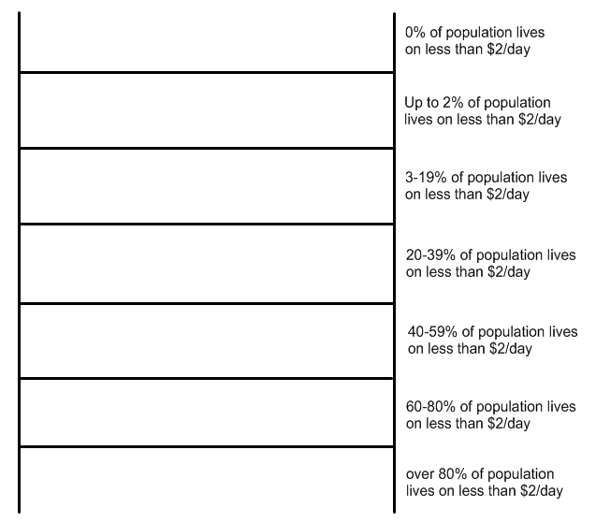
Part 2. Fertility and Economics
Connections between fertility rates and economic prosperity have been made by several organizations. Fertility rate is defined as the number of babies born each year per 1,000 women.

Directions.
1. Go to www.prb.org
2. Click on the “Data Finder” tab at the top of the page.
3. Click on the “United States & International Profiles”
4. Find the 25 countries you selected on the Economic Ladder Worksheet (Worksheet 1) on the drop-down menu under “World Data.”
5. When you click on each of these countries’ names, a list of statistics will appear. Find the number for the Total Fertility Rate (TFR). This is the average number of children born to a woman during her lifetime.
6. Enter the data on the Fertility Rate Ladder (Worksheet 2)

Worksheet 2. Fertility Rate Ladder

Analysis Questions.
1. Describe the relationship between high fertility rates and the % of people living below $2/day.

After reading the article, High Birth Rates Hamper Development in Poorer Countries, Warns UN Forum, complete the following questions:
2. What presents a barrier to reducing poverty levels?

3. What is the major cause of the persistence in high fertility rates?

4. Explain at least 3 benefits to reducing fertility rates.

*adapted from Climbing the Ladder www.prb.org

