Freshwater Pollution Case Study

Dissolved Oxygen
Although water is composed of oxygen and hydrogen atoms, biological life in water depends upon another form of oxygen—molecular oxygen. Oxygen is used by organisms in aerobic respiration, where energy is released by the combustion of sugar in the mitochondria. This form of oxygen can fit into the spaces between water molecules and is available to aquatic organisms. Fish, invertebrates, and other aquatic animals depend upon the oxygen dissolved in water. Without this oxygen, they would suffocate.
Some organisms, such as salmon, mayflies, and trout, require high concentrations of oxygen in their water. Other organisms, such as catfish, midge fly larvae, and carp can survive with much less oxygen. The ecological quality of the water depends largely upon the amount of oxygen the water can hold. The following table indicates the normal tolerance of selected animals to temperature and oxygen levels. The quality of the water can be assessed with fair accuracy by observing the aquatic animal populations in a stream.
Animal Temperature Range (°C) Minimum Dissolved Oxygen (mg/L)
Trout 5–20 6.5
Smallmouth bass 5–28 6.5
Caddisfly larvae 10–25 4.0
Mayfly larvae 10–25 4.0
Stonefly larvae 10–25 4.0
Catfish 20–25 2.5
Carp 10–25 2.0
Mosquito 10–25 1.0
Water boatmen 10–25 2.0

Indicator Species

An indicator species is an organism whose presence, absence or abundance reflects a specific environmental condition. Indicator species can signal a change in the biological condition of a particular ecosystem, and thus may be used as a proxy to diagnose the health of an ecosystem. Relative numbers of an indicator species can be used to calculate the value of a biotic index

Biotic Indices

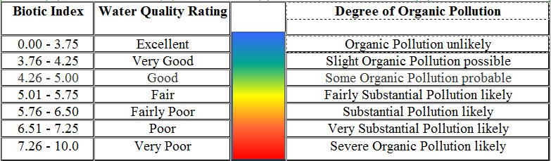
A biotic index is a scale for showing the quality of an environment by indicating the types and abundances of organisms present in a representative sample of the environment. It is often used to assess the quality of water in marine and freshwater ecosystems

Case Study – freshwater pollution
A small town pumps sewage into a river which runs through a woodland. The level of pollution that this causes is investigated by taking samples of bacteria from the water and also by measuring the amount of dissolved oxygen. The information is shown on the graph below:

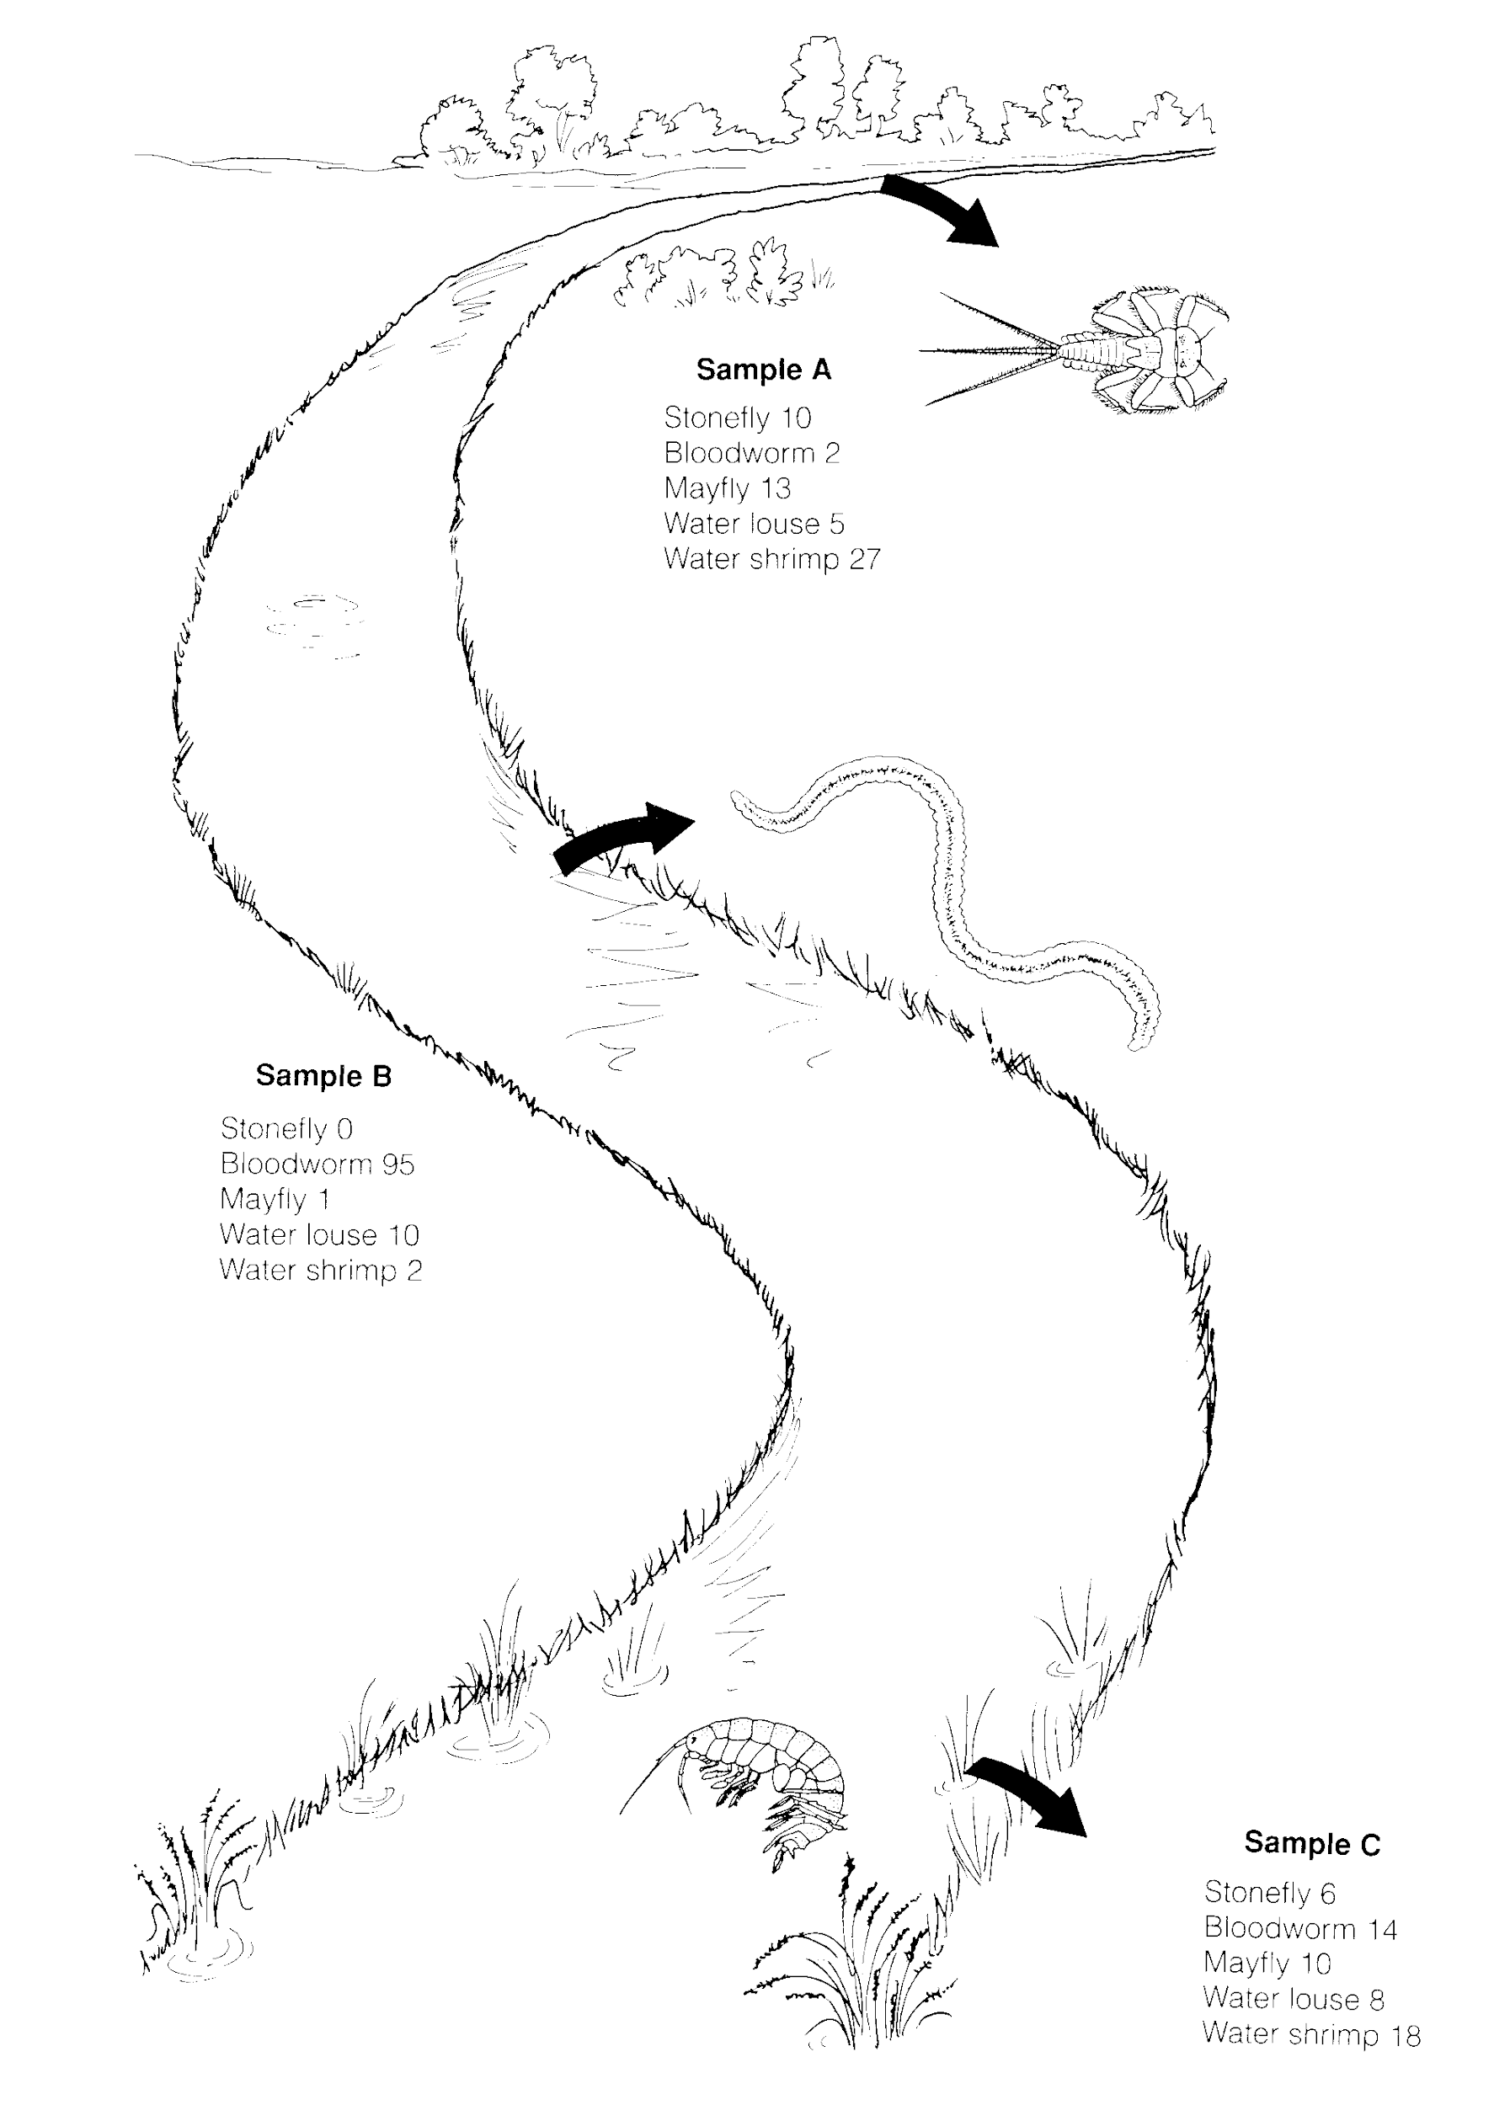
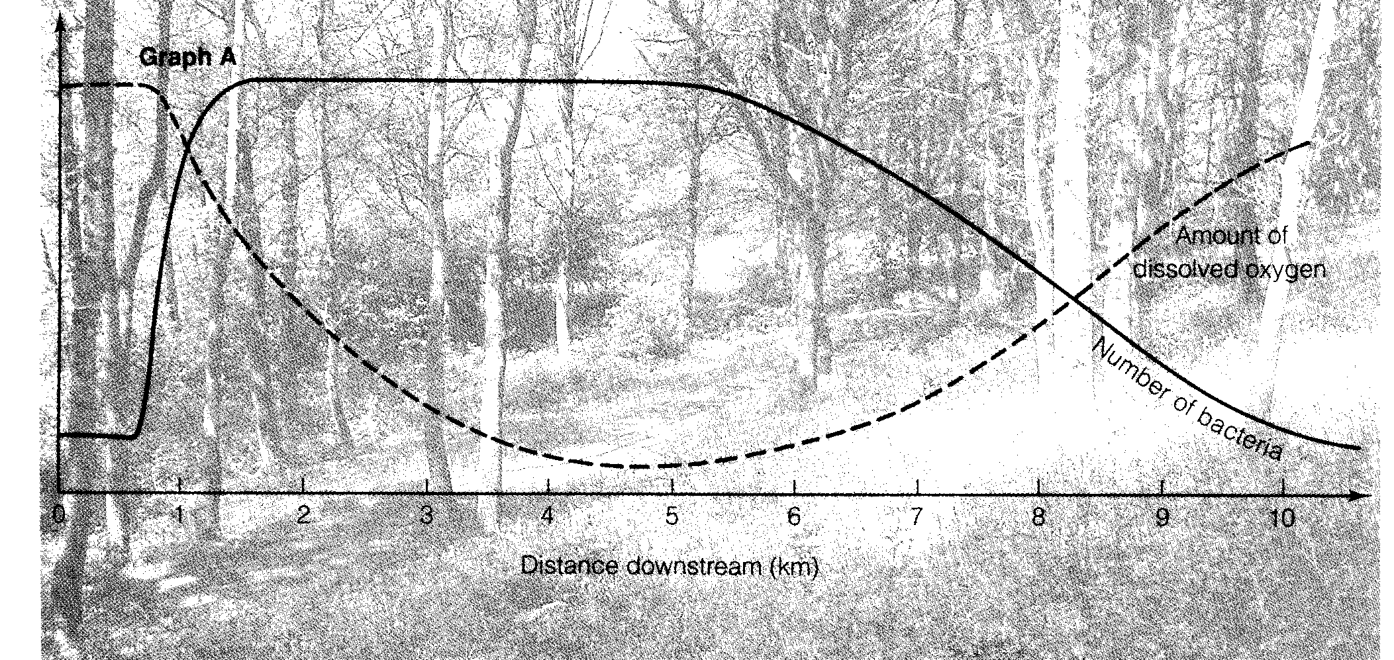
This drawing shows three sites where samples of the invertebrate animals in the river ere taken. The numbers and types of invertebrates present are also given.

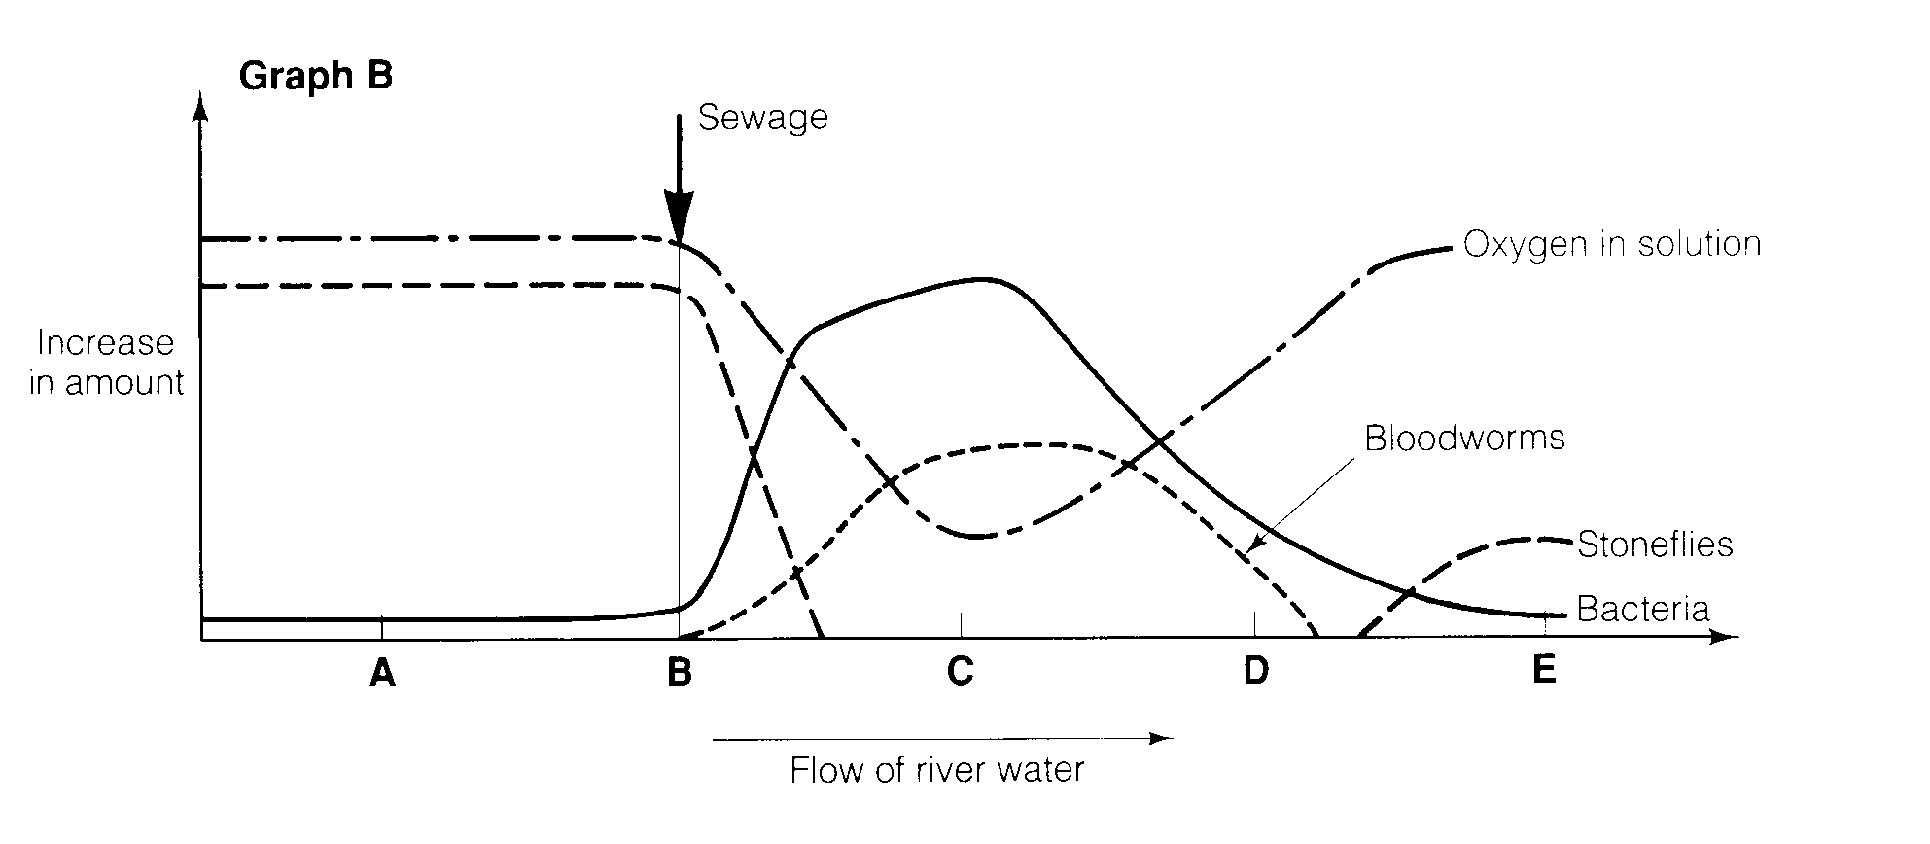
This graph shows the results of a study on another river. The lines on the graph refer to oxygen, microbes, and several indicator species.

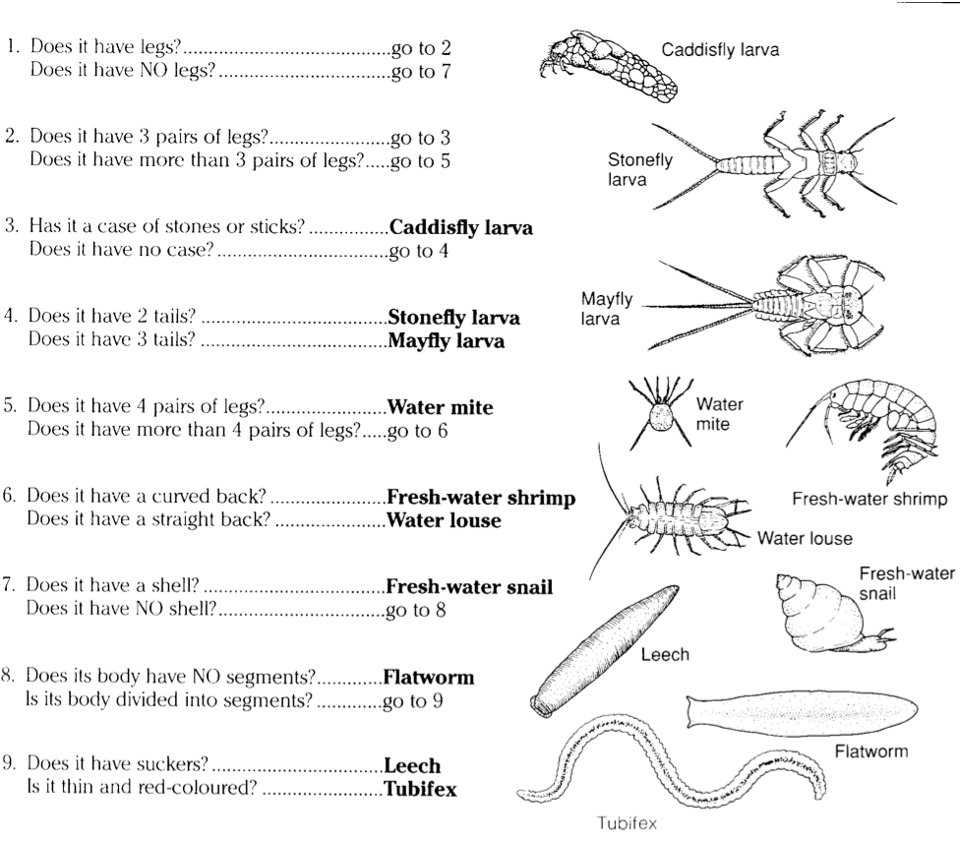
Key of some freshwater invertebrates

Read the case study before answering these questions:
- Describe how samples of the organisms at A, B and C would be taken.

- Identify the three organisms in the pictures, using the key to help you.

- Draw three bar charts to show the number of each species at each sample site.

- Describe where you think the sewage pipe joins the river. Explain your choice.

- Describe what is meant by an indicator species.

- Outline how indicator species can be used to assess pollution levels in water.

- The river in graph B flows from A to E. Explain how the lines on the graph support this statement.

- What evidence is there that the river is able to recover from the effects of sewage discharge?

- Which type of organism shown on the graph could be used as an indicator of pollution?

- Which organism not shown on the graph might be used as an indicator of unpolluted water?

- Fishermen reported dead fish floating in the water at a point on the river. Which of the points A to E might this be?

