Name: __________________________________

Key concepts:
- Energy balance equation
- Radiation: Long and short-wave
- Albedo and reflectivity of surface (short-wave radiation)
- Equilibrium temperature

Background information:
The Gaia Theory - Daisyworld
(http://ccl.northwestern.edu/netlogo/models/Daisyworld)

Daisyworld is an artificial world having a very simple biota which is specifically designed to display the characteristics in which we are interested - namely, close coupling of the biota and the global environment (McGuffie and Henderson-Sellers,1997). In simple terms, this means that living things are affected by, but also affect, the environment. This simple (zero-dimensional) computer model is designed to illustrate Lovelock's Gaia Hypothesis, which views the Earth as a living, self-regulating entity. While evolving, life forms on earth modulate their environment (temperature, etc.).

This model describes an imaginary planet called Daisyworld (see figure on the next page). Daisyworld is a very simple planet that has only two species of life on its surface – white and black daisies. The planet is assumed to be well-watered, with all rain falling at night so that the days are cloudless. The atmospheric water vapor and CO2 are assumed to remain constant, so that the greenhouse of the planet does not change. The key aspect of Daisyworld is that the two types of daisies have different colors and thus different albedos. In this way, the daisies can alter the temperature of the surface where they are growing.

Before you begin…
Define the following Vocabulary:

Albedo

Luminosity

Radiation
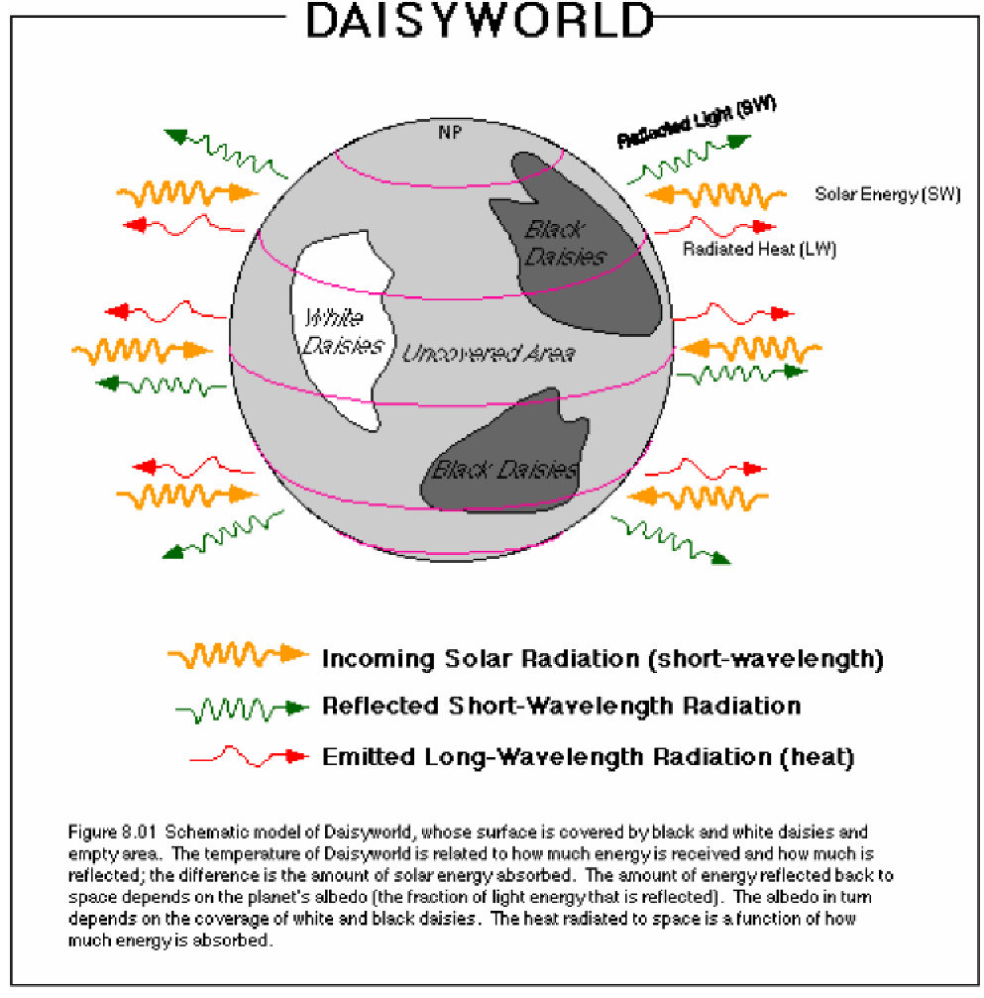

To access the simulation, go to the following link: http://netlogoweb.org/launch#http://netlogoweb.org/assets/modelslib/Sample%20Models/Biology/Daisyworld.nlogo

Once the page has loaded, in the Search the Models Library Drop Down Menu, choose Sample Model/Biology/Daisyworld
After you do the settings, click ‘Setup’ before clicking ‘Go’.

Use ESS terminology on all answers.

- Set the solar luminosity to 1.000 (present conditions). Set the population of daisies to 20% white, 20% black. The albedo the surface should be 0.50, white daisies should be 0.75, and black daisies should be 0.25.
- Describe what happens to the populations of black and white daisies.

- What happens to the temperature of the Earth?

- Draw a feedback loop that can occur within Daisyworld. Label it as a positive or negative feedback.

- Why do the populations of both daisies remain stable when both are present?

- Gradually decrease solar luminosity to 0.800.

- Describe what happens to the populations of black and white daisies.

- What happens to the temperature of the Earth? Why?

- Repopulate the world with 20% each of white and black daisies. Set the solar luminosity to 1.000, and run the simulation until temperatures stabilize. Then slowly increase solar luminosity to 1.400.

- Describe what happens to the populations of black and white daisies.

- What happens to the temperature of the Earth? Why?

A. Populate Daisyworld with all white daisies and set the solar luminosity to 0.900. Describe what happens.

B. Populate Daisyworld with mostly white daisies and 1 black daisy (use the Paint tool to insert only 1 black daisy), and set solar luminosity to 0.900. Describe what happens this time.

- Why are there different results? Relate to the Gaia hypothesis.

- Crank up the heat by changing the solar luminosity to 2.000. Remove all of the daisies.

- Paint on a few white daisies while the simulation is running. What happens to the daisies, and why?

- Stop the simulation, and add a big patch of daisies (at least a third of the world). How is the result different from the previous simulation? Why?

- Stop the simulation, set up Daisyworld with 20% each white and black daisies, and run the "ramp-up-ramp-down" (found under ‘scenario’) luminosity simulation a few times through. (Try it 3 or 4 times by resetting in between simulations.) Speed up the simulation so this doesn't take an hour.

- There are three different ways this simulation can end. Name two of them. What biological event(s) determine the destiny of the planet?

- What might you be able to do (what are some planetary conditions you can adjust) to save any surviving white daisies at the end of the simulation? How do your changes indirectly affect the environment?

- Imagine the Earth was covered in daisies, just like Daisyworld. Yes, these daisies can grow on glaciers, and bare rock, and even oceans. They are space-daisies from another planet, after all.

- Predict which daisies would dominate at high latitudes (near poles)? Low latitudes (near equator)? Justify your answer.

- What would happen to the temperature difference between the equator and the poles? Why?

- Given your answer to B, would you expect average wind speeds on Earth to increase, decrease, or stay constant? What might cause the change? (It is okay to go online and see what factors impact wind.)

