How Do Scientists Read Chromosomes?
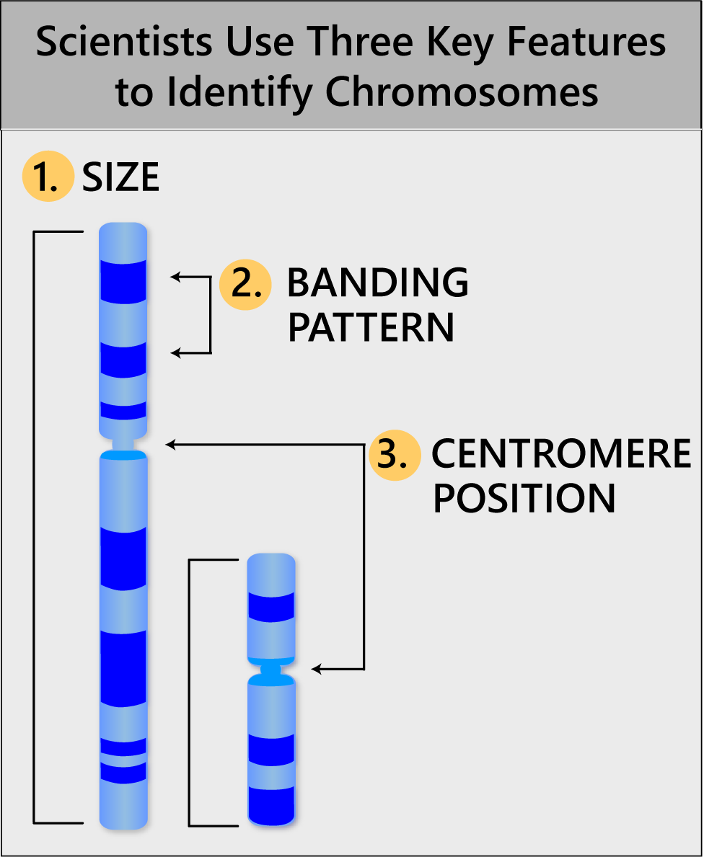
To "read" a set of chromosomes, scientists use three key features to identify their similarities and differences:
- Size. This is the easiest way to tell chromosomes apart.
- Banding pattern. The size and location of Giemsa bands make each chromosome unique.
- Centromere position. Centromeres appear as a constriction. They have a role in the separation of chromosomes into daughter cells during cell division (mitosis and meiosis).
Using these key features, scientists can identify all 46 chromosomes — one set of 23 from each parent

What are centromeres for?
Centromeres are required for chromosome separation during cell division. The centromeres are attachedment points for microtubules, which are protein fibers that pull duplicate chromosomes toward opposite ends of the cell before it divides. This separation ensures that each daughter cell will have a full set of chromosomes.
Each chromosome has only one centromere.

During cell division, microtubules attach to centromeres and pull the chromosomes to opposite ends of the cell.
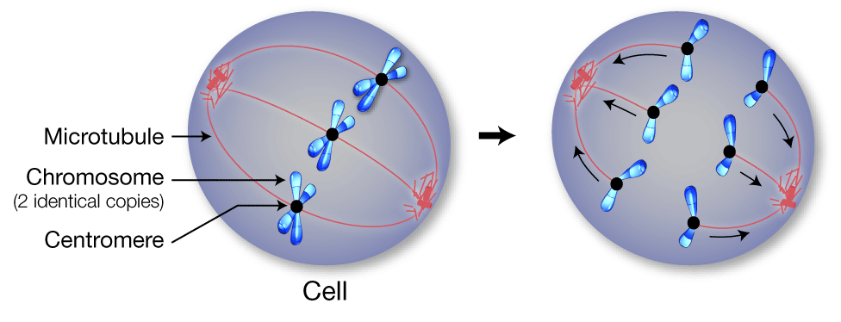

Centromere Positions
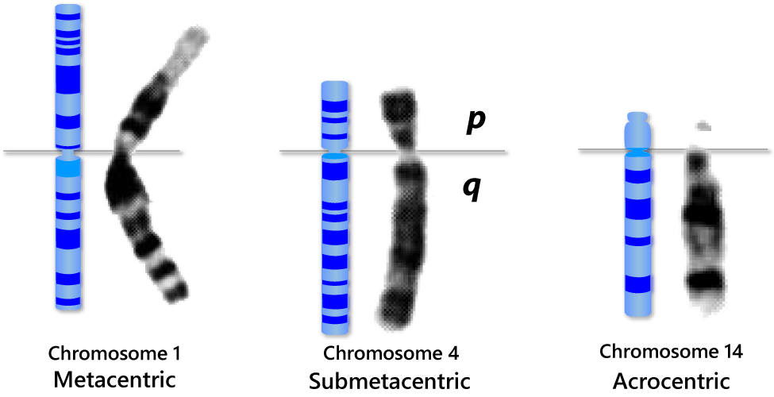
The position of the centromere relative to the ends helps scientists tell chromosomes apart. Centromere position can be described three ways: metacentric, submetacentric or acrocentric.
In metacentric (met-uh-CEN-trick) chromosomes, the centromere lies near the center of the chromosome.
Submetacentric (SUB-met-uh-CEN-trick) chromosomes have a centromere that is off- center, so that one chromosome arm is longer than the other. The short arm is designated "p" (for petite), and the long arm is designated "q" (because it follows the letter "p").
In acrocentric (ACK-ro-CEN-trick) chromosomes, the centromere is very near one end.

Funding provided by grant 51006109 from the Howard Hughes Medical Institute, Precollege Science Education Initiative for Biomedical Research.

