Lake Lanier as a System

Background

Lake Lanier came to be in 1956, when the Corps of Engineers completed Buford Dam on the Chattahoochee River. The Corps built the lake to manage navigation and flood control of the Chattahoochee River, provide hydroelectricity, and supply water for the city of Atlanta

http://thatlakestore.com/lake-lanier-map/

Located in the foothills of the Georgia Blue Ridge Mountains
- Headwaters of the Apalachicola/Chattahoochee/Flint (ACF) watershed
- Impounded by the Buford Dam and extends up the Chattahoochee and Chestatee Rivers.
- 692 miles of shoreline | 38,542-acre Reservoir Area
- Holds approx. 637 billion gallons of water | approx. 354 billion in the conservation storage
- Holds 63% of the total managed reservoir conservation water storage in the ACF watershed; drainage basin is approx. 6% of ACF watershed drainage area
- Touches seven Georgia counties: Dawson, Forsyth, Habersham, Hall, Gwinnett, Lumpkin, and Whit

- Area: 57.92 mi²
- Max depth: 156′ 0″
- Length: 44 mi

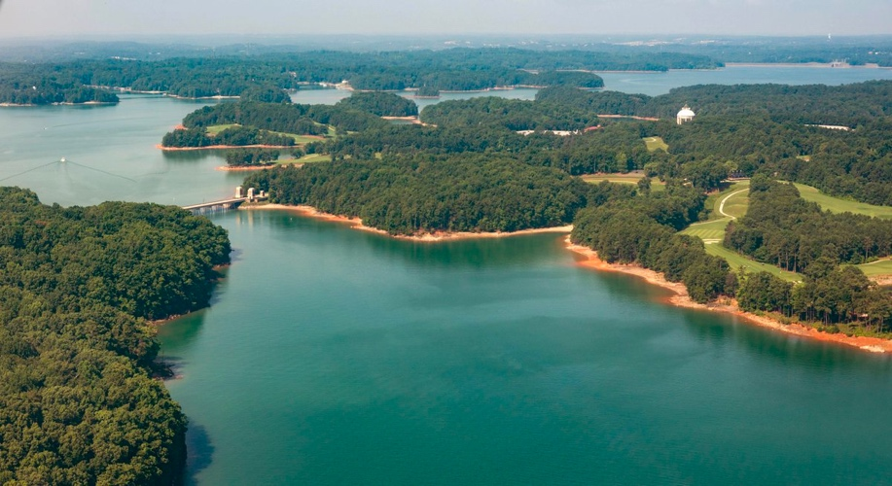

https://geology.com/lakes-rivers-water/georgia.shtml

https://www.dawsonnews.com/sports/emphasis-water-safety-lake-lanier-enters-recreation-season/
As the population grows around Lake Lanier and the creeks and rivers that feed it, these bodies of water are absorbing more runoff and treated wastewater — enough that regulators are starting the process of tightening restrictions for municipalities and water utilities
That growth is causing more runoff into state waterways with more roads, parking lots and gutters, more subdivisions, lawns and vehicles.

The issue is the amount of nutrient flowing into the upper portion of the Chattahoochee River watershed, a corridor of streams, rivers and lakes stretching from North Carolina through Georgia and through the Florida Panhandle. The upper watershed includes Lake Lanier, the Chattahoochee River and its feeder streams in the north part of Georgia.

As communities expand around the lake, the watershed and particularly Lake Lanier are seeing higher concentrations of phosphorus and nitrogen — two nutrients that promote growth of algae that in large enough quantities can foul water supplies for both humans and wildlife

https://www.researchgate.net/figure/Lake-Lanier-location-and-water-quality-sampling stations_fig1_7544088

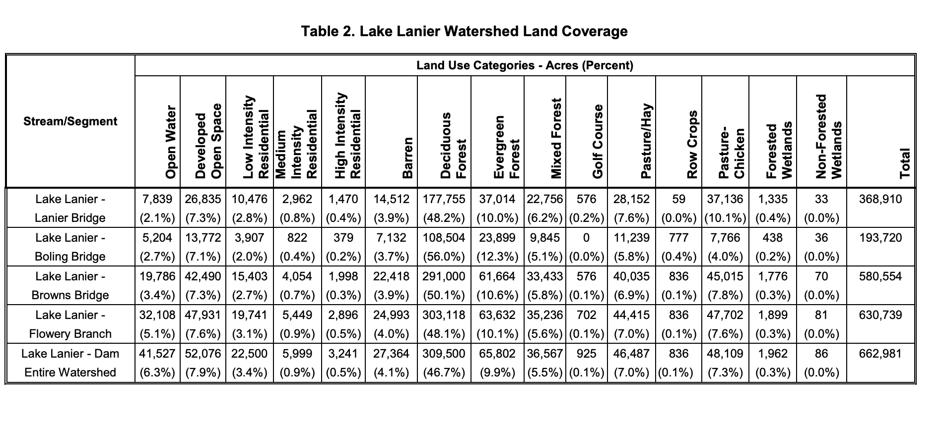
https://epd.georgia.gov/sites/epd.georgia.gov/files/related_files/site_page/EPD_Final_Lake_Lanier_ChlorophyllA_Phosphorous_TMDL_2017.pdf

Lake Lanier is surrounded by hills and these hills provide the catchment area for the lake; rain falling on
these hills will naturally drain into the lake. Alongside the rainfall are various other inputs. As we
look at the lake we will discuss what these inputs are and how they result in outputs from the Lanier
Lake System.

Assessment:
You are required to provide two pieces of work for this lab:
- An annotated map of the lake showing and discussing the various sources of contamination, natural inflows and outflows and some of the problems that the lake faces.
- A labeled system diagram of Lanier Lake with arrows showing the various sizes of inputs and outputs into and out of the system. You will also be expected to note the stores, flows and transformations

