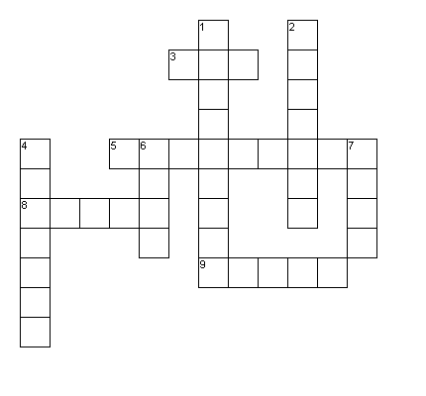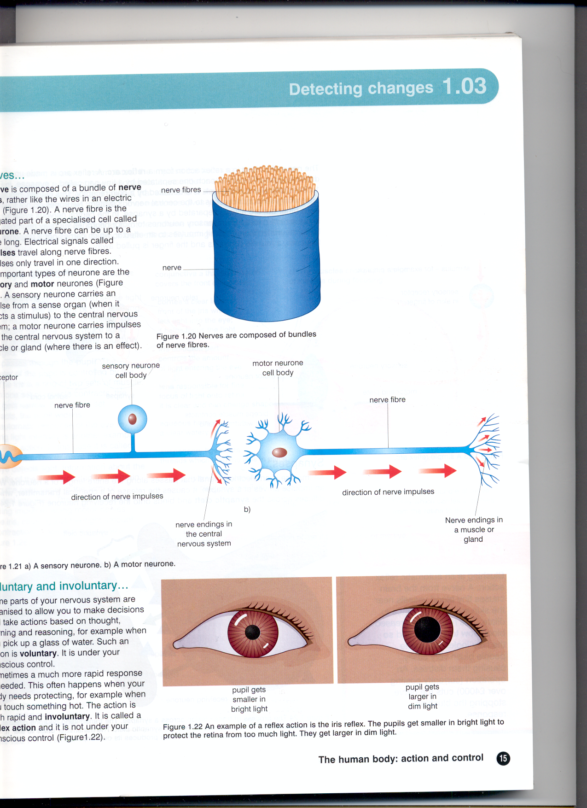

Nerves

T R E C E L P E E L T O E R S L S P C R I E N D M E I A M N U G P U L M P I S E A S H S T S A N E D L L S T O A N G N N R E A E U R S O N U E S A B R B Y T D O L K R W T P U D E S S G D T U J U Z R B S X N Z X P V D R J S D I R H B A O B T E

**Q1. Find these words. They are all stimuli that are detected by receptors**

BALANCE LIGHT PAIN

PRESSURE SMELL SOUND

TASTE TEMPERATURE

**The letters left over spell a secret message**

__ __ __ __ __ __ __ __ __ __ __ __ __ __ __ __ __ __ __ __ __ __

__ __ __ __ __ __ __ __ __ __ __ __ __

**Across** 3. The sense organ for balance 5. Nerve endings 8. A bundle of neurones 9. Stimuli that the nose detects

**Down** 1. These detect taste 2. A very long cell that carries impulses 4. A type of neurone 6. Sense organs that detect light 7. Where pain receptors are found

Neurones

Nerve

Nerves are bundles of long cells called neurones

**Q2. Do the crossword**

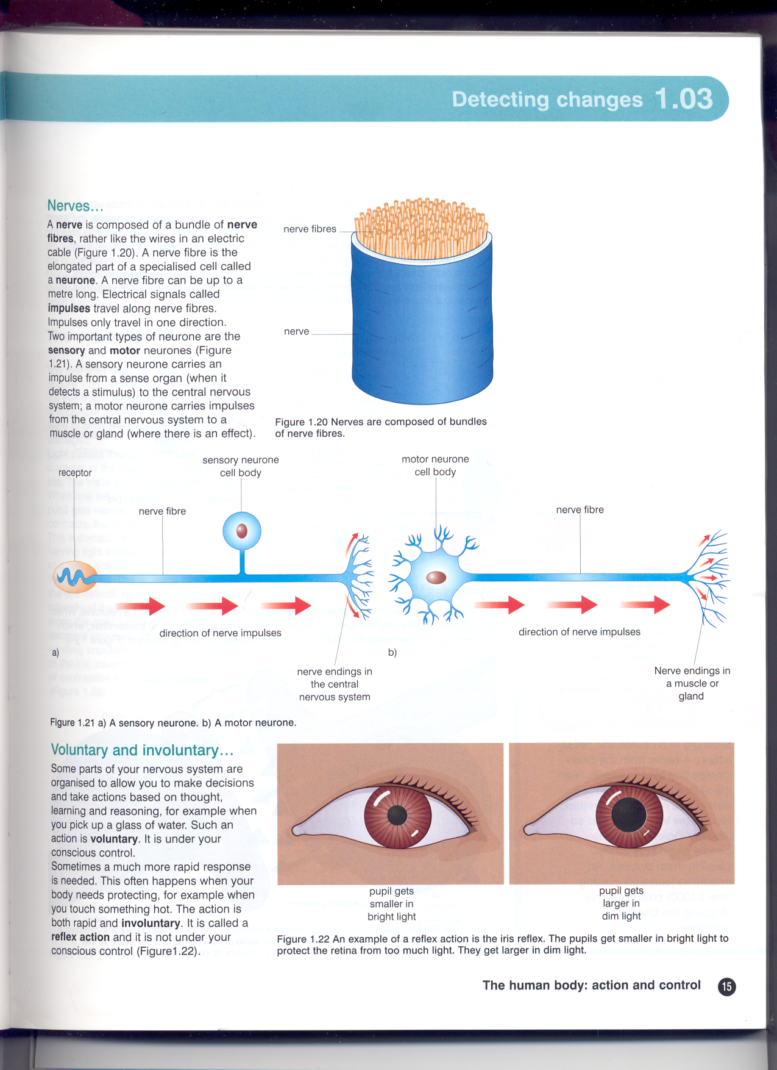

S…………………………………… Neurone

M……………………………. Neurone

**Q3. These are the two types of neurones in your body. Fill in the labels**

Impulses travel up the sensory neurone to the spinal cord.

The person’s finger touches the pin.

The pain receptors in the skin detect pain.

The impulses reach the bicep muscle. They cause the muscle to contract (get smaller)

Impulses travel from the spinal cord down the motor neurone.

The arm lifts up away from the pin.

**Q4. Put the sentences in order to show why you lift your arm away from a sharp object like a pin.**

1