Paper Bag of Values

To show your value system and how you became the person you are today, you will create a “paper bag of values.” This will be a very visual project, please take your time putting it together. You will be asked to share this project with the class. Remember to get creative (pictures, colors, collage) and dig deep into what makes you. This is a passion project with no right answer. The goal is to explore your values and understand where they came from.

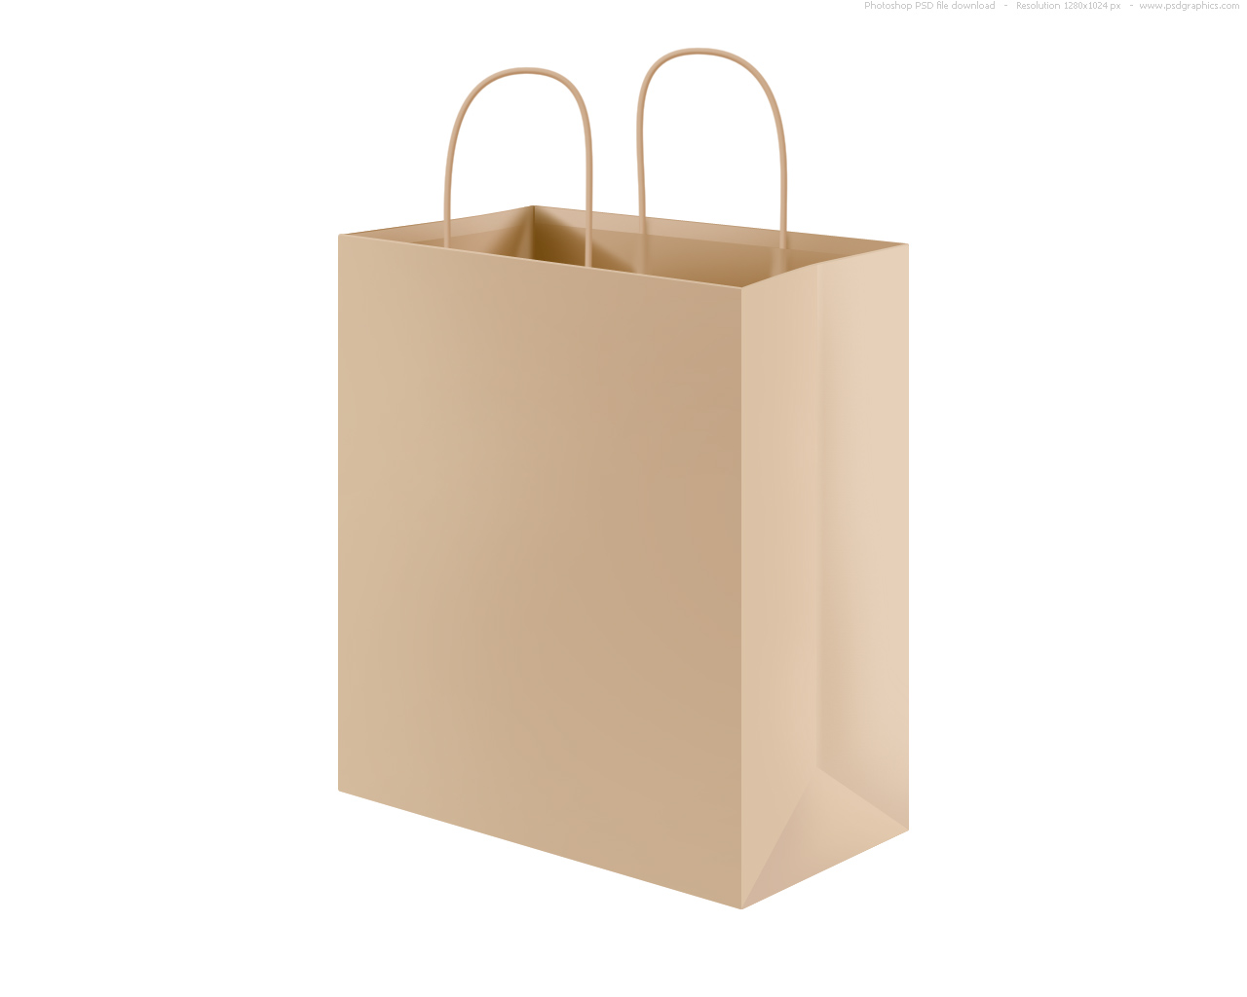
Supplies:
- A small paper bag (please reuse one if possible)
- Art supplies, photos, magazine clippings, etc.
- Objects of importance to you
All objects and photos will be returned to you after the project has been assessed. If you have any difficulty acquiring supplies, please let Mr. Green know.

Requirements:
- Side 1: (Inputs) What made you into the person you are today and shaped your way of thinking? This can include education, travel, religion, or other experiences. It should cover one entire large side of the bag.
- Side 2: (Outputs) This will represent YOUR environmental value system. Which of the three philosophies do you identify the most strongly with? Explain why with diagrams, pictures, words, etc. If you identify with more than one or are somewhere on the spectrum, note that as well. It should cover one entire large side of the bag.
- Inside: (Processes) Objects (at least 3) to represent who you are today and what you value in your life. Ideas include mementos of travel, sports, education, hobbies, religion, etc. Make it your own as this represents you!

