Name _____________________________
Date____________ period _____________
IB Environmental Systems and Societies

Population Theorists: Malthus and Boserup

 | Malthus  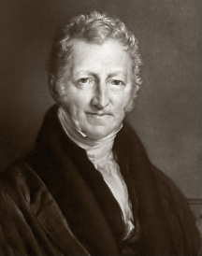 | Boserup
Main Ideas
Limitations to Theory
Applications
Provide an example that shows how their theory may be correct

What do you think? Are you a Malthusian or a Boserupian? Will human population continue to grow and agricultural methods change, or will population max out, limited by resource use?

